

UCD-PROD Upgrade Documentation

Pre-Upgrade



**Index**

**1] UCD Prod Version5**

**2] Dashboard** 5

**3] Component** 5

3.1] Component tab **5**

3.2] Template tab6

**4] Application** 6

4.1] Application tab **6**

4.2] Template tab7

**5] Configuration** 7

**6] Processes** 8

**7] Resources 8**

7.1] Resource Tree **8**

7.2] Resoruce Template 9

7.3] Agents 9

7.4] Agent Configuration Template 9

7.5] Agent Relays **10**

7.6] Agent Pools 10

7.7] Cloud Connection11

**8] Calendar** 11

**9] Work Items 12**

**10] Reports** 12

10.1] Deployment 13

10.1.1] Deployment Total Duration 13

10.1.2] Deployment Average Duration 14

10.1.3] Deployment Count **15**

10.1.4] Deployment Details 16

**10.2] Security** 17

10.2.1] Environment Security 17

10.2.2] Resource Security 18

10.2.3] User Security **19**

10.2.4] Component Security 20

10.2.5] Application Security 21

**10.3] My Reports**  22

**11] Settings** 22

**11.1] Automation 22**

11.1.1] Automation Plugin 22

11.1.2] Source Configuration Plugin 23

11.1.3] Running Version Import 23

11.1.4] Locks 24

11.1.5] Blueprint Designer Integrations **25**

11.1.6] Post Processing Scripts 25

11.1.7] Statuses 25

**11.2] Security** 26

**11.2.1] API Keys and Certificates** 26

**11.2.2] Authentication (Users) 27**

**11.2.2.1] Internal Security** 27

11.2.2.1.1] Users Tab 27

11.2.2.1.2] Edit Tab 28

**11.2.2.2] LDAP_Realm_YBL** 28

11.2.2.2.1] Users Tab 28

11.2.2.2.2] Edit tab 29

**11.2.2.3] LDAP2 30**

11.2.2.3.1] Users Tab 30

11.2..2.3.2] Edit tab 30

**11.2.2.4] Storage Team-2** 31

11.2.2.4.1] Users Tab31

11.2.2.4.2] Edit tab **32**

**11.2.2.5] Storage Team** 33

11.2.2.5.1] Users Tab 33

11.2.2.5.2] Edit tab 33

**11.2.2.6] UCD – Integration user Realm** 34

11.2.2.6.1] Users Tab 34

11.2.2.6.2] Edit tab 35

**11.2.3] Authorization (Groups) 36**

11.2.3.1] Authorization Realms 36

11.2.3.2] Groups 36

**11.2.4] Teams** 37

11.2.4.A] ESB_TEAM 37

11.2.4.B] NewConsole_TEAM **39**

11.2.4.C] OBDX_Team40

11.2.4.D] RPA_TEAM 42

11.2.4.E] SVC_Digi **43**

11.2.4.F] System Team 45

11.2.4.G] UAAS_TEAM 48

11.2.4.H] Yes_Aim_CA 50

**11.2.5 ] Tokens** **51**

**11.2.6] Role Configuration** **52**

11.2.6.A] Administrator 52

11.2.6.B] Automation Engineer 52

11.2.6.C] DB_PWD_AUTOMATION 53

11.2.6.D] Integration Users 53

11.2.6.E] ODBX Release Engineer 54

11.2.6.F] Read_Only 54

11.2.6.G] RELEASE ENGINEER 55

11.2.6.H] Release Team **55**

11.2.6.I] UAT_Deployer 56

11.2.6.J] UC Auto Configure 56

11.2.6.K] UC Auto Discovery 57

11.2.6.L] UC Version Import 57

**11.2.7] Type Configuration** **58**

11.2.7.1] Agent Types 58

11.2.7.2] Agent Configuration Template types 58

11.2.7.3] Agent Pool Types 59

11.2.7.4] Agent Relay Type 59

11.2.7.5] Application **60**

11.2.7.6] Application Template Type 60

11.2.7.7] Cloud Connection types 61

11.2.7.8] Component Type 61

11.2.7.9] Component Template Type **62**

11.2.7.10] Environment 62

11.2.7.11] Environment Template Type 63

11.2.7.12] Process 63

11.2.7.13] Resource Type 64

11.2.7.14] Resource Template types **64**

**11.3 ] System** 65

11.3.1] Logging 65

11.3.2] Network67

11.3.3] Notification Scheme 68

11.3.4] Patches **68**

11.3.5] Properties 69

11.3.6] Audit Log 70

11.3.7] CodeStation 70

11.3.8] Diagnostics 71

11.3.8.A] JAVA Thread Dumps 71

11.3.8.B] REST call Log 71

11.3.8.C] Metadata Indexing **72**

**11.3.9] System Settings 72**

**1] UCD Prod Version :**

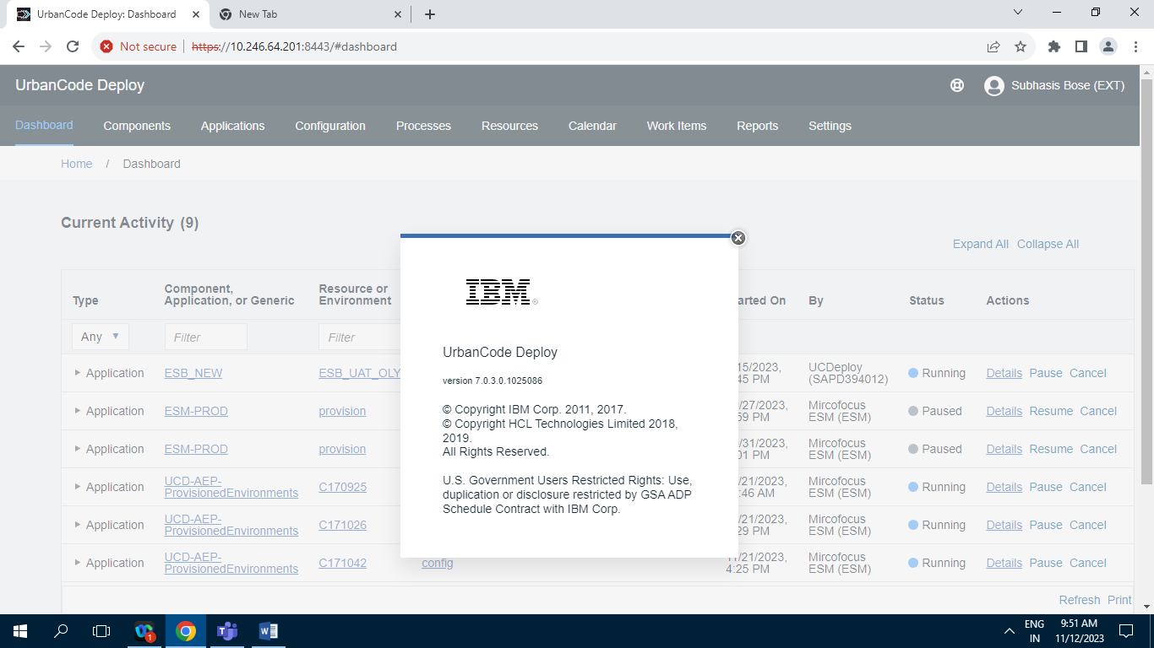

**3] Component :**

**3.1] Component tab :**

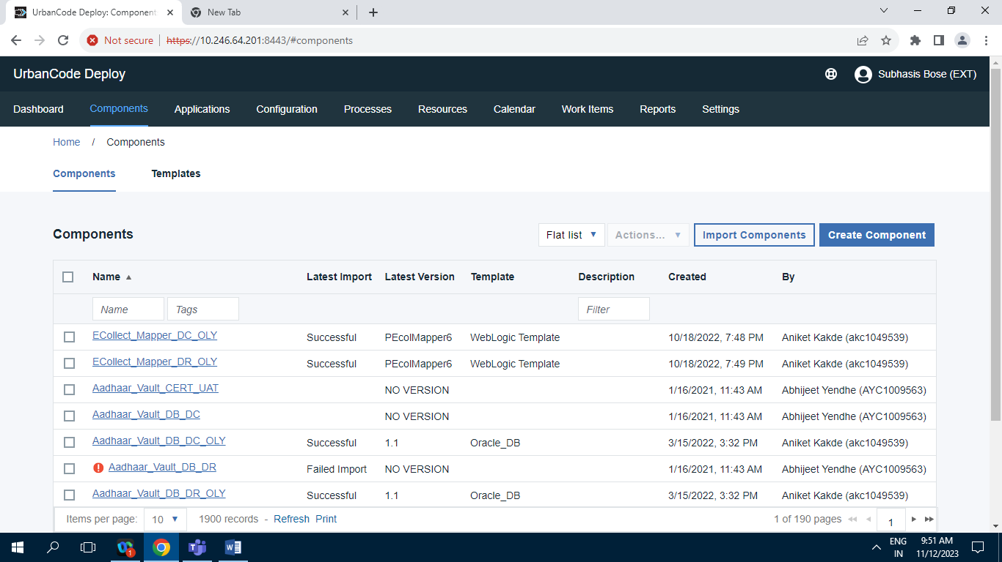

Screenshot of Component tab having 1900 Records.

**3.2] Template :**

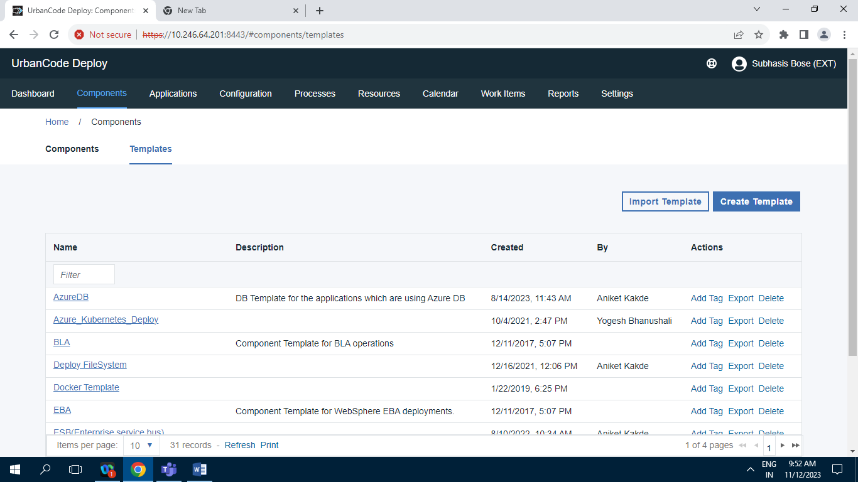

Screenshot of Template tab having 31 Records.

**4] Application :**

**4.1] Application tab:**

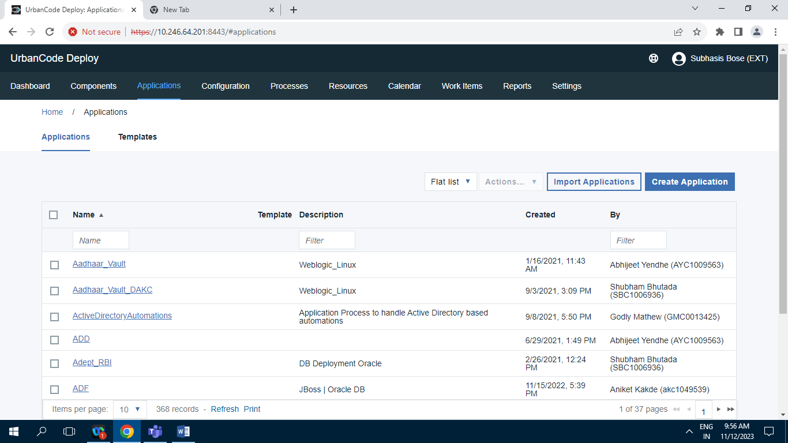

Screenshot of application tab having 368 records.

**4.2] Template tab :**

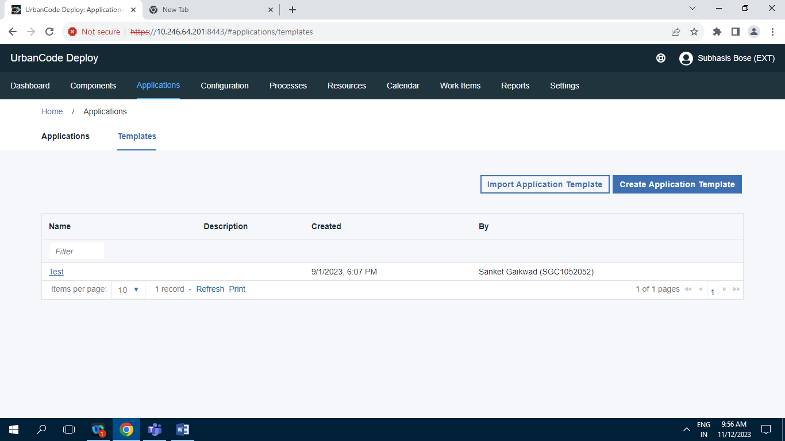

Screenshot of Template tab having 1 record.

**5] Configuration :**

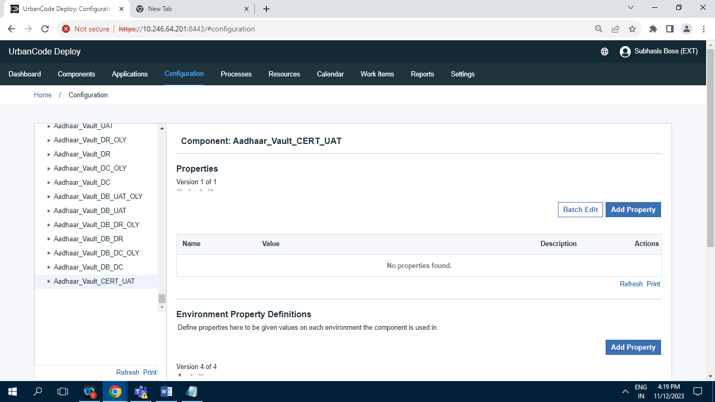

**6] Processes :**

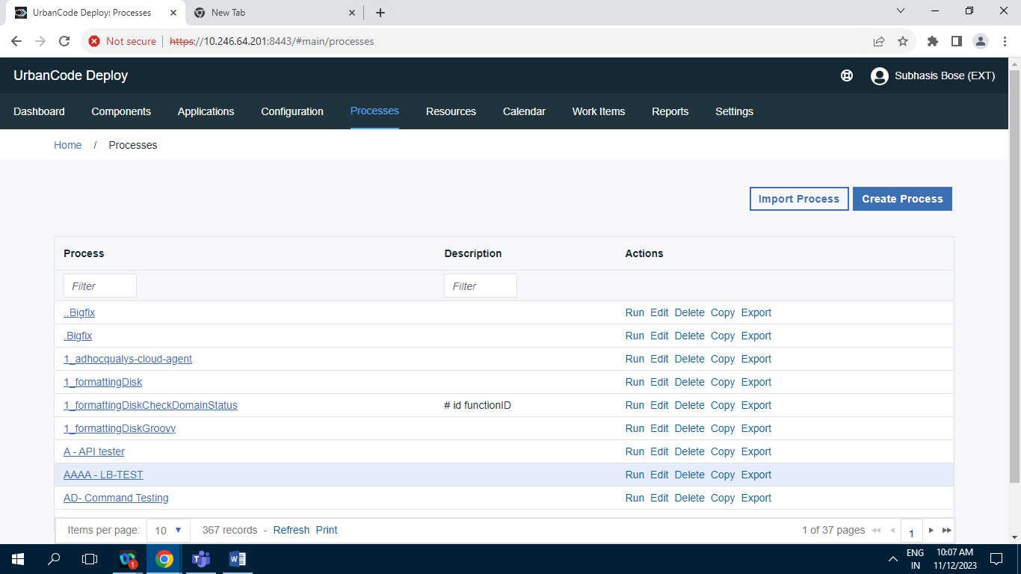

Screenshot of processes tab having 367 records .

**7] Resources :**

**7.1] Resource Tree :**

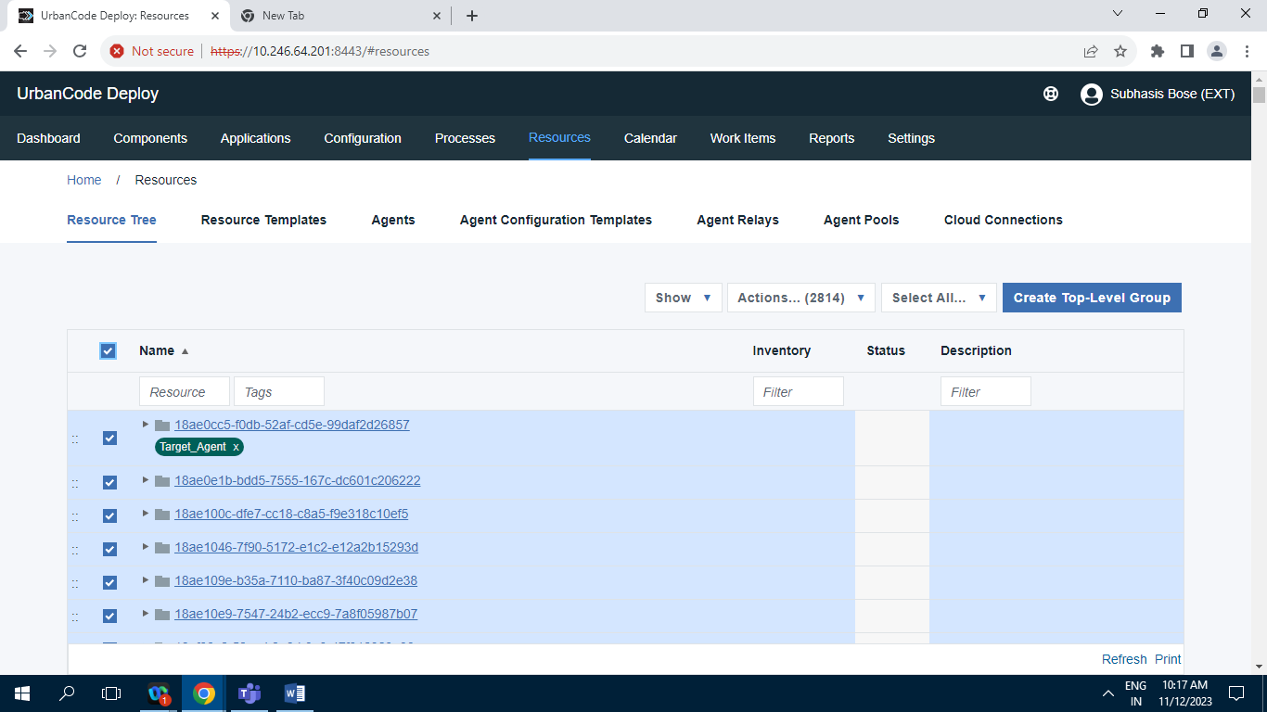

Screenshot of Resource tree tab having 2814 records

**7.2] Resoruce Template :**

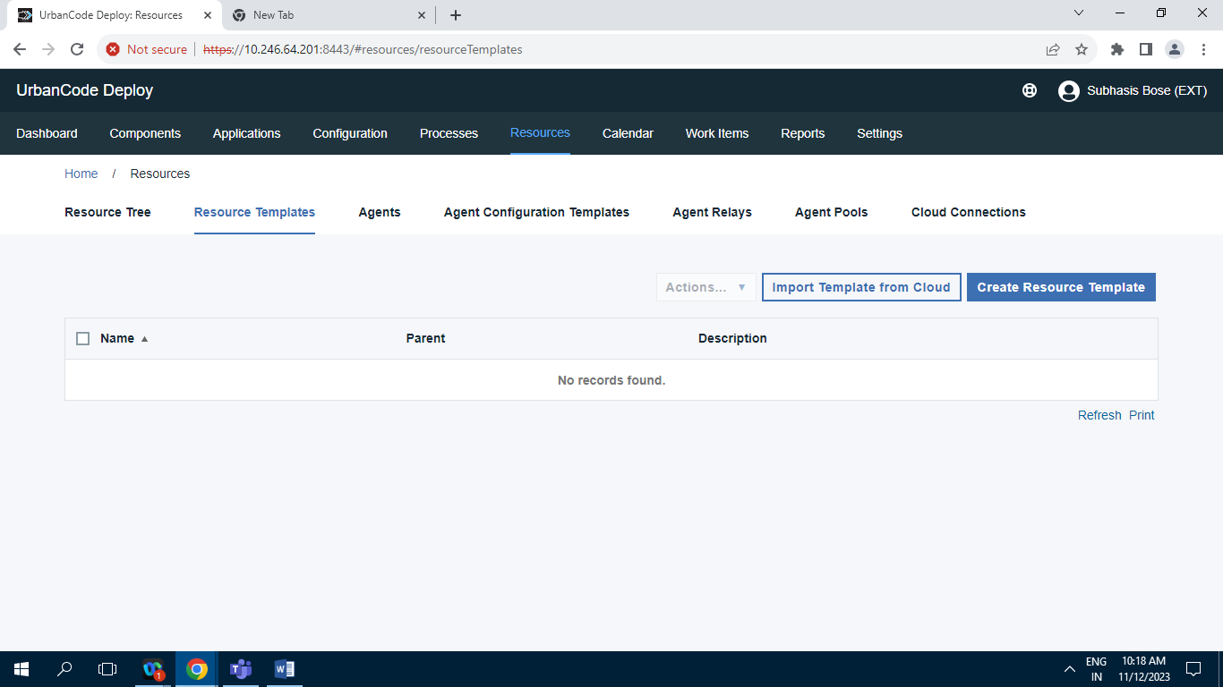

Screenshot of resource template tab having 0 zero record.

**7.3] Agents :**

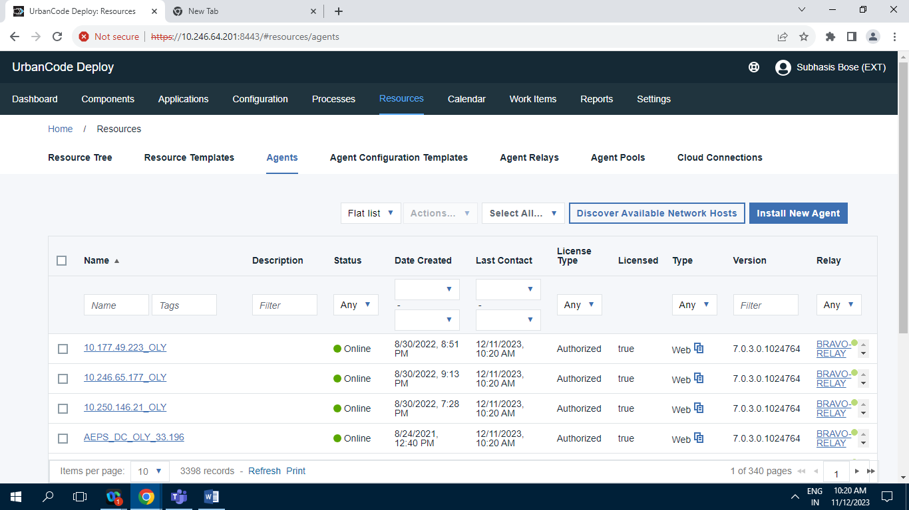

Screenshot of Agents tab having 3398 Records.

**7.4] Agent Configuration Template :**

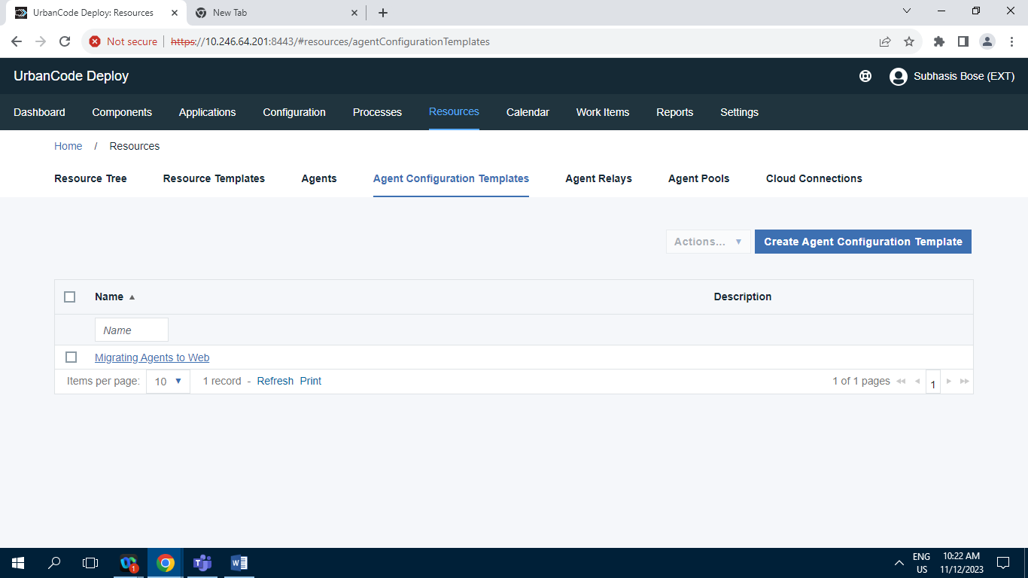Screenshot of Agent Configuration Template Tab having 1 Record.

**7.5] Agent Relays :**

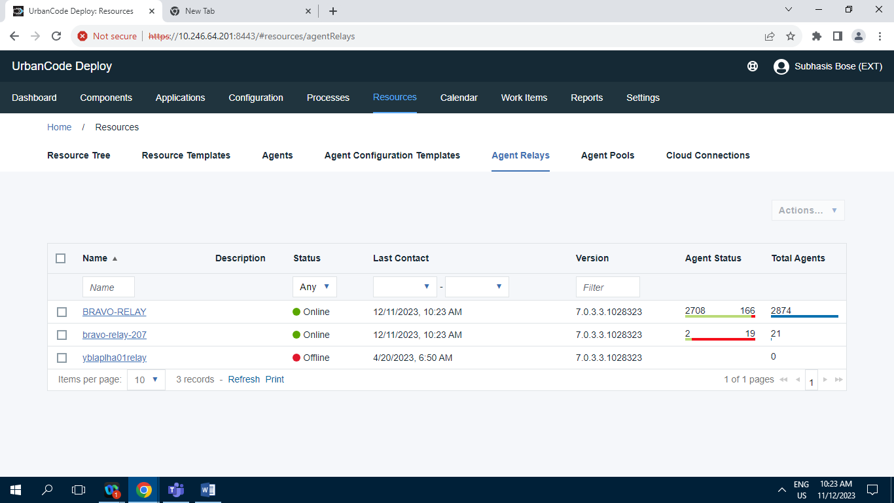

Screenshot of Agent Relay Tab having 3 Records.

**7.6] Agent Pools :**

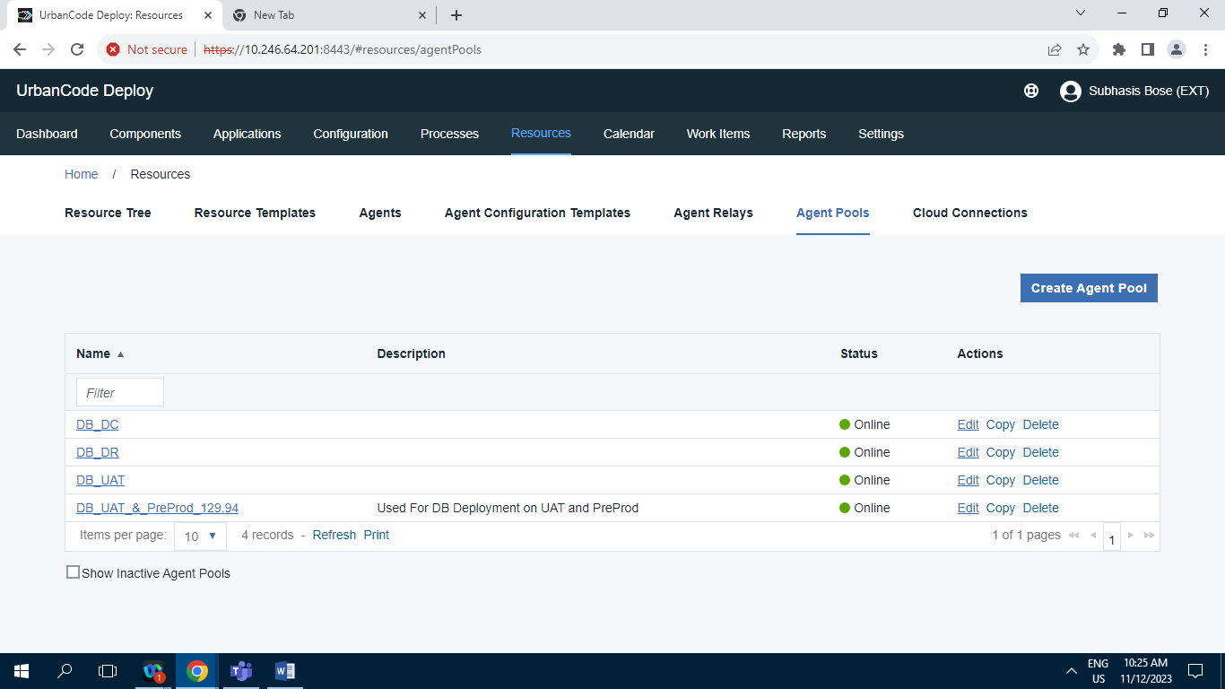

Screenshot of Agent Pools tab having 4 Records.

**7.7] Cloud Connection :**

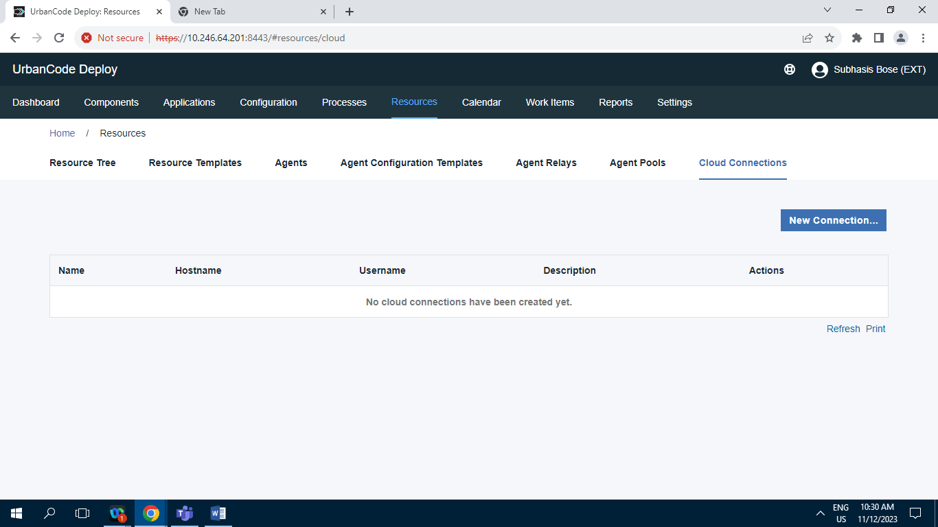

Screenshot of Cloud Connection tab Having 0 Records.

**8] Calendar :**

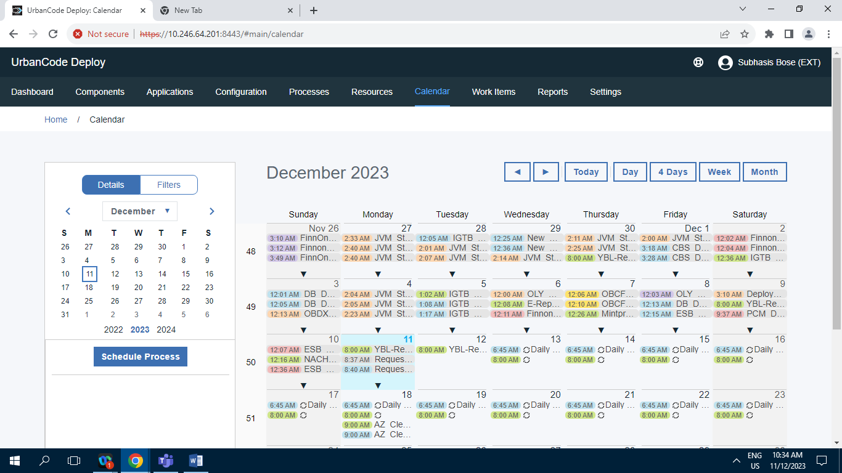

Screenshot of Calendar Tab.

**9] Work Items :**

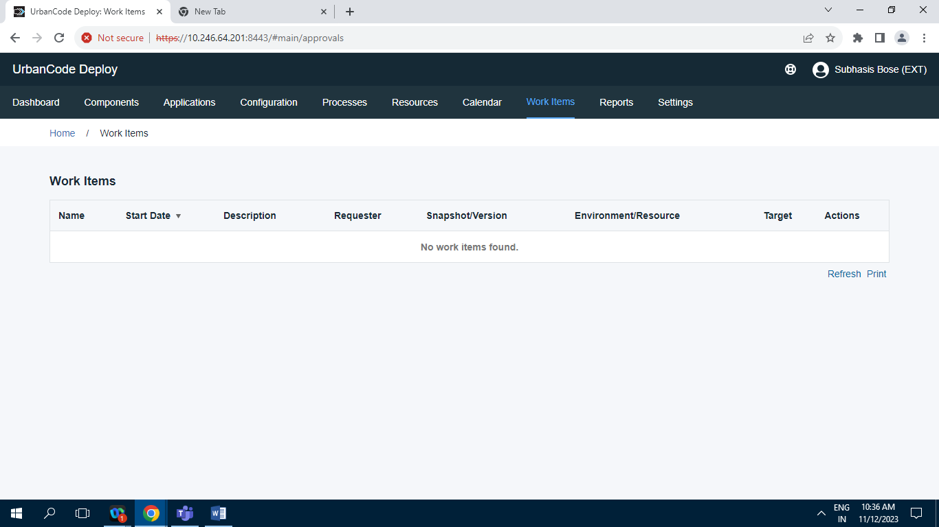

Screenshot of Work Items having 0 Record.

**10] Reports :**

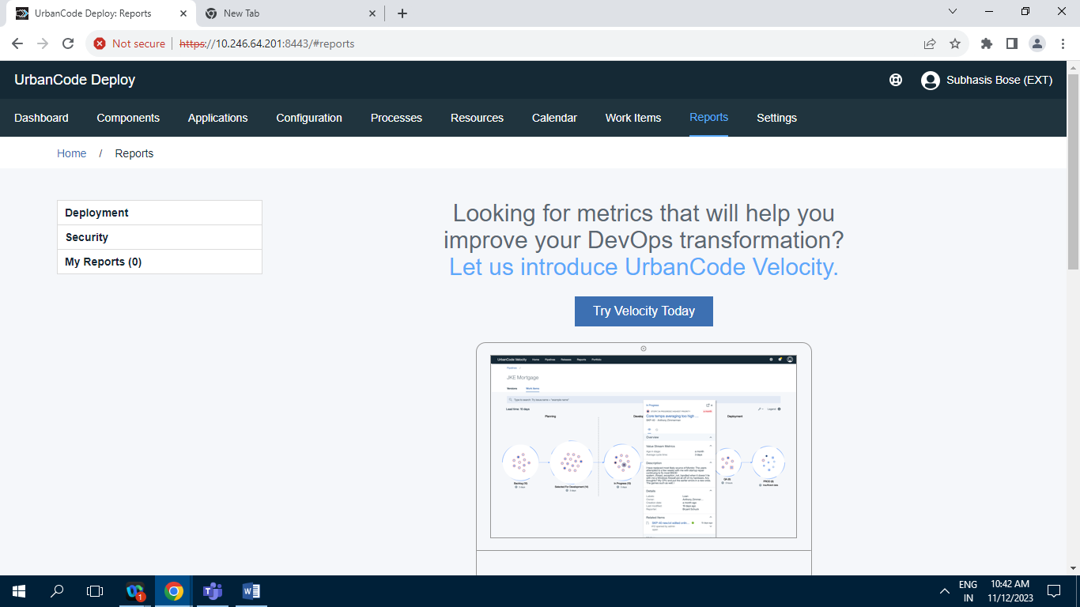

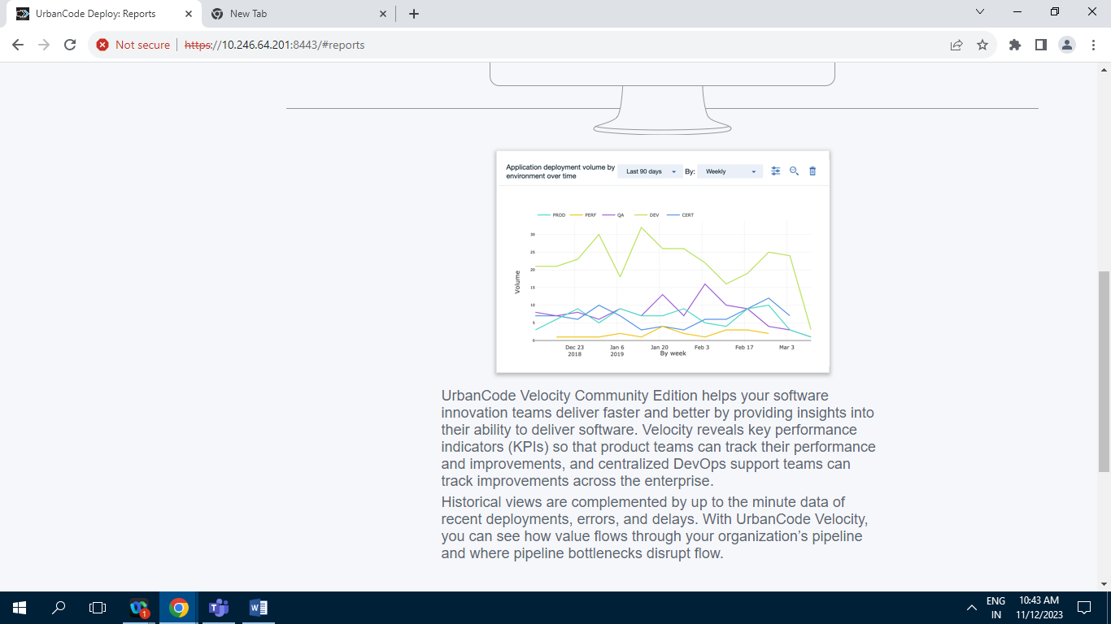

**10.1] Deployment :**

**10.1.1] Deployment Total Duration :**

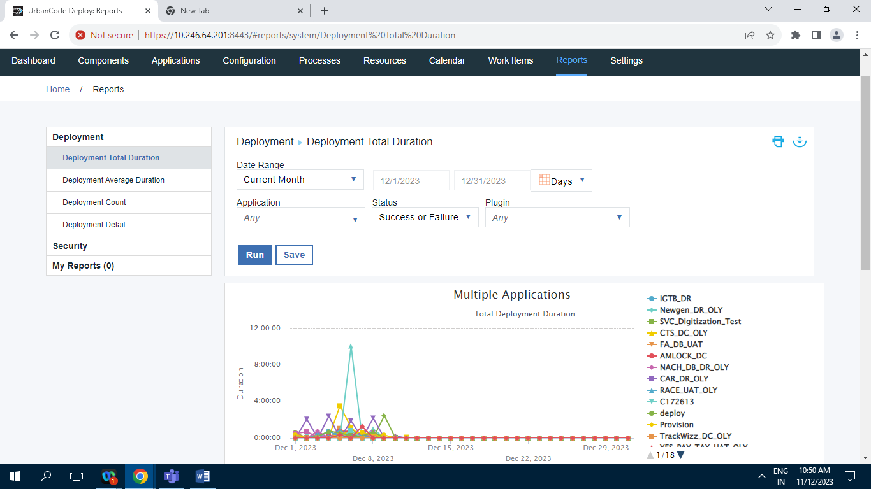

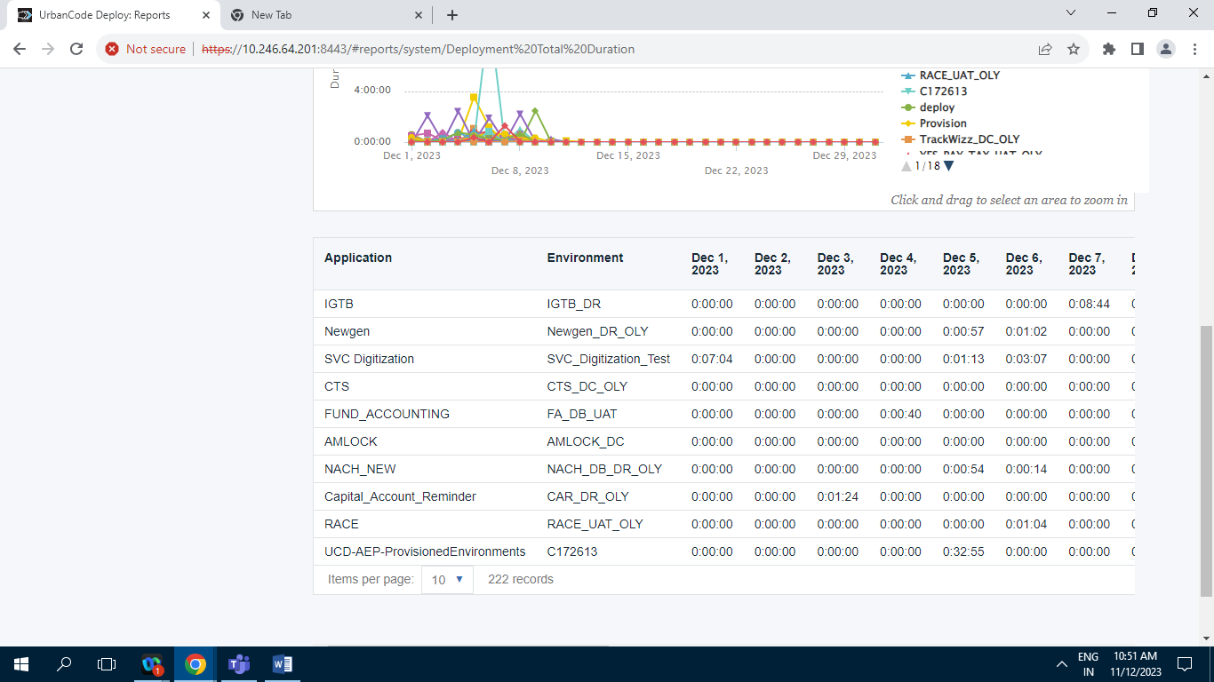

Screenshot of Deployment Total Duration tab having 222 Records.

**10.1.2] Deployment Average Duration :**

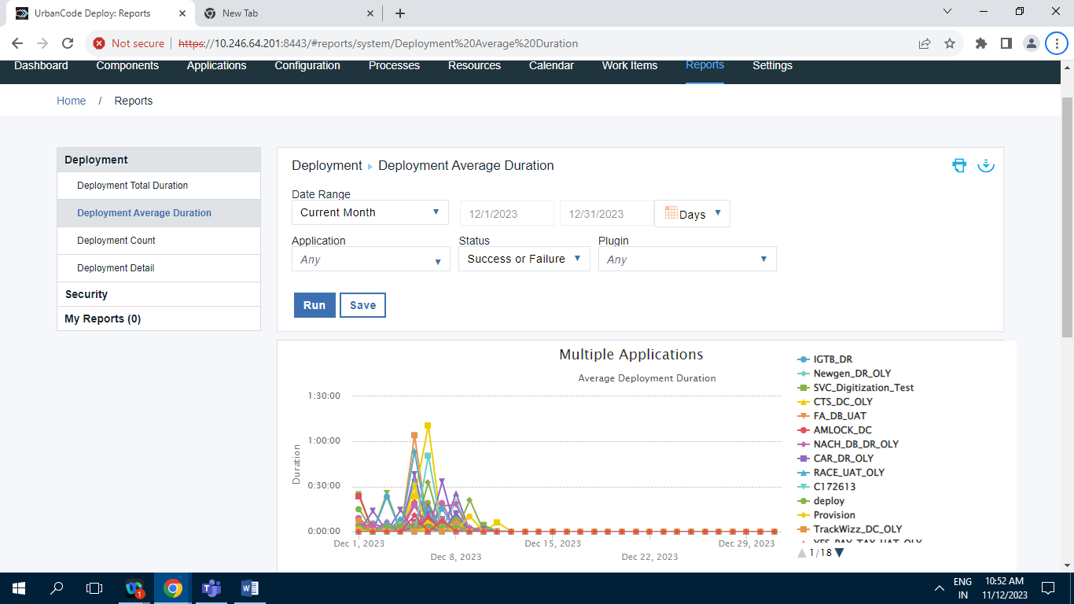

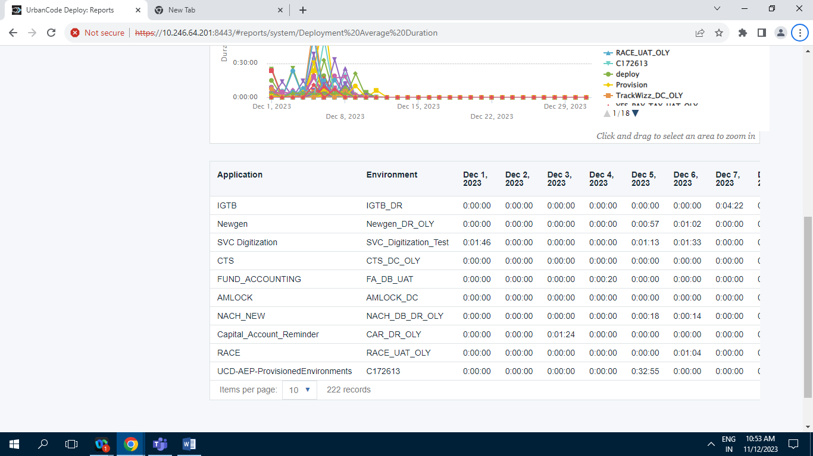

Screenshot of Deployment Average Duration having 222 Records.

**10.1.3] Deployment Count :**

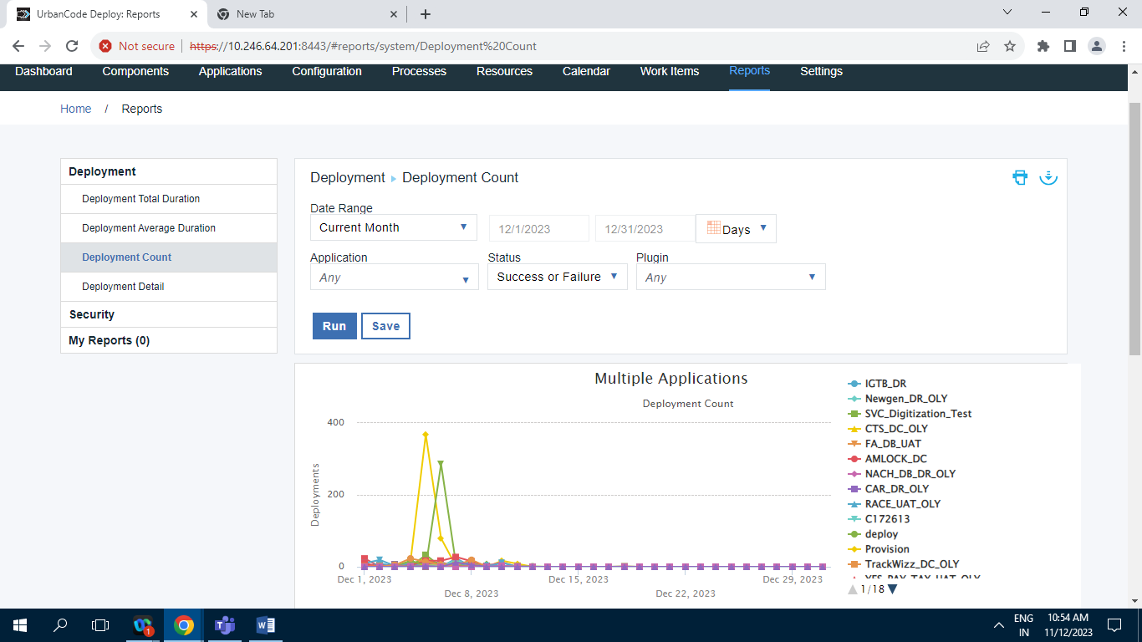

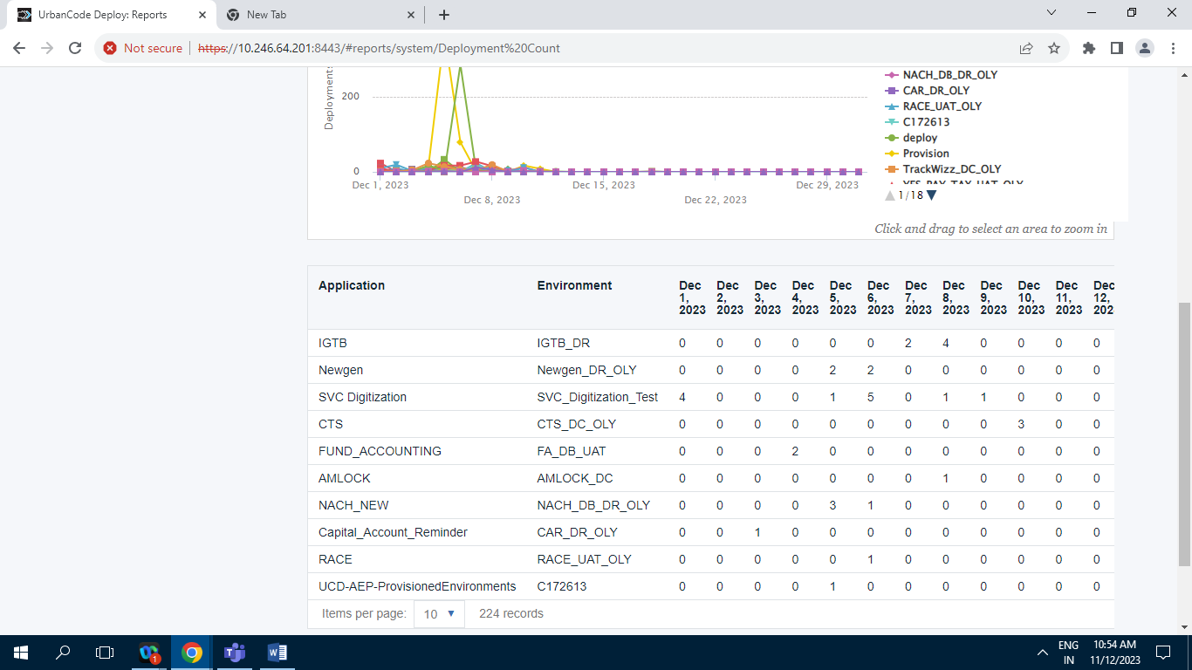

Screenshot of Deployment Count Having 224 Records.

**10.1.4] Deployment Details :**

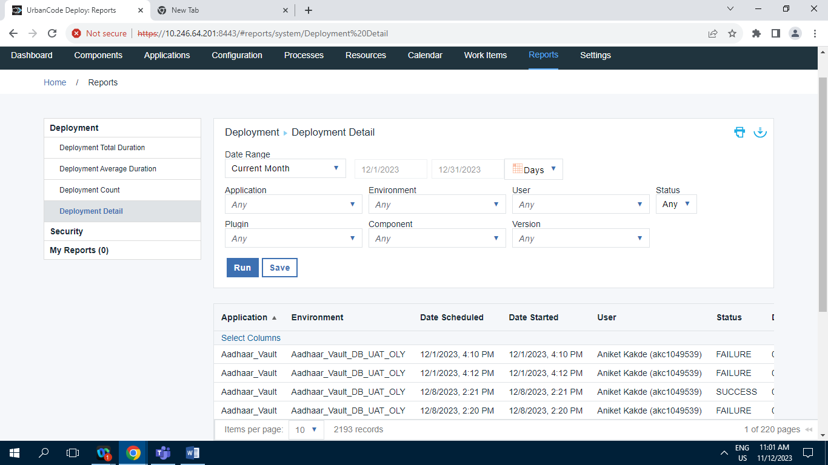

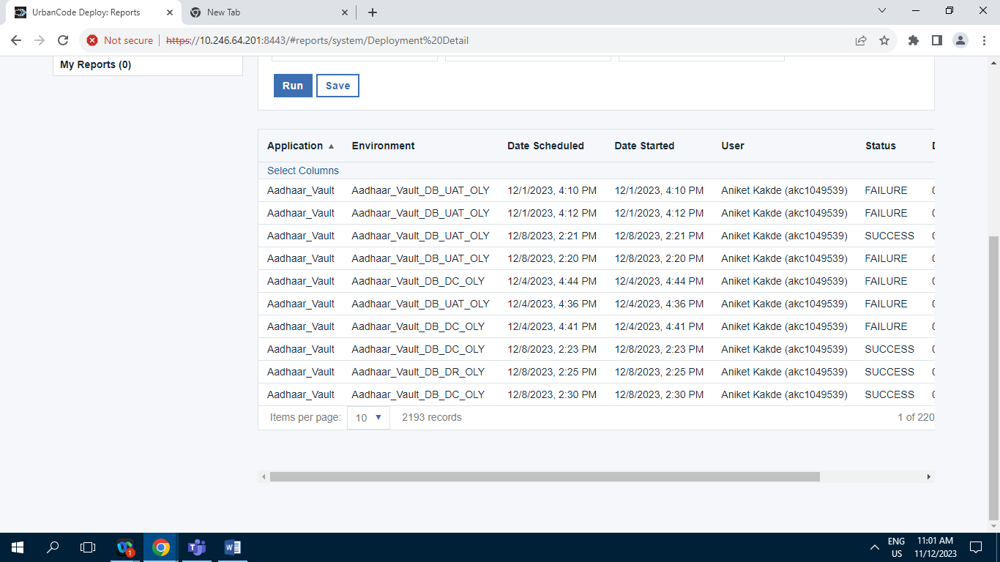

Screenshot of Deployment Detail having 2193 Records.

**10.2] Security :**

**10.2.1] Environment Security :**

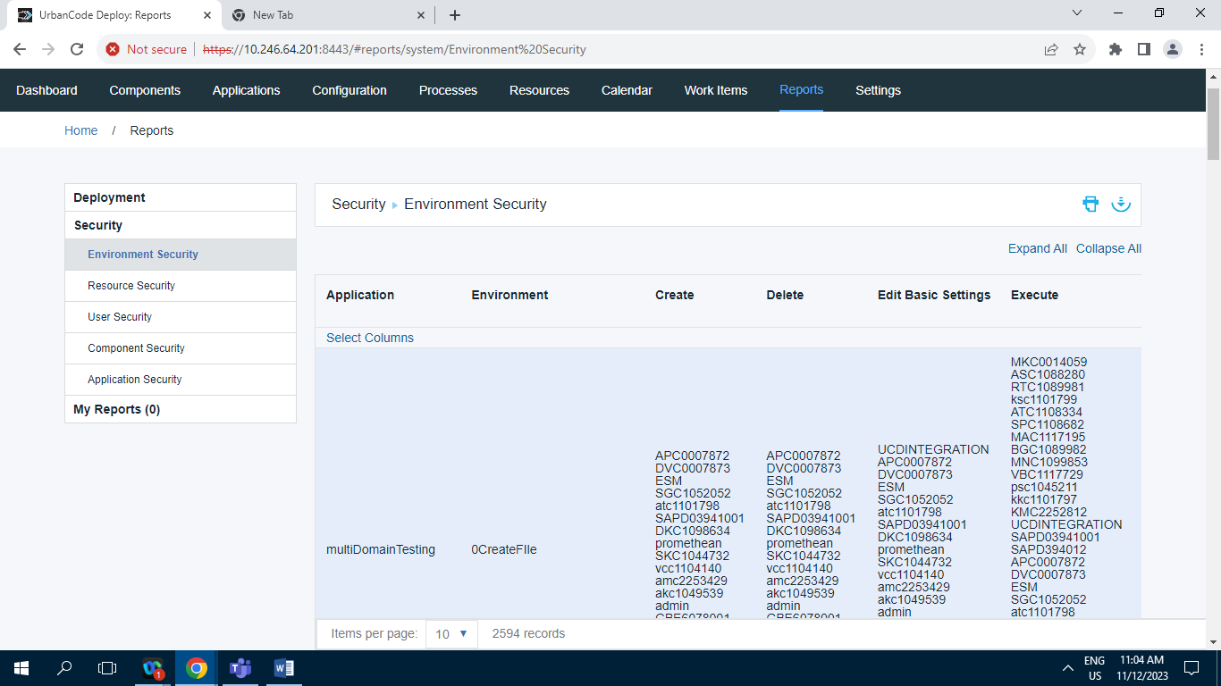

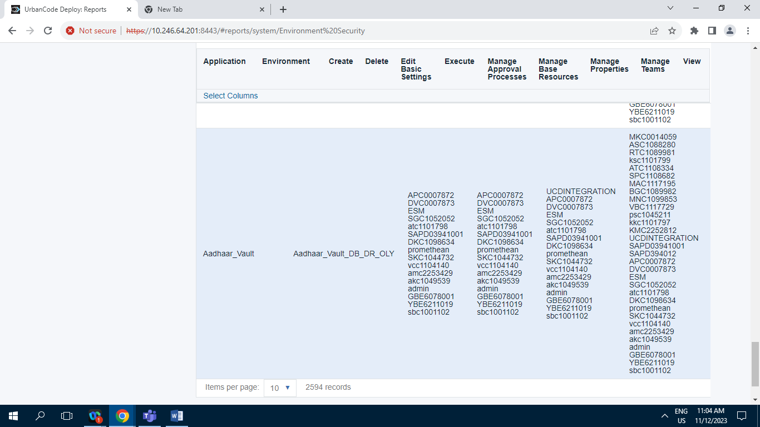

Screenshot of Environment Security having 2594 Records .

**10.2.2] Resource Security :**

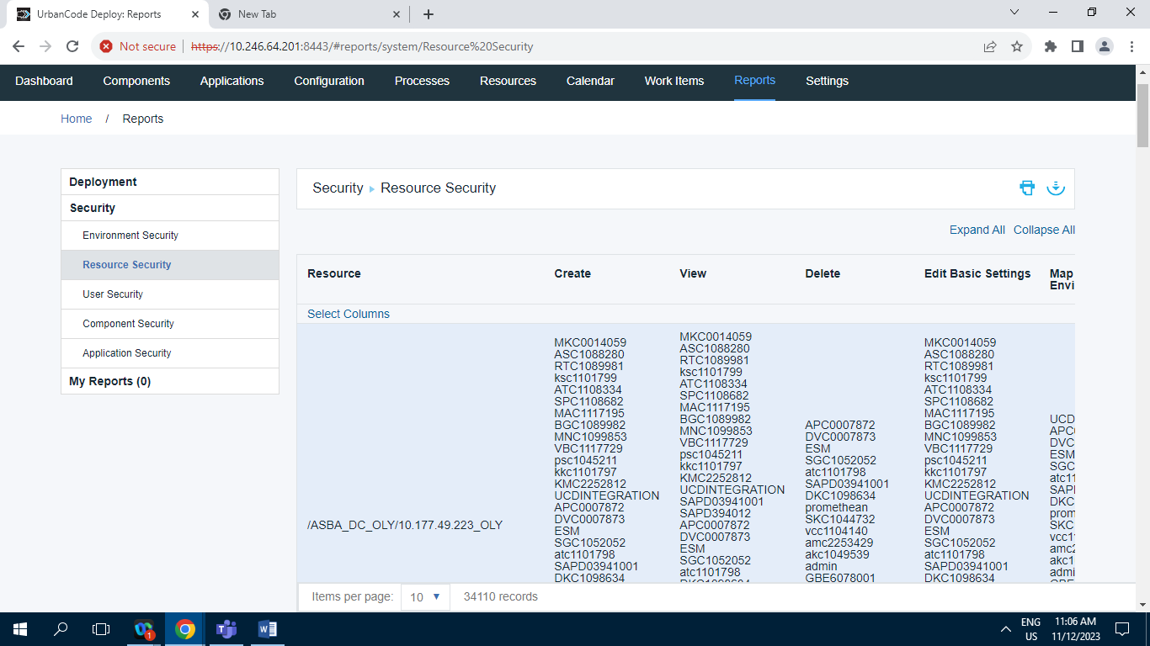

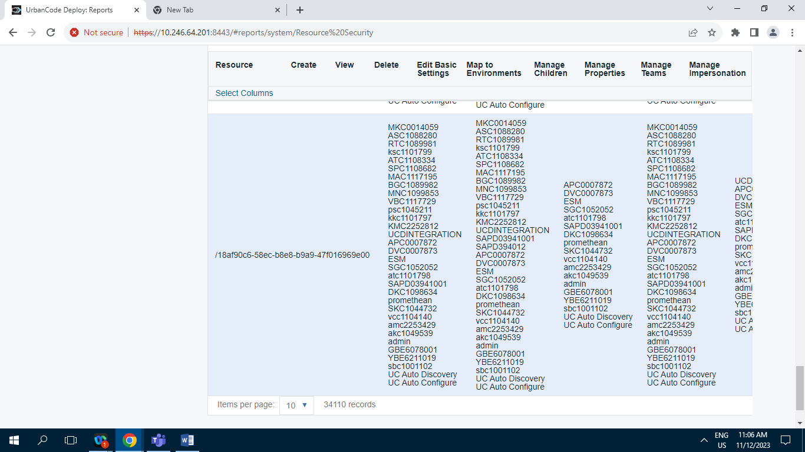

Screenshot of Resource Security having 34110 Records

**10.2.3] User Security :**

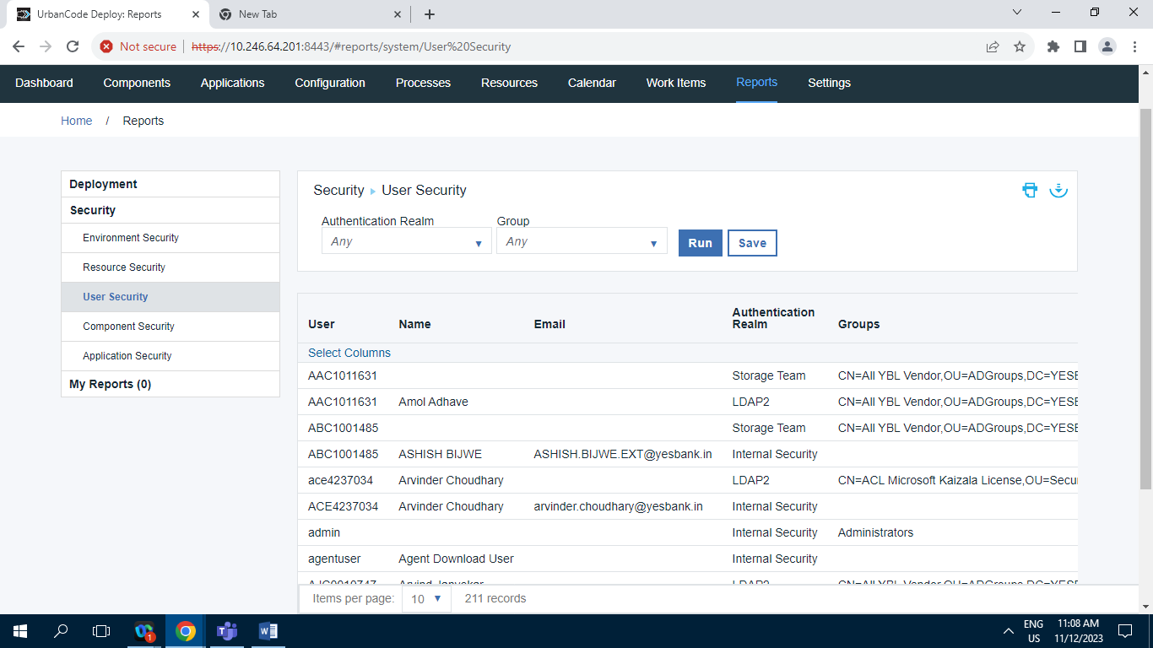

Screenshot of User Security having 211 Records.

**10.2.4] Component Security :**

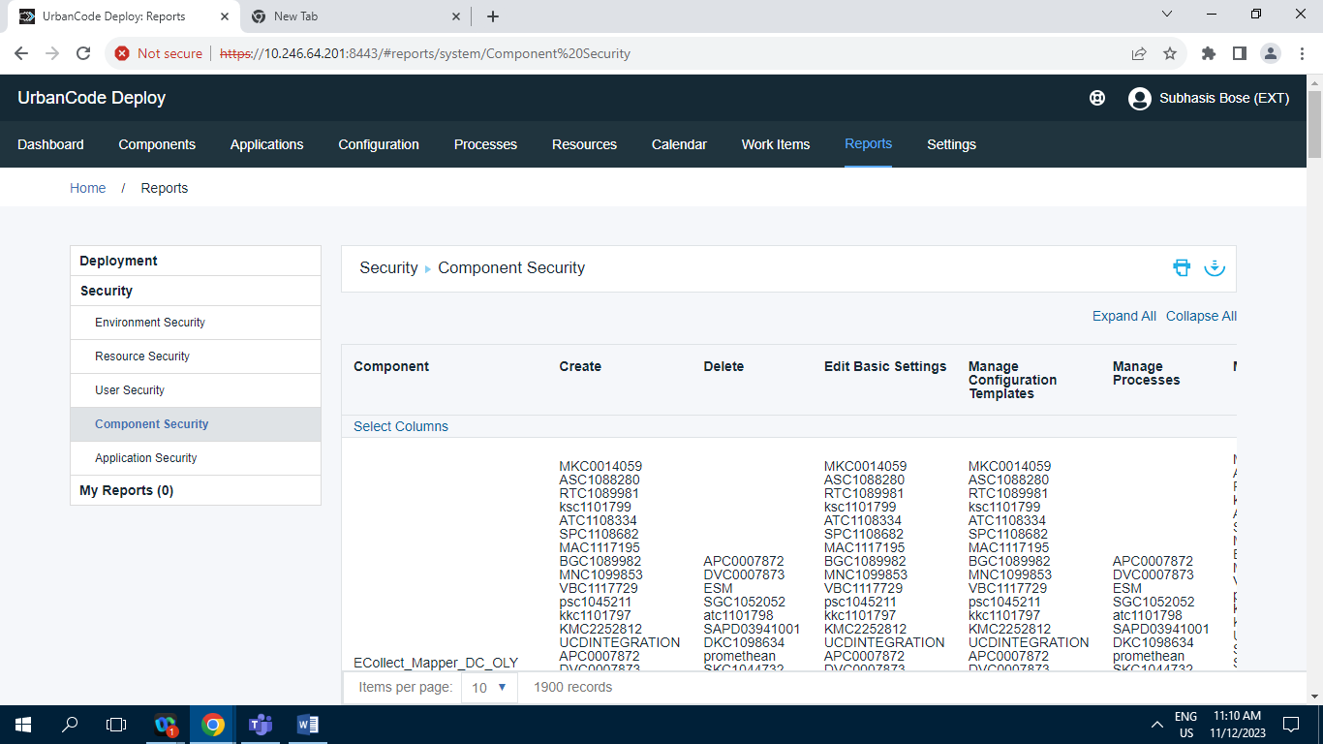

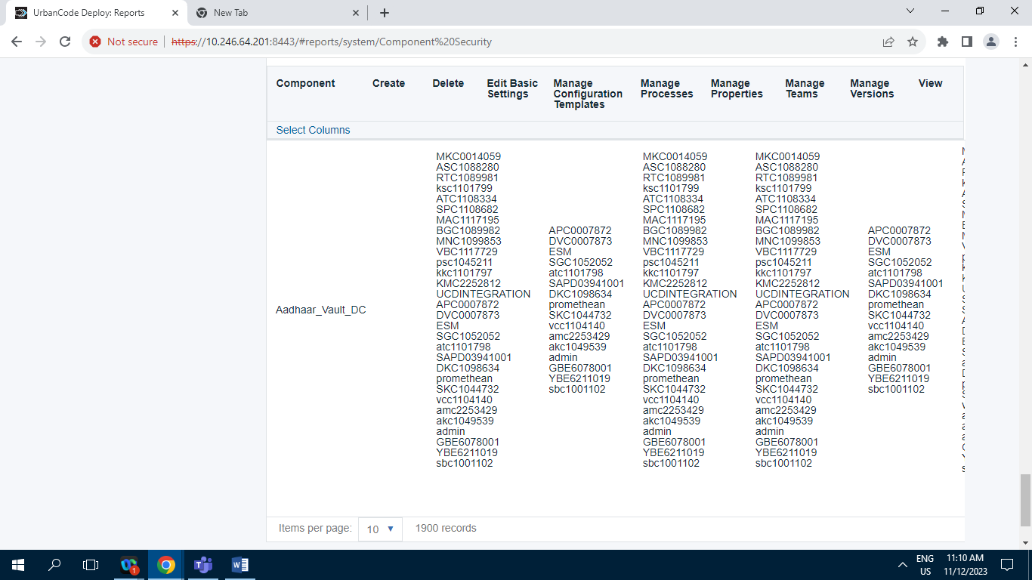

Screenshot of Component Security having 1900 Records.

**10.2.5] Application Security :**

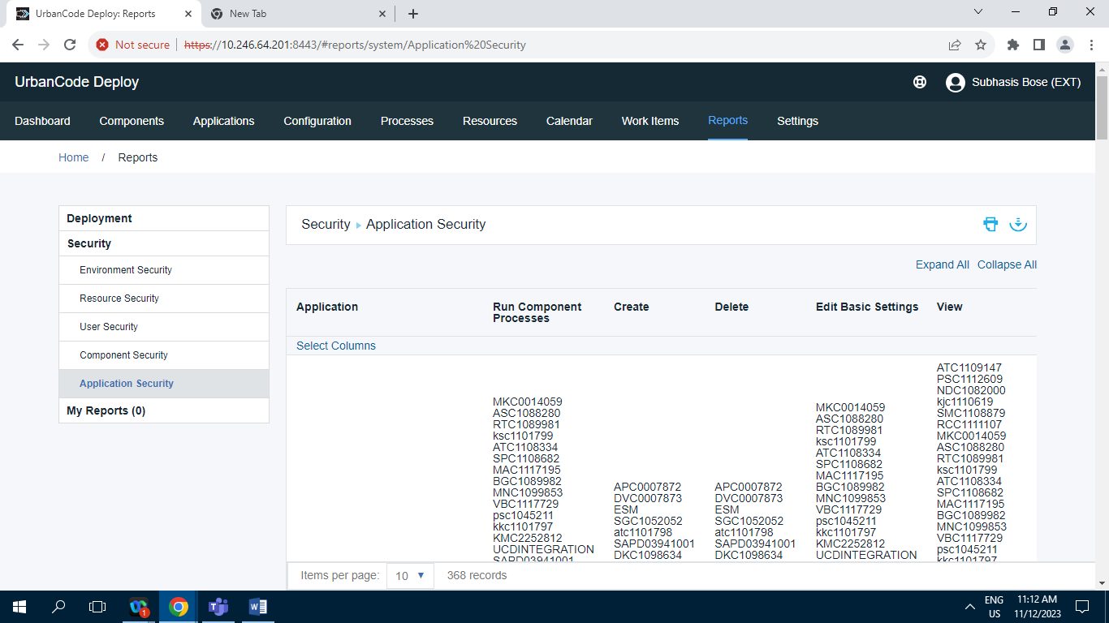

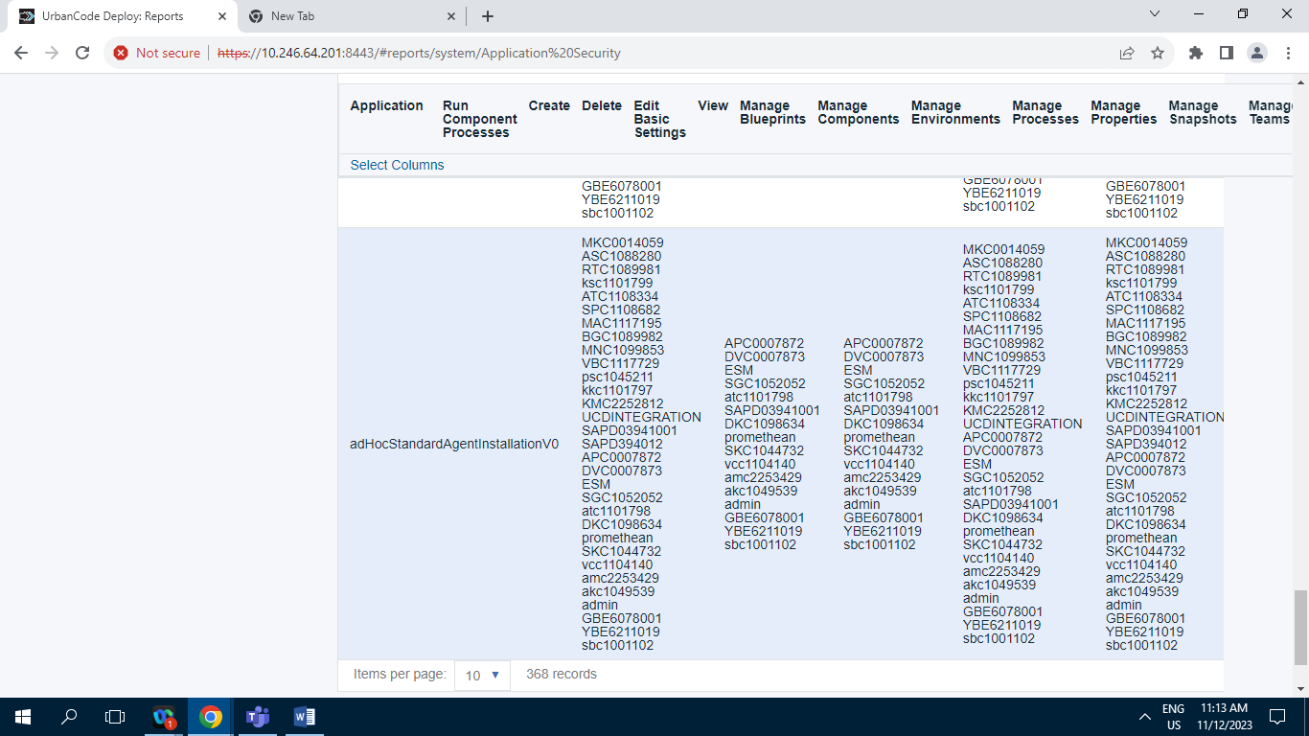

Screenshot of Application Security having 368 Records.

**10.3] My Reports :**  Zero Records in My Report tab.

**11] Settings :**

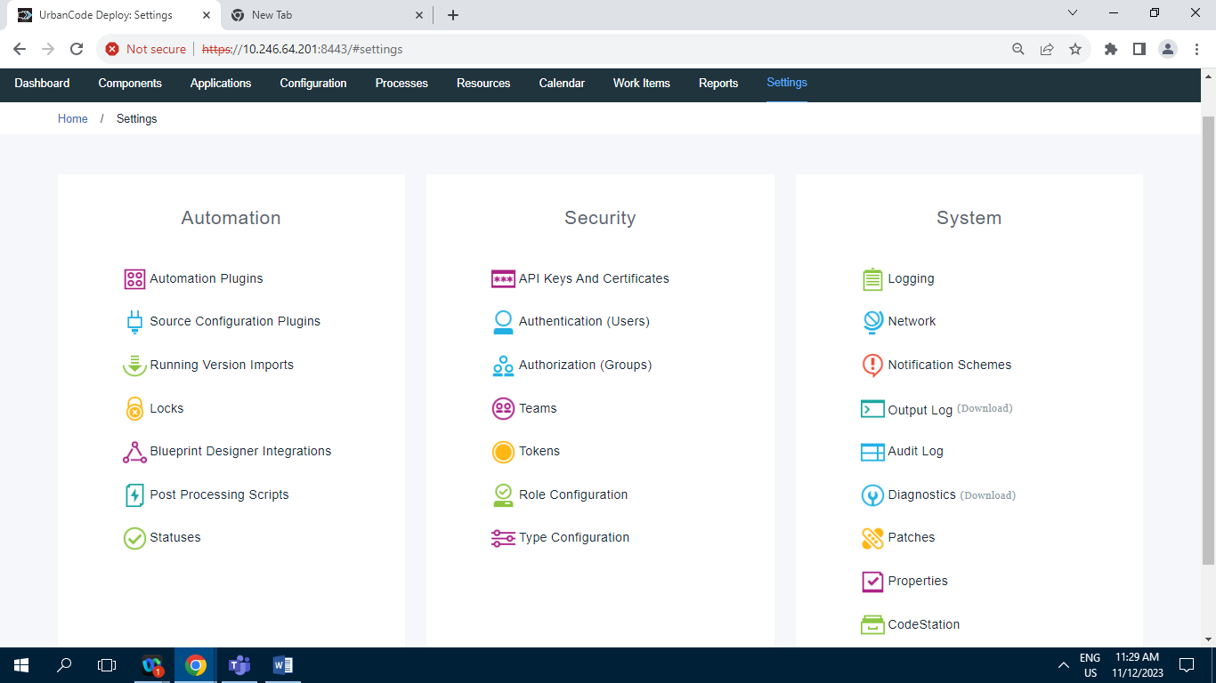

**11.1] Automation :**

**11.1.1] Automation Plugin :**

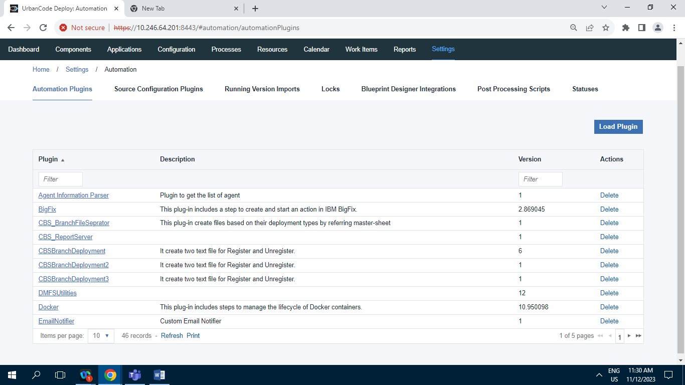

Screenshot of Automation Plugin having 46 Records.

**11.1.2] Source Configuration Plugin :**

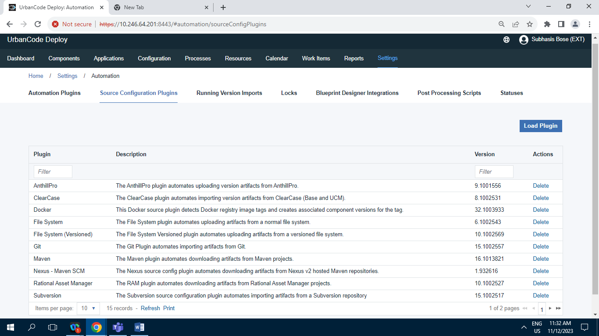

Screenshot of Source Configuration Plugin having 15 Records.

**11.1.3] Running Version Import :**

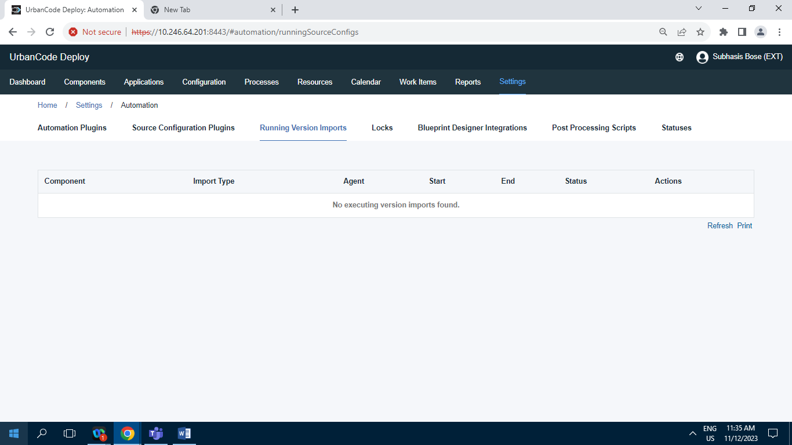

Screenshot of Running Version Import having 0 Record.

**11.1.4] Locks :**

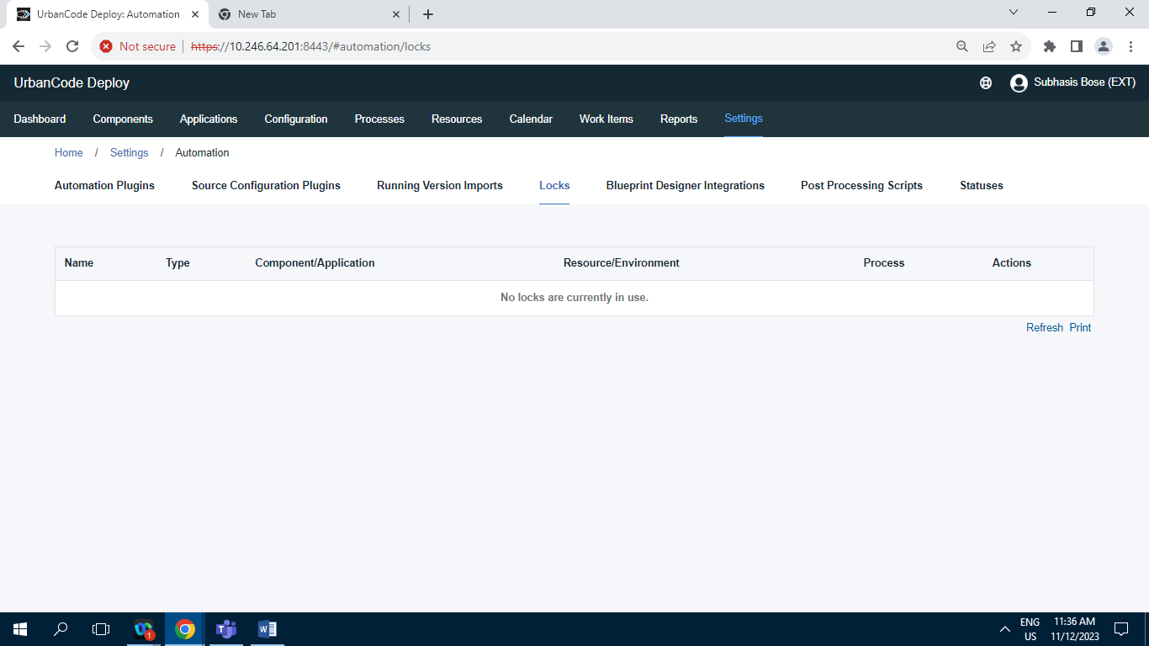

Screenshot of Locks tab Having 0 Records .

**11.1.5] Blueprint Designer Integrations :**

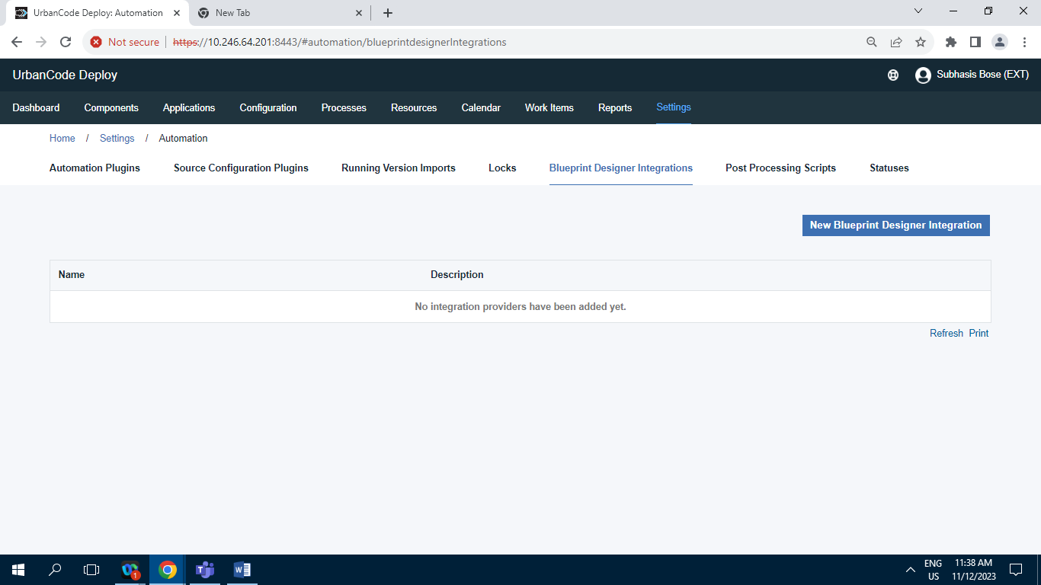

Screenshot of Blueprint Designer Integrations having 0 Record.

**11.1.6] Post Processing Scripts :**

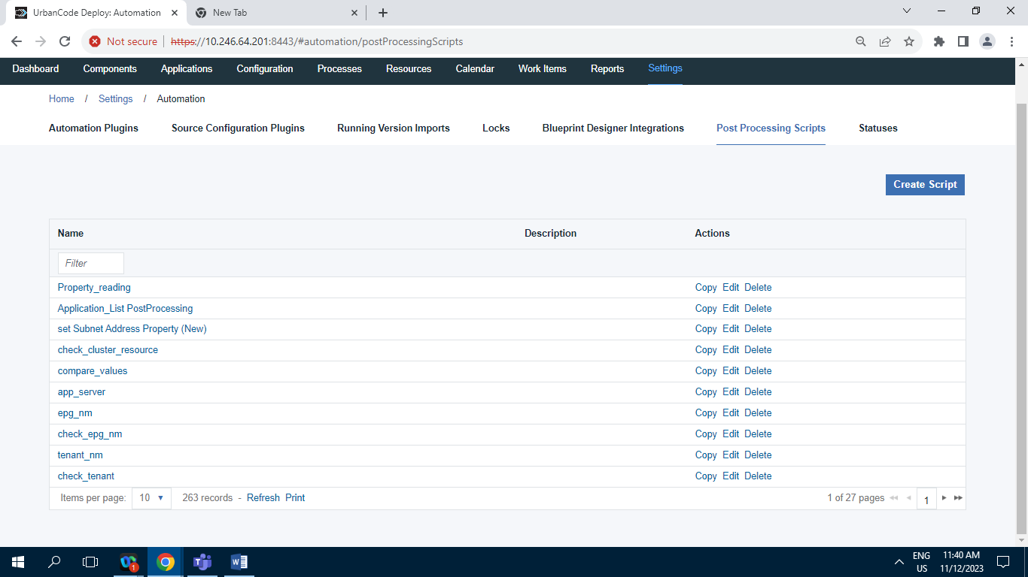

Screenshot of Post Processing Script having 263 Records.

**11.1.7] Statuses :**

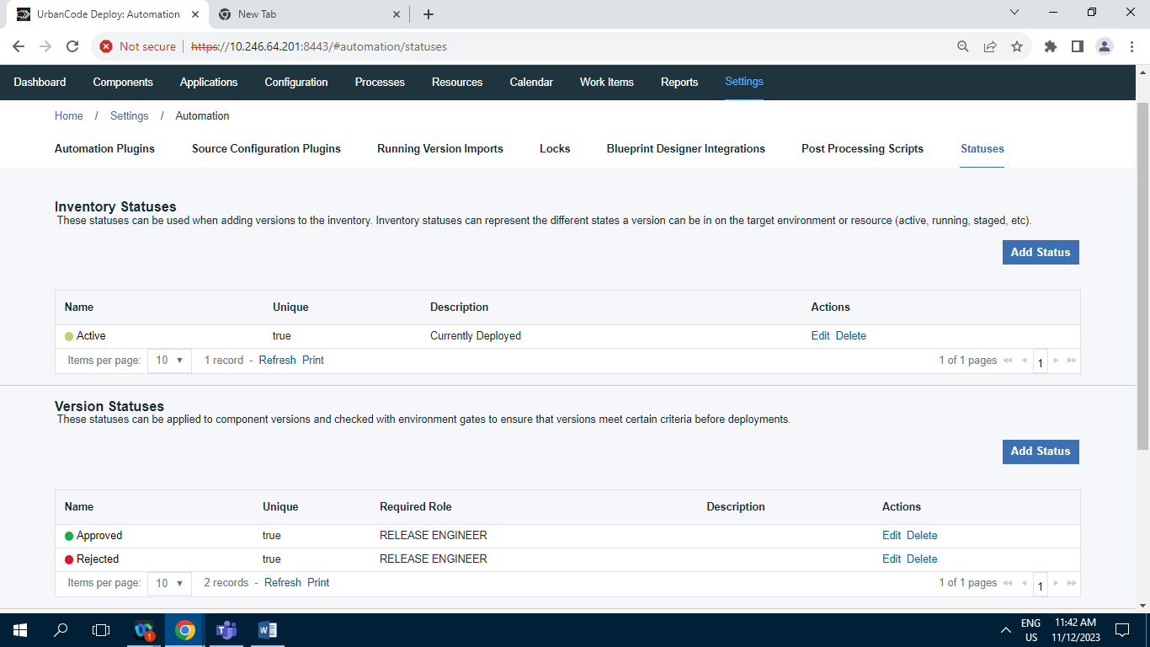

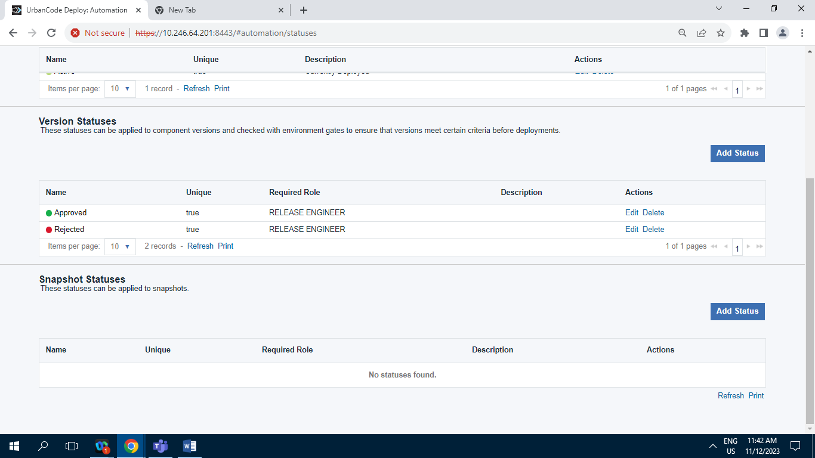

**11.2] Security :**

**11.2.1] API Keys and Certificates :**

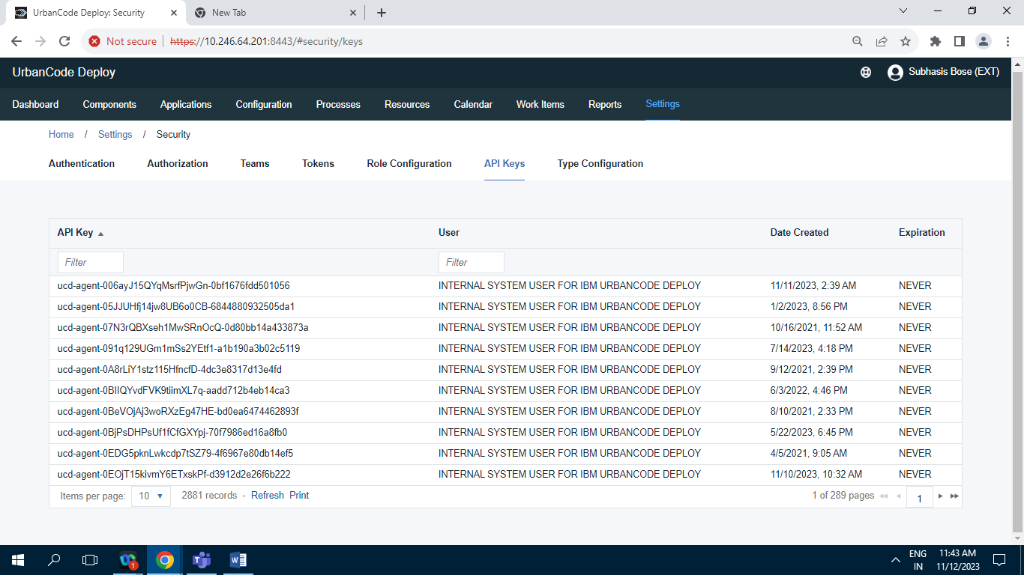

Screenshot of Api keys and certificates tab having 2881 Records.

**11.2.2] Authentication (Users) :**

**11.2.2.1] Internal Security :**

**11.2.2.1.1] Users Tab**

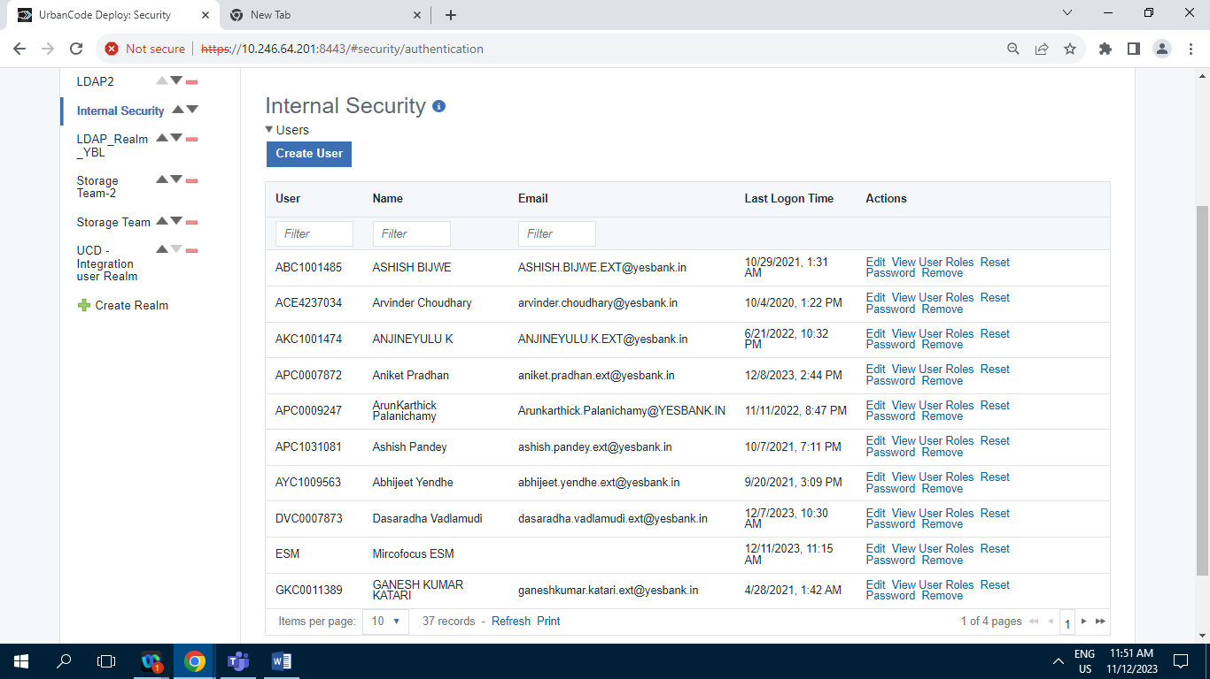

Screenshot of Internal Security tab having 37 Records.

**11.2.2.1.2] Edit Tab** :

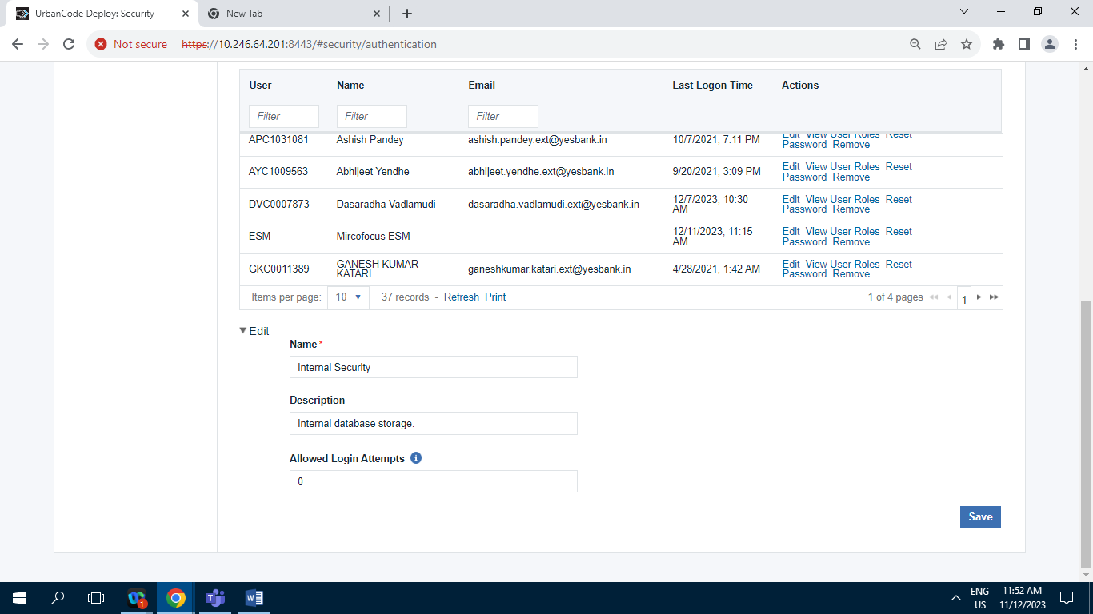

**11.2.2.2] LDAP_Realm_YBL :**

**11.2.2.2.1] Users Tab :**

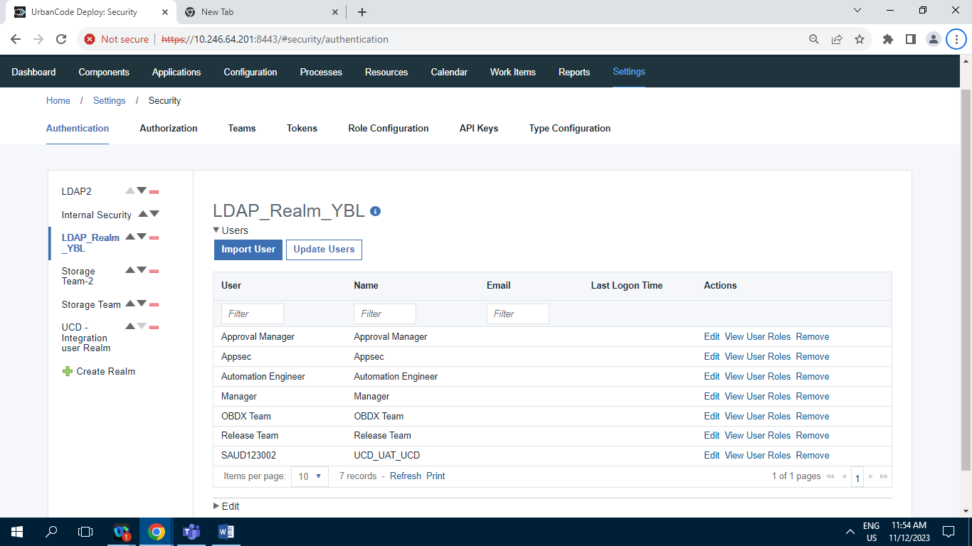

Screenshot of LDAP_Realm_YBL tab having 7 Records.

**11.2.2.2.2] Edit tab :**

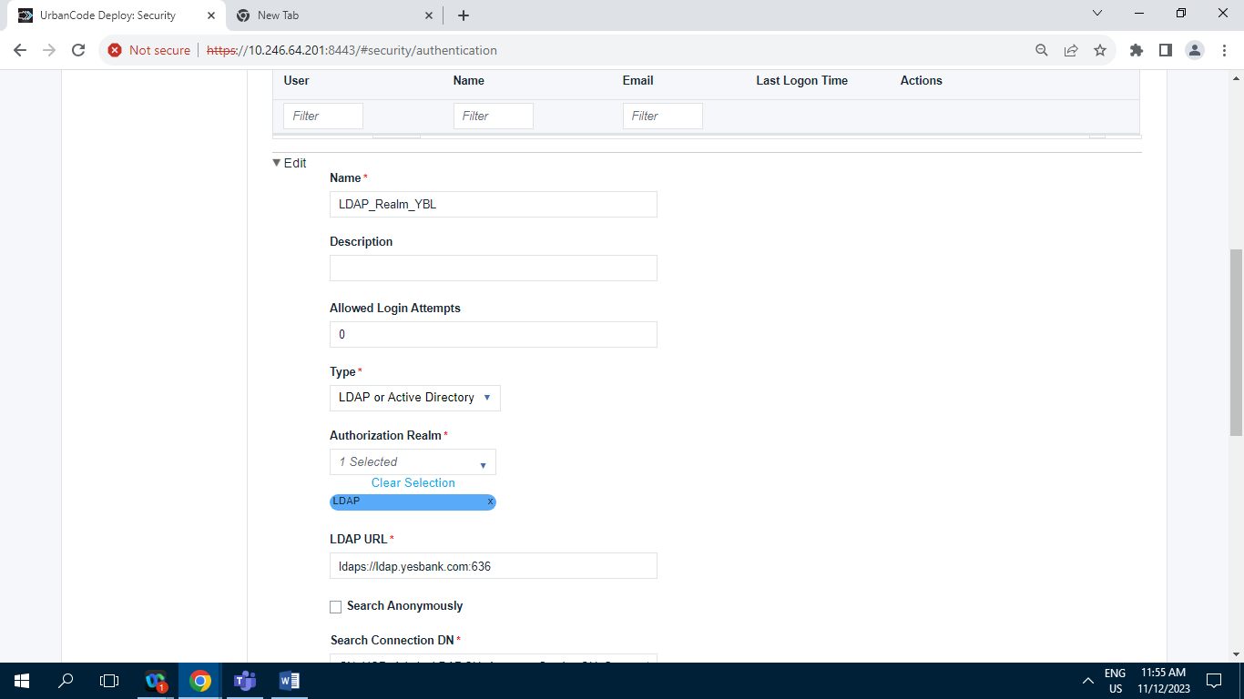

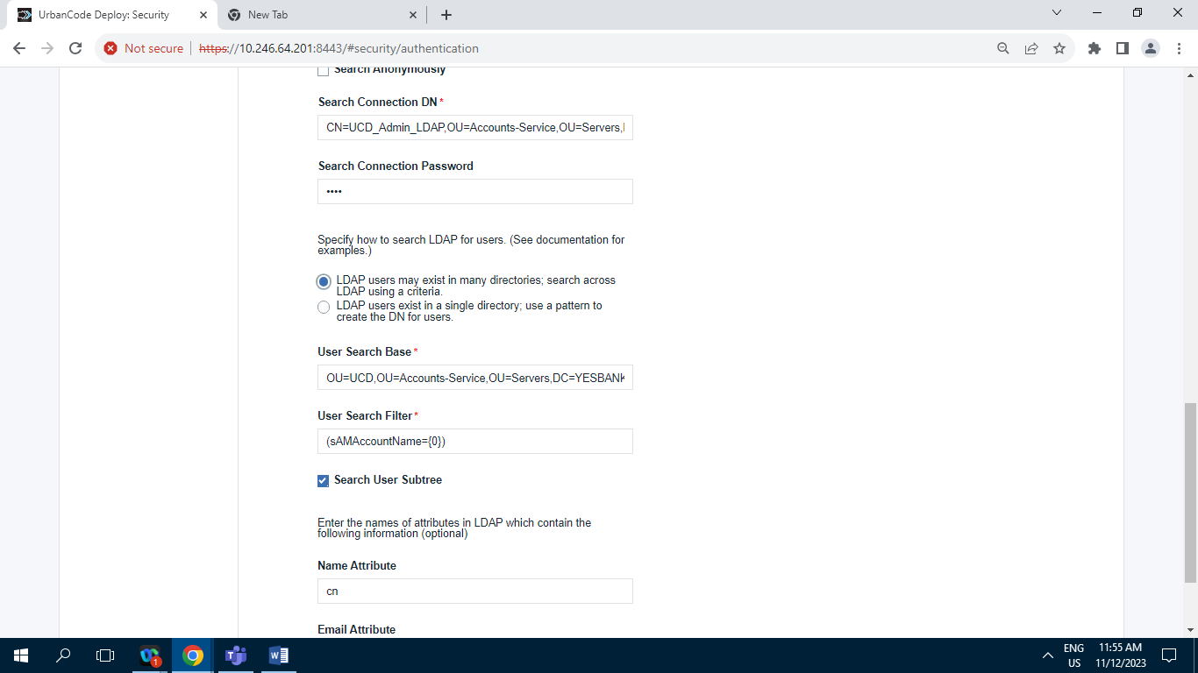

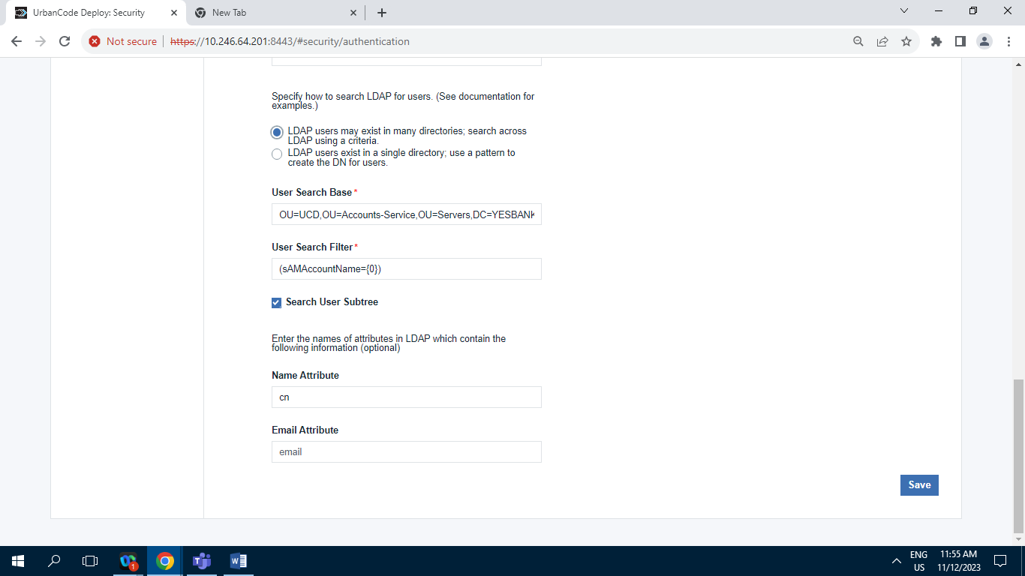

**11.2.2.3] LDAP2** :

**11.2.2.3.1] Users Tab :**

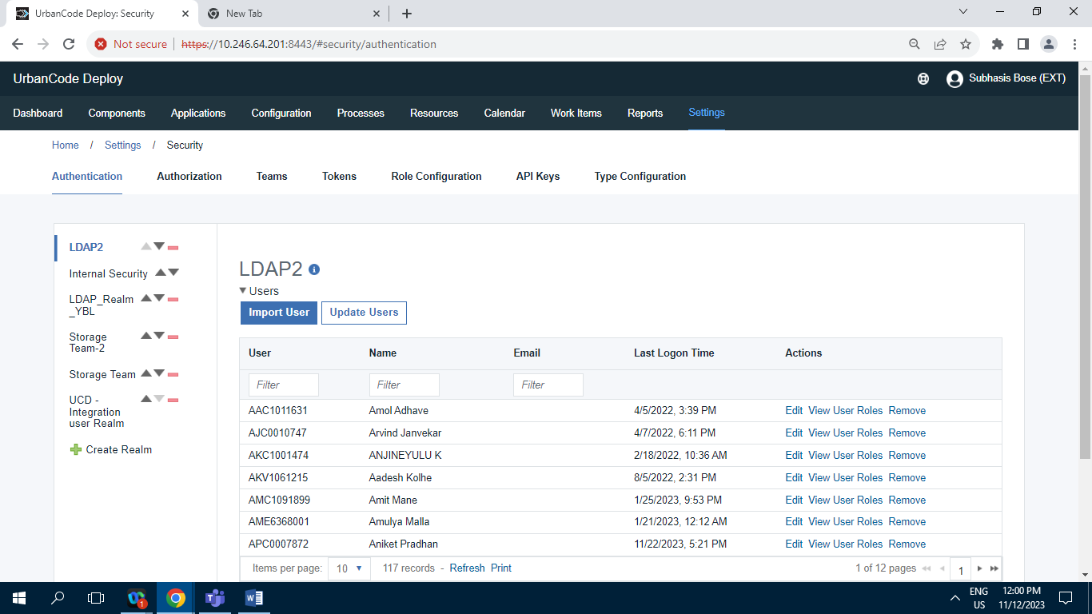

Screenshot of LDAP2 tab having 117 Records .

**11.2..2.3.2] Edit tab :**

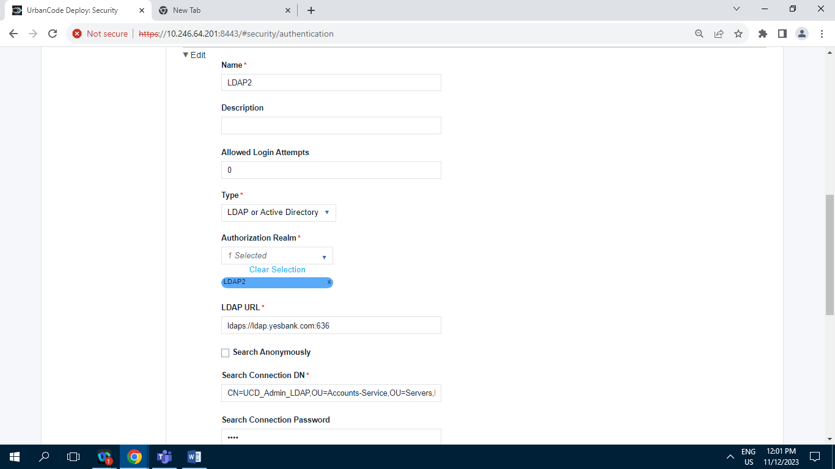

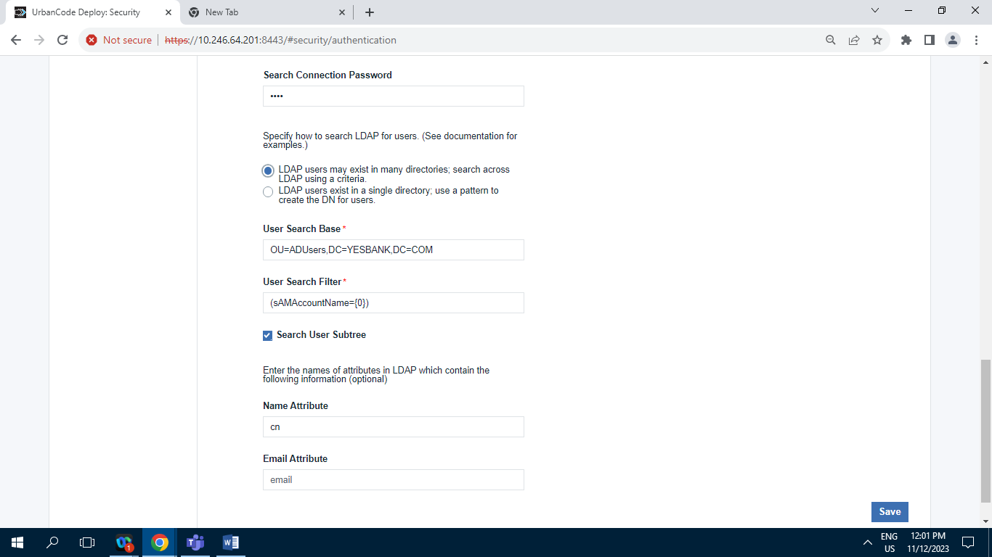

**11.2.2.4] Storage Team-2 :**

**11.2.2.4.1] Users Tab :**

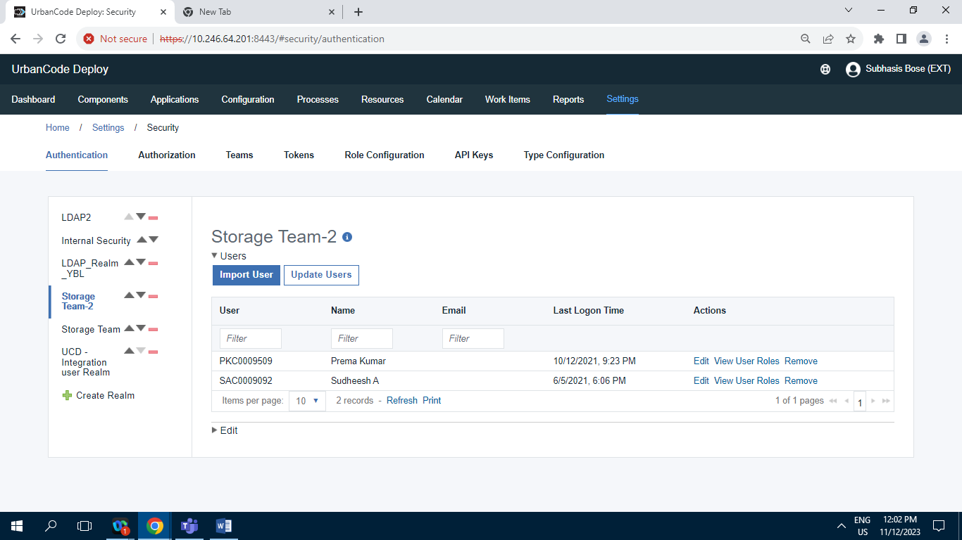

Screenshot of Storage Team-2 having 2 Records.

**11.2.2.4.2] Edit tab :**

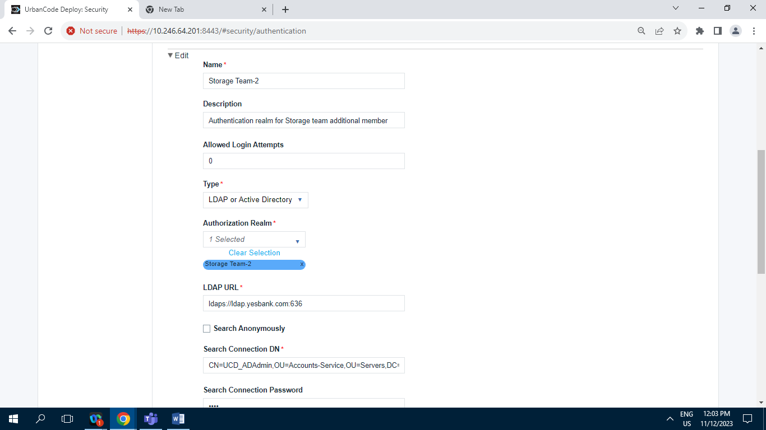

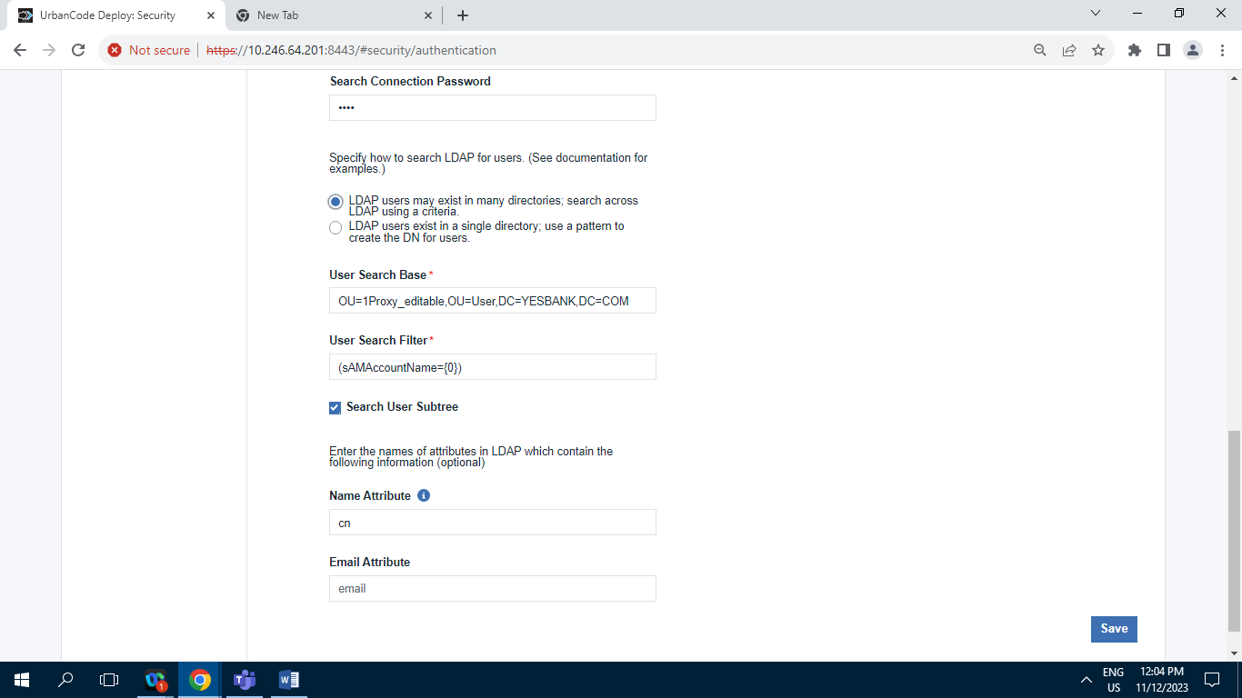

**11.2.2.5] Storage Team :**

**11.2.2.5.1] Users Tab**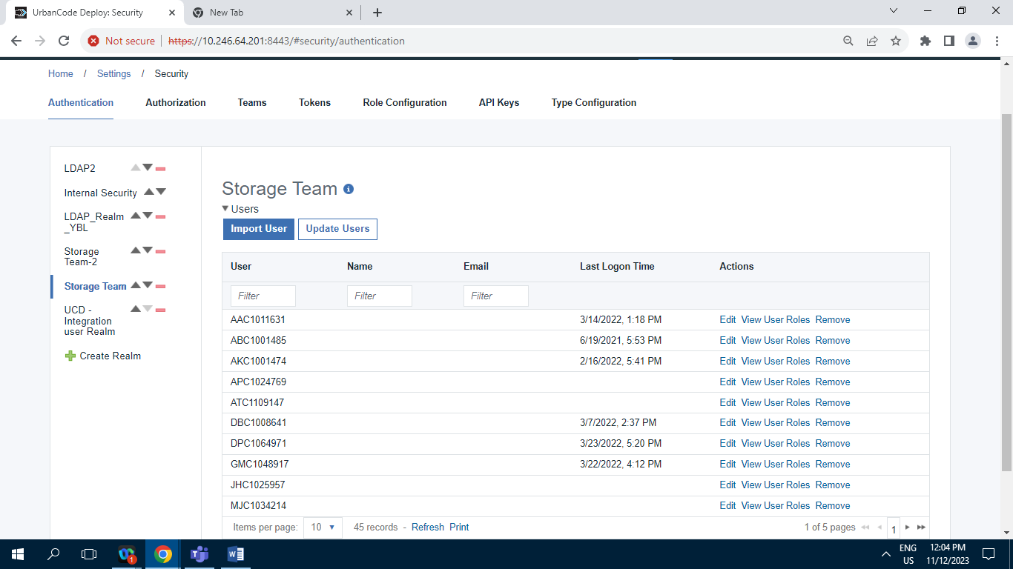

Screenshot of Storage Team having 45 Records.

**11.2.2.5.2] Edit tab :**

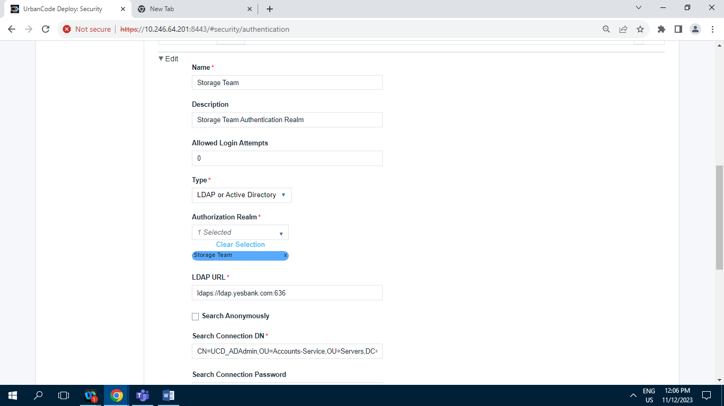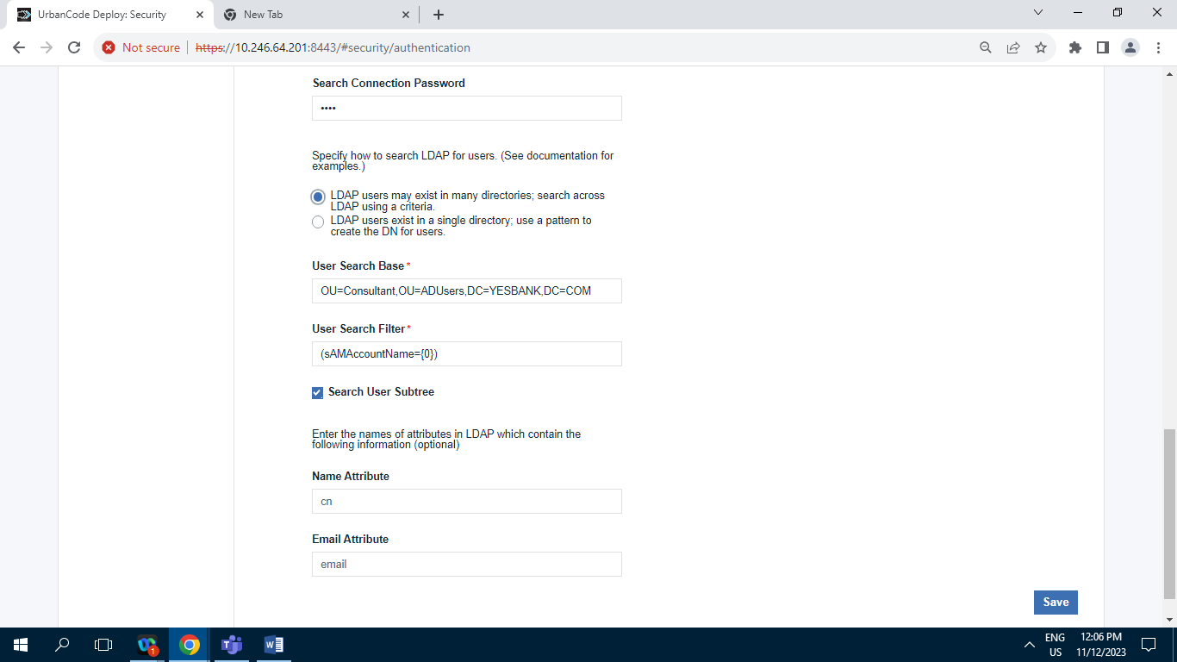

**11.2.2.6] UCD – Integration user Realm :**

**11.2.2.6.1] Users Tab :**

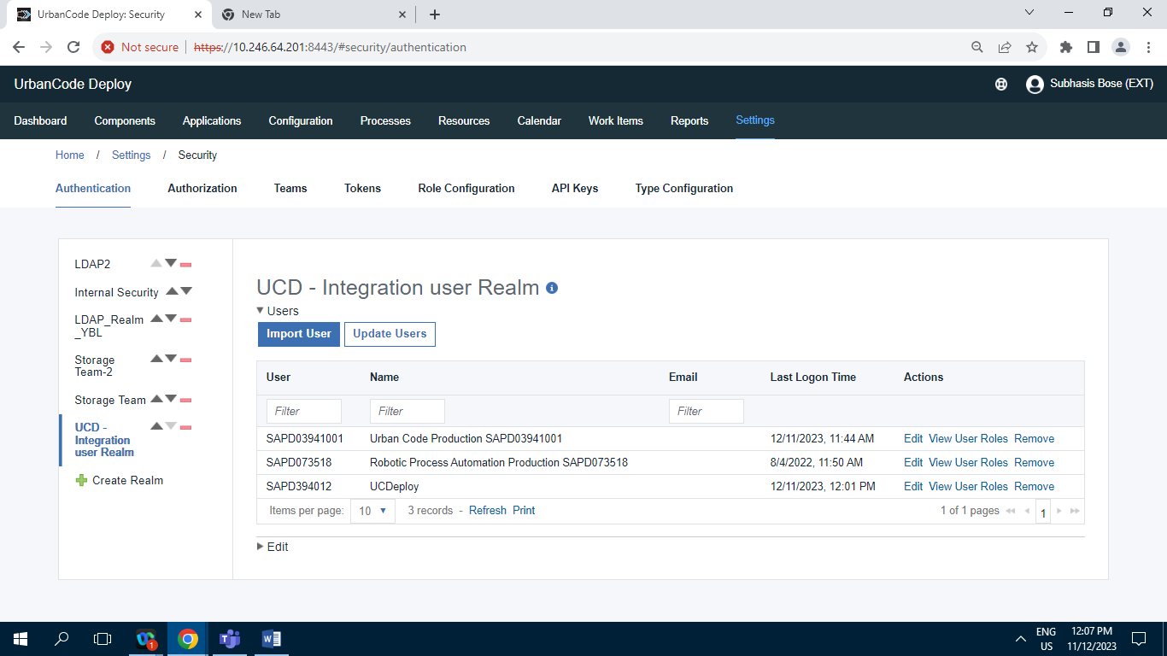

Screenshot of UCD – Integration user Realm tab having 3 Records.

**11.2.2.6.2] Edit tab :**

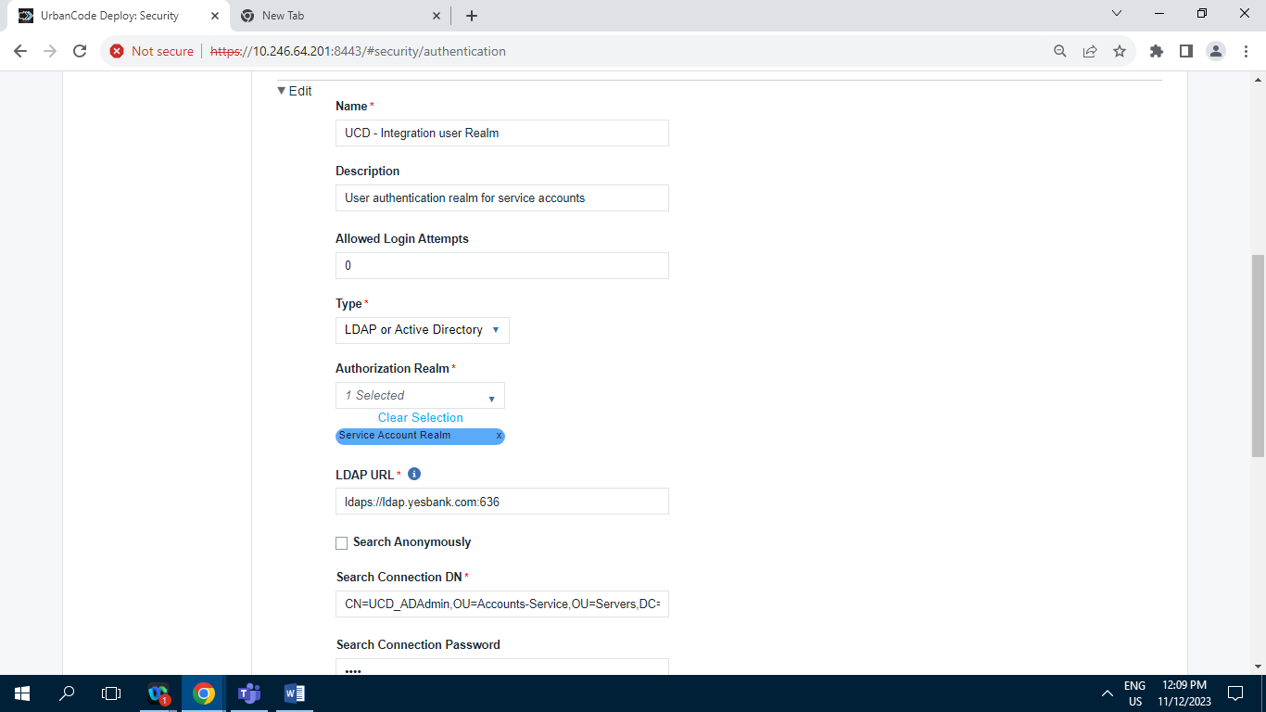

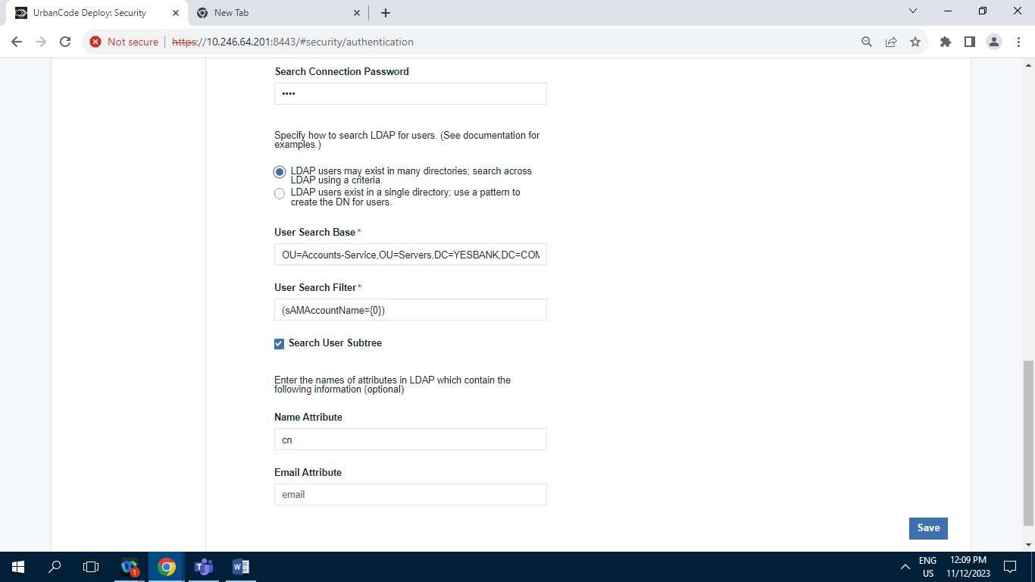

**11.2.3] Authorization (Groups) :**

**11.2.3.1] Authorization Realms**

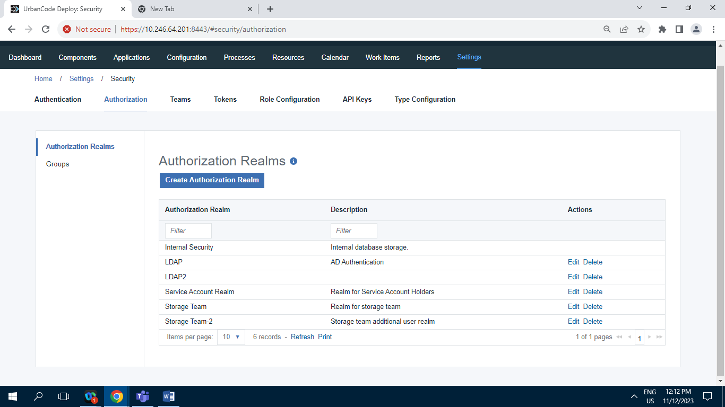

Screenshot of Authorization Realm tab having 6 Records.

**11.2.3.2] Groups :**

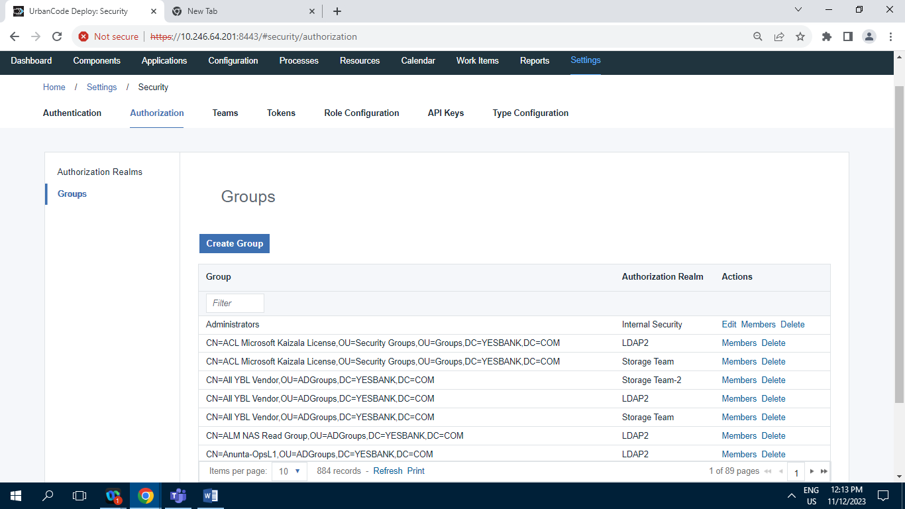

Screenshot of Groups tab having 884 Records.

**11.2.4] Teams :**

**11.2.4.A] ESB_TEAM :**

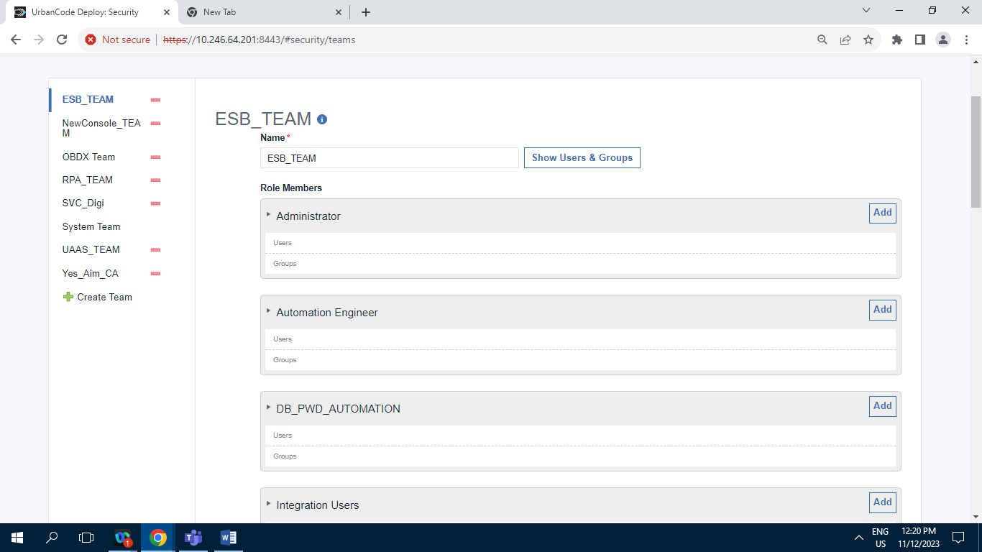

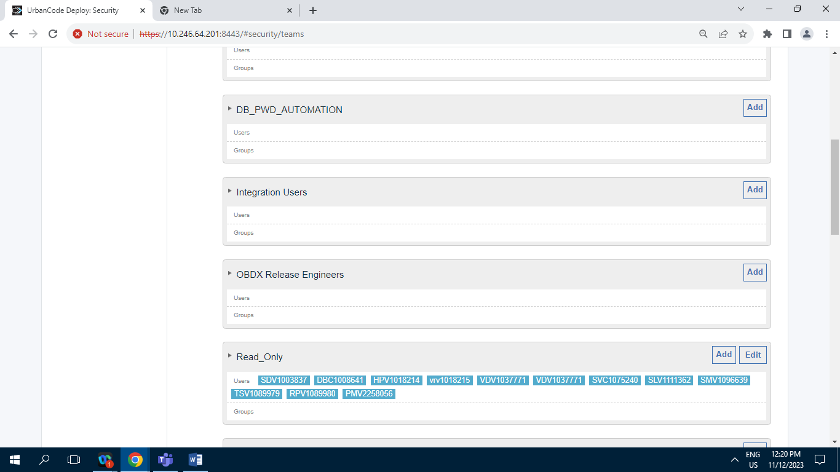

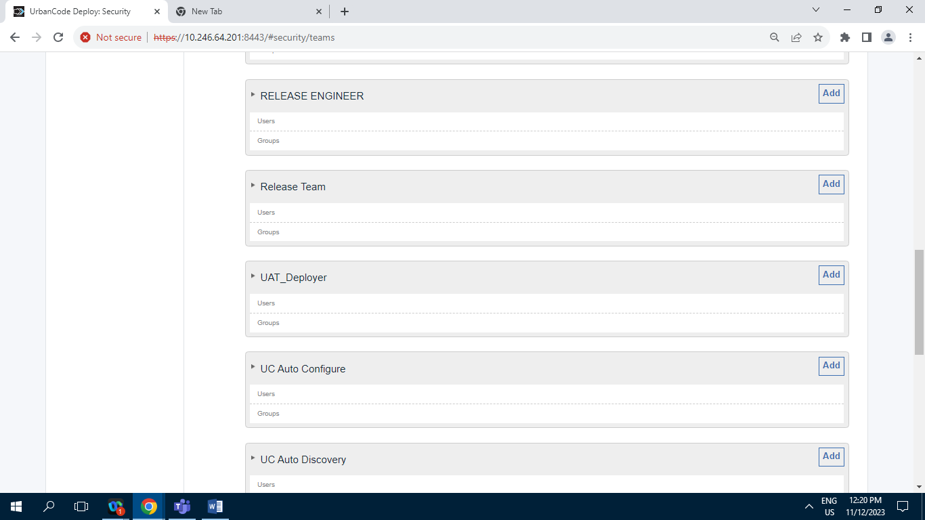

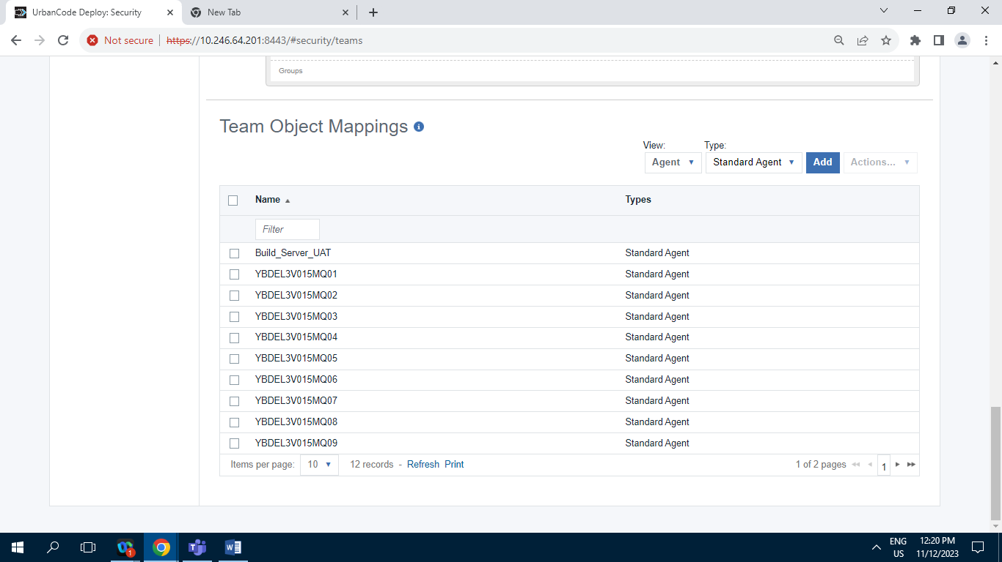

**11.2.4.B] NewConsole_TEAM :**

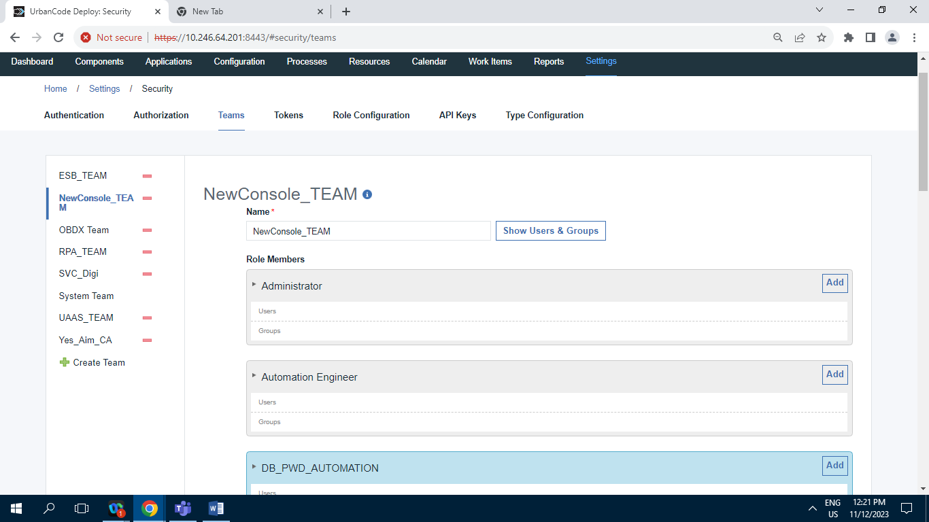

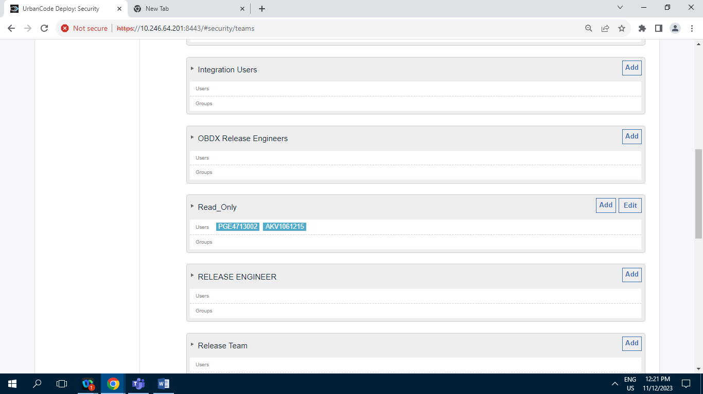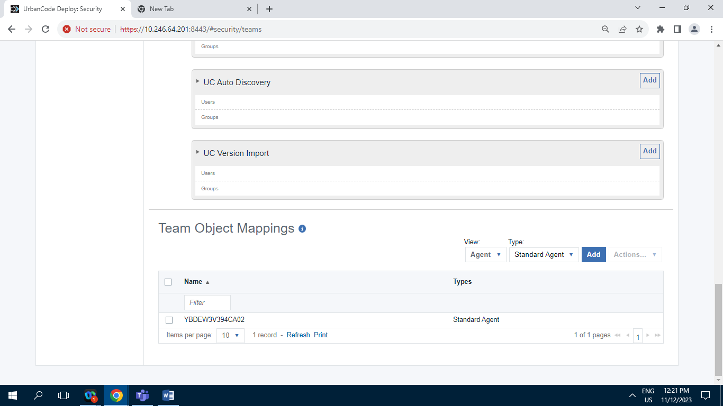

**11.2.4.C] OBDX_Team :**

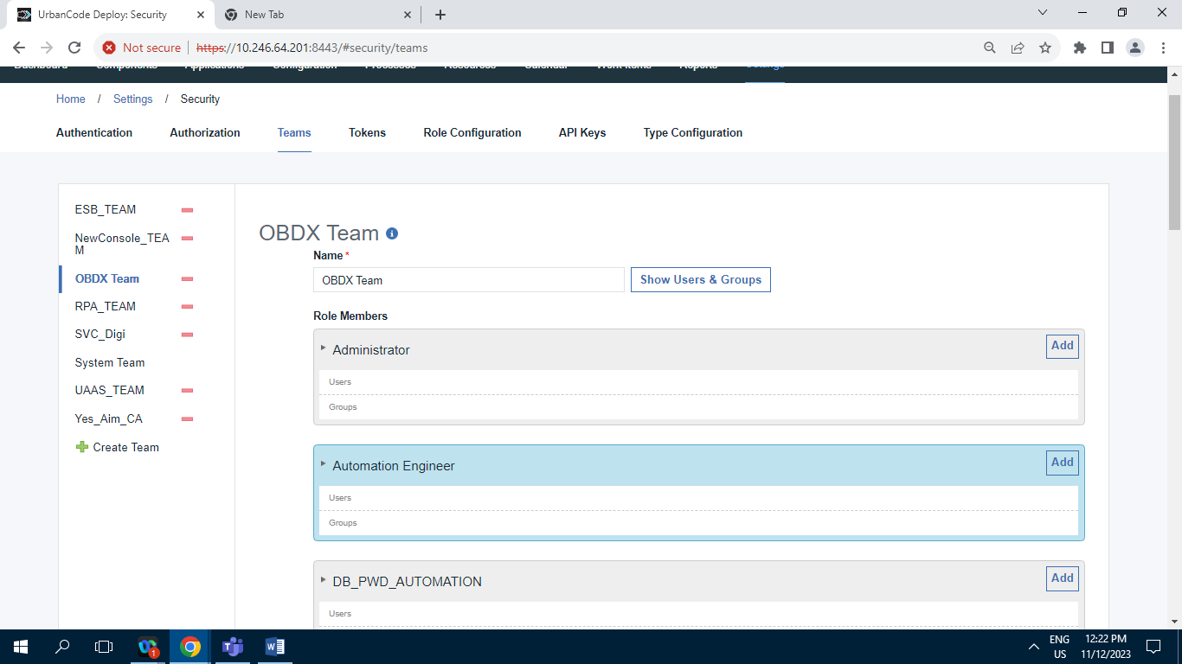

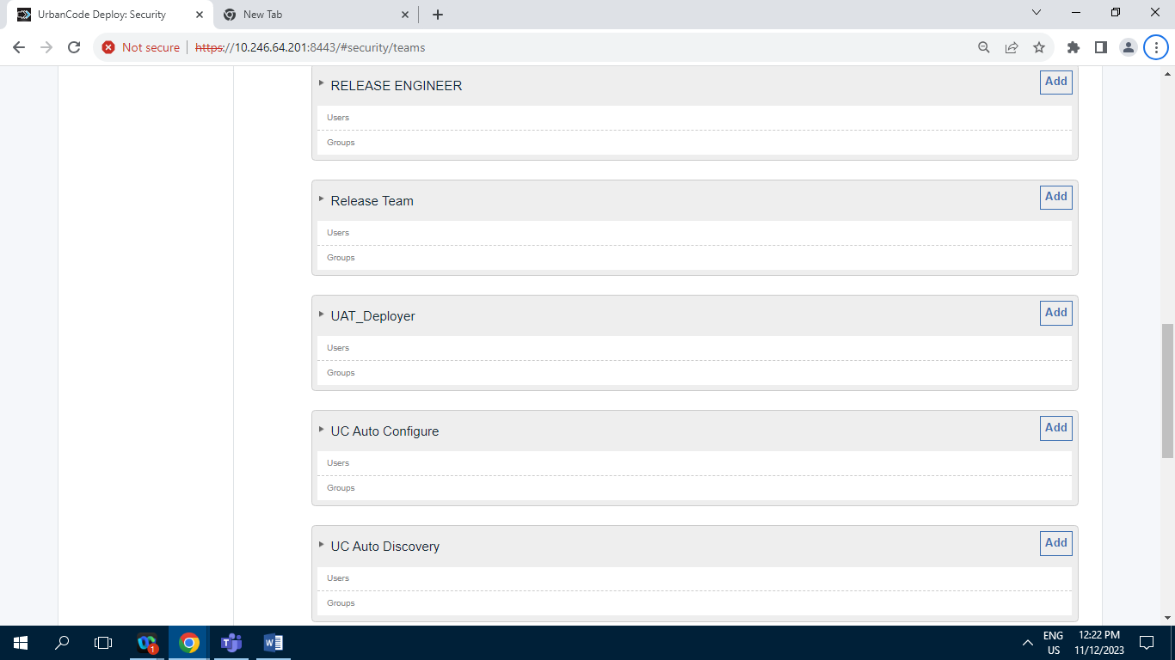

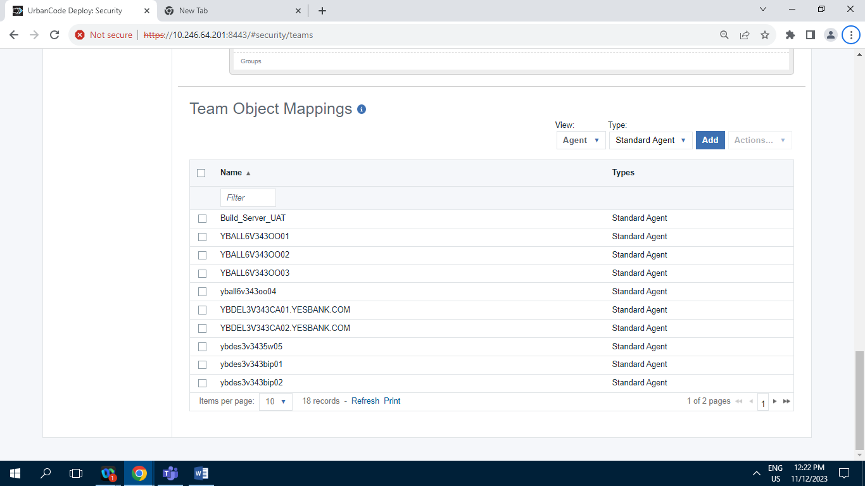

**11.2.4.D] RPA_TEAM :**

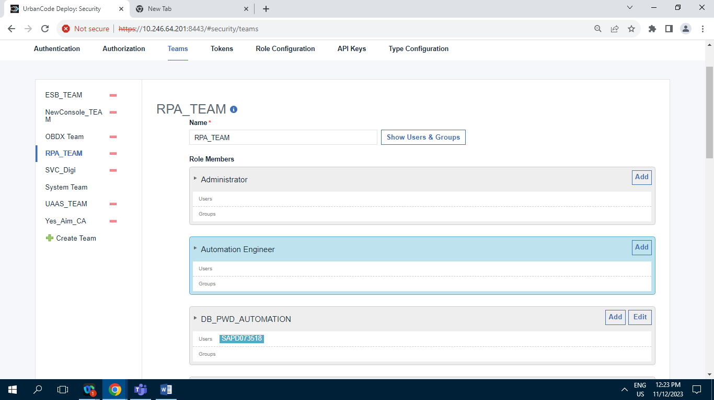

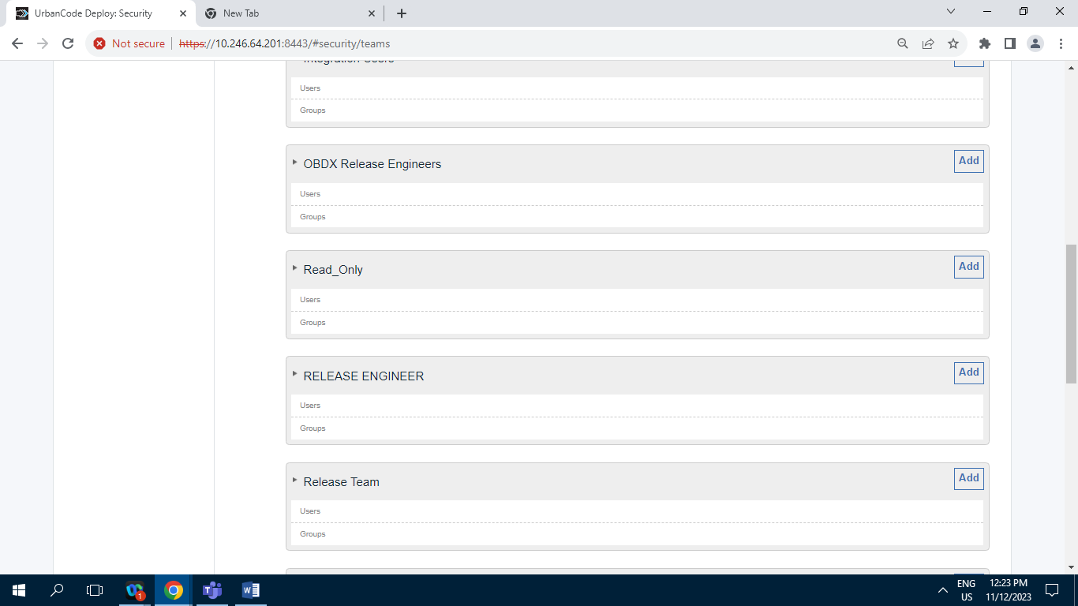

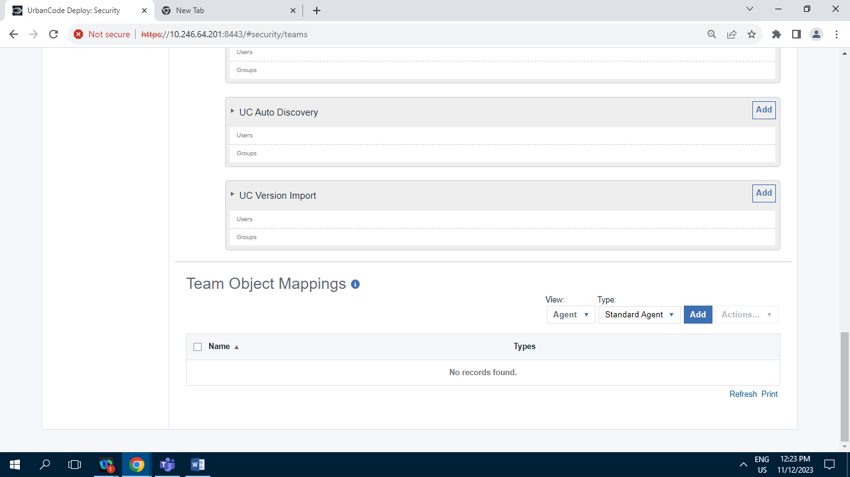

**11.2.4.E] SVC_Digi :**

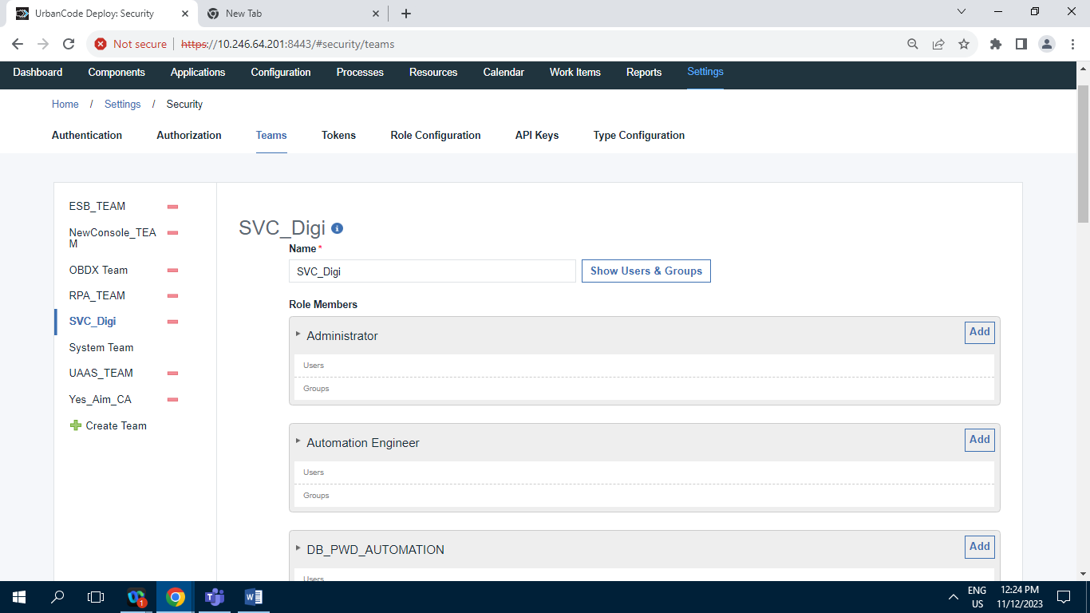

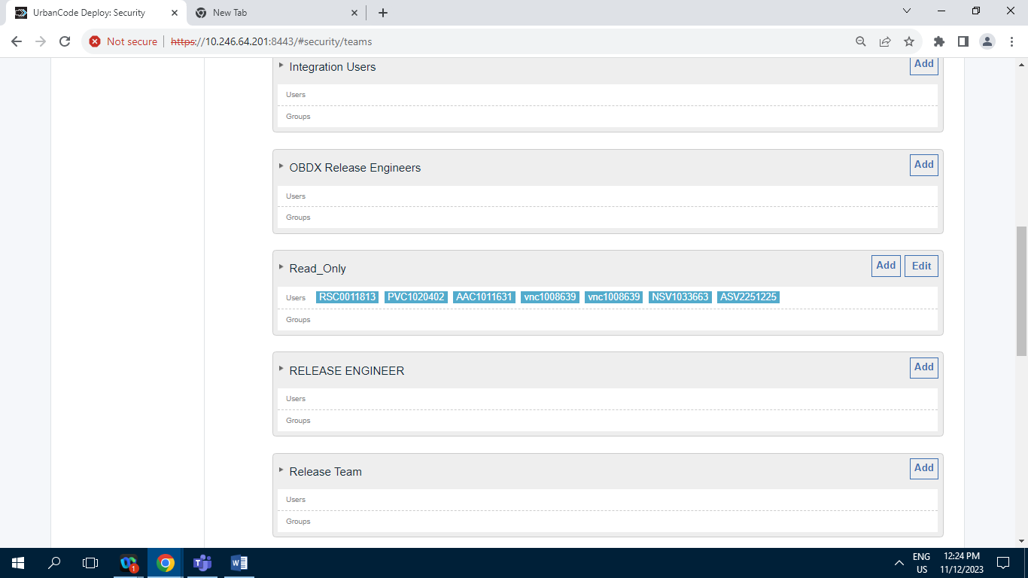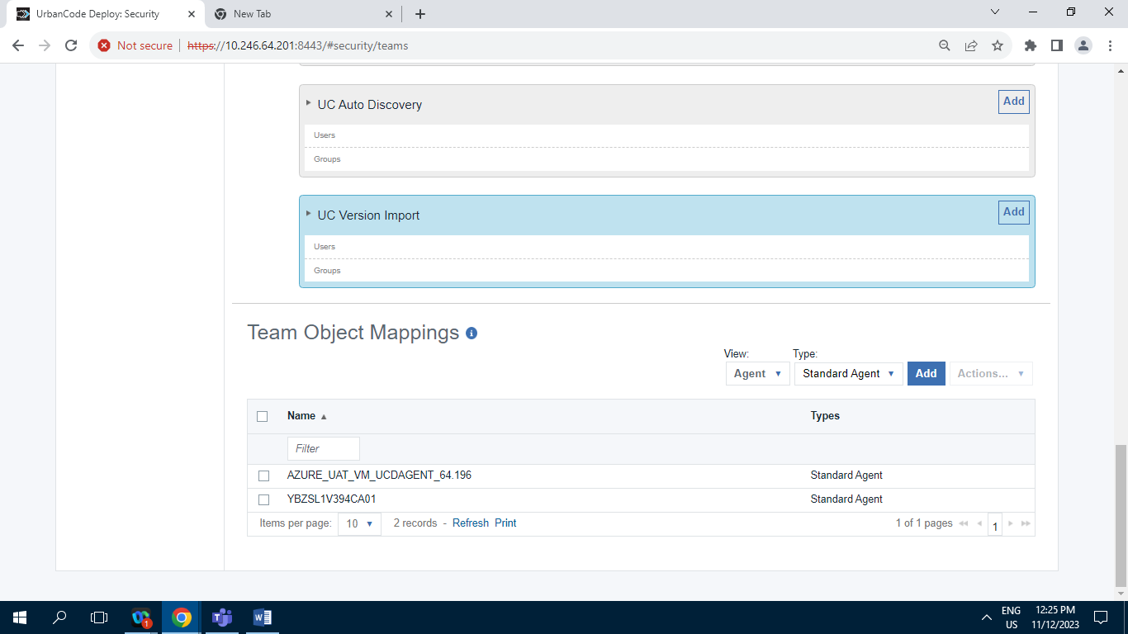

**11.2.4.F] System Team :**

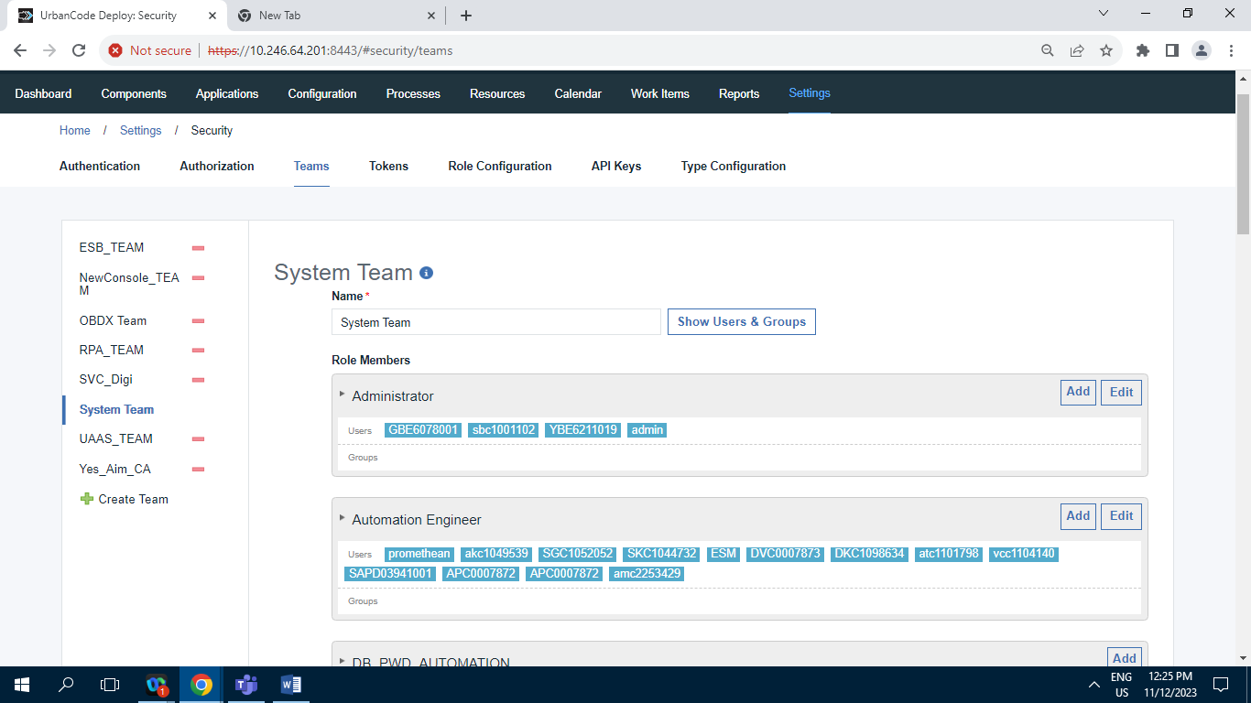

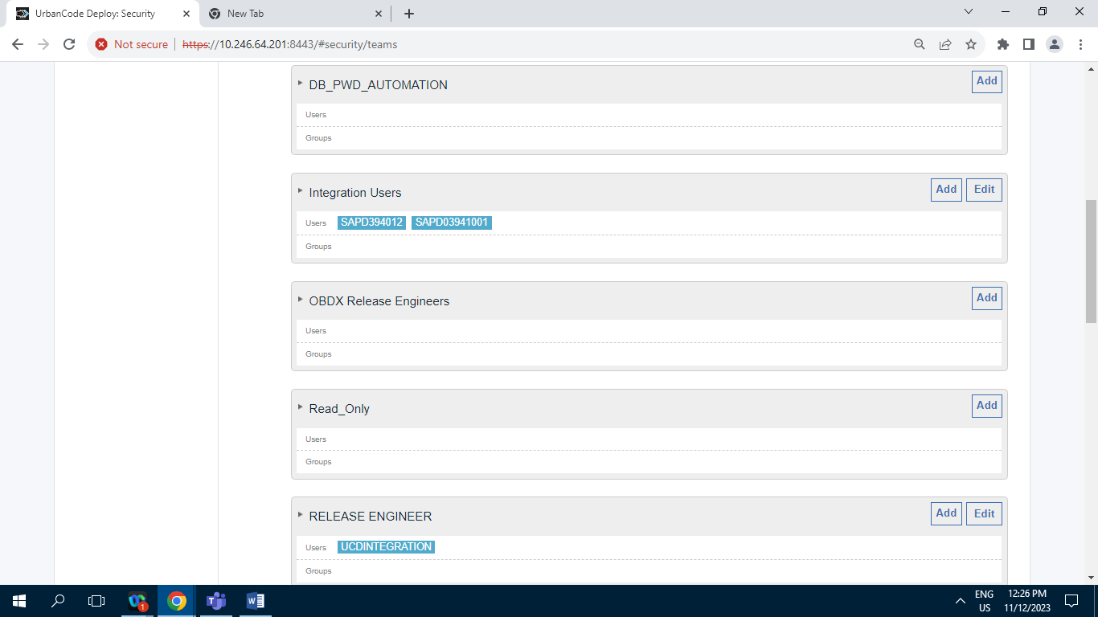

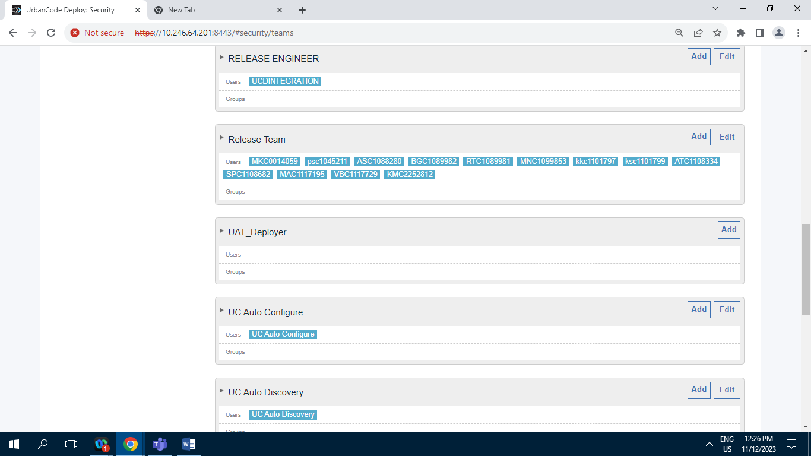

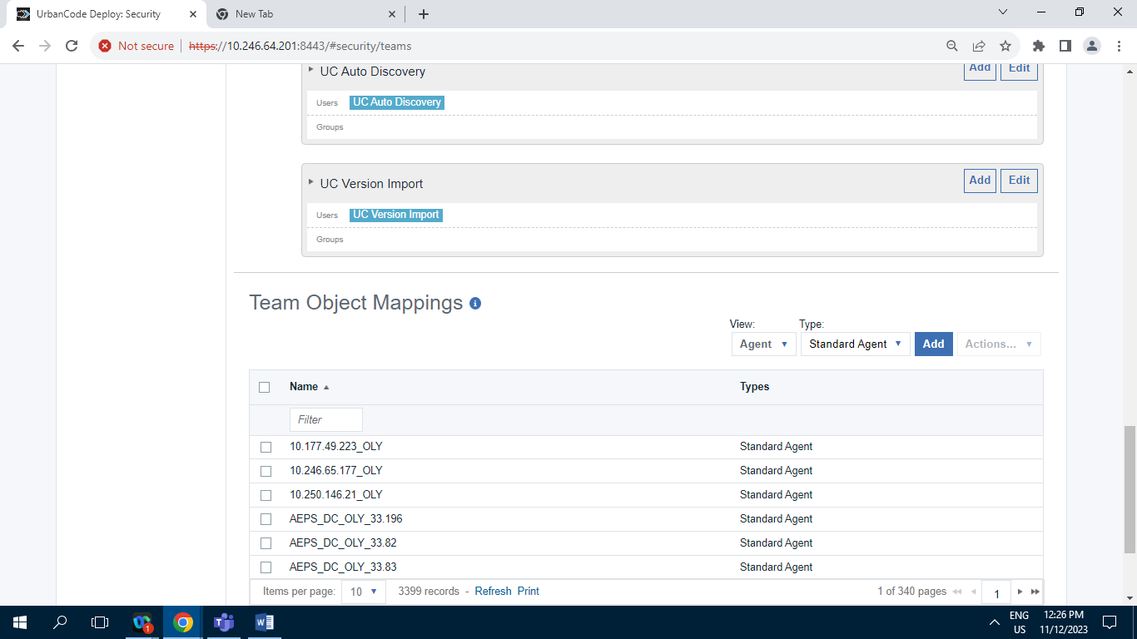

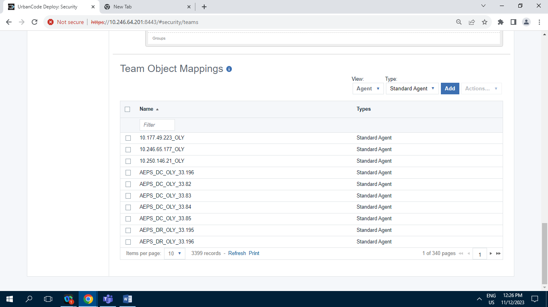

**11.2.4.G] UAAS_TEAM :**

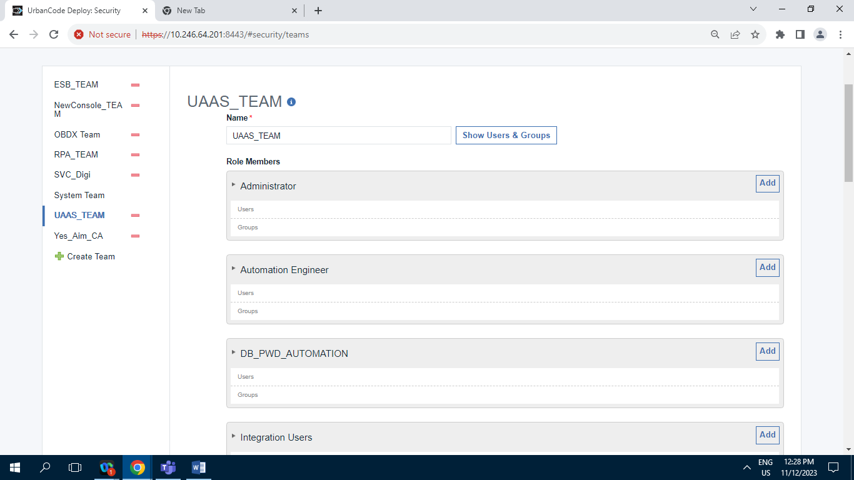

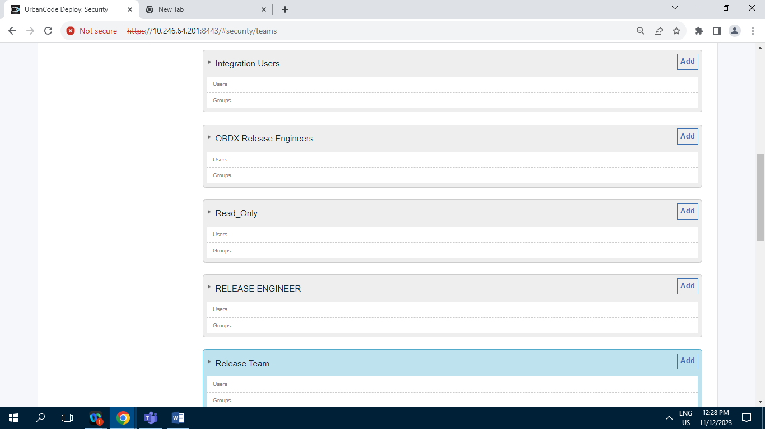

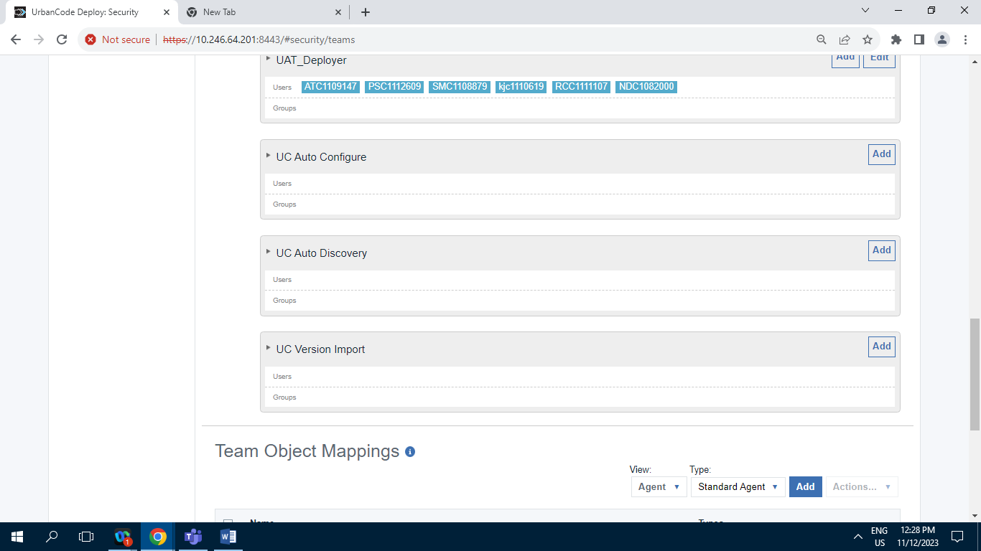

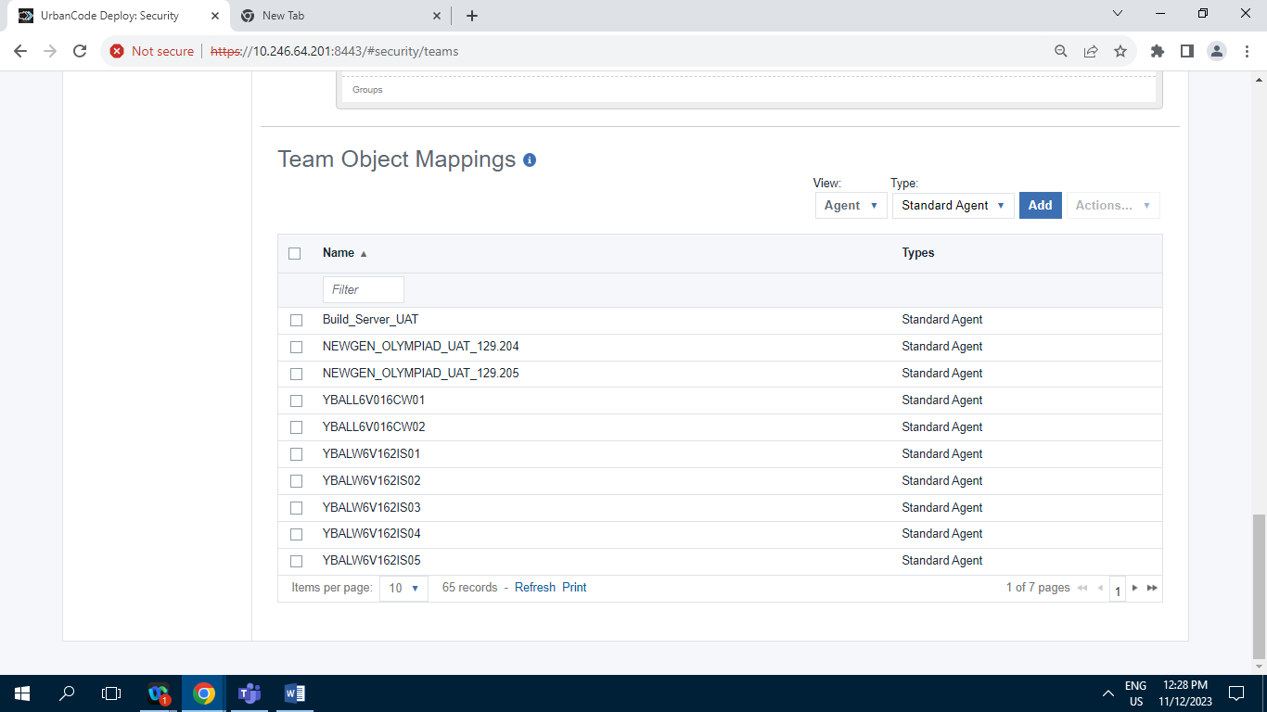

**11.2.4.H] Yes_Aim_CA :**

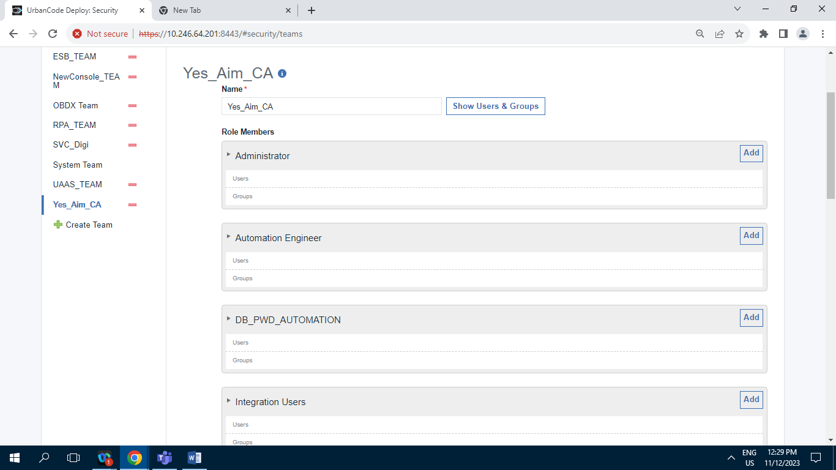

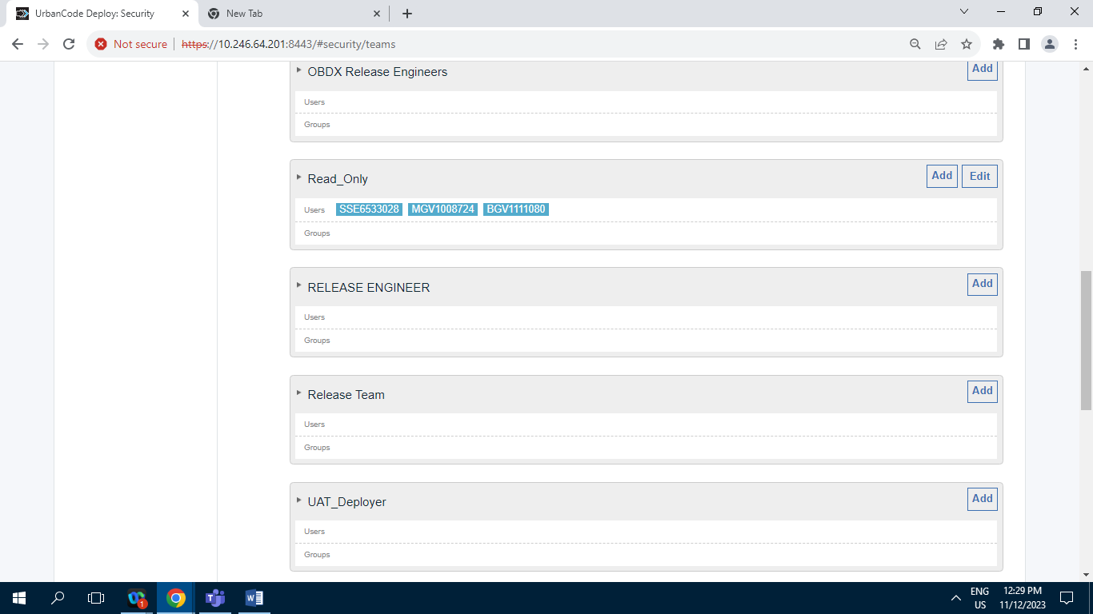

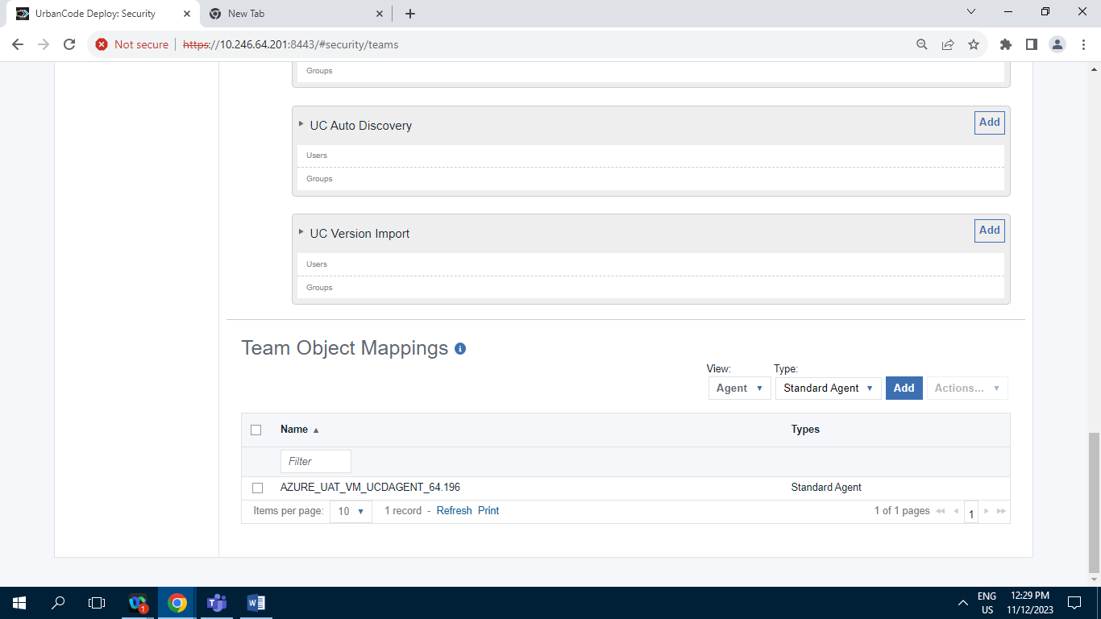

**11.2.5 ] Tokens :**

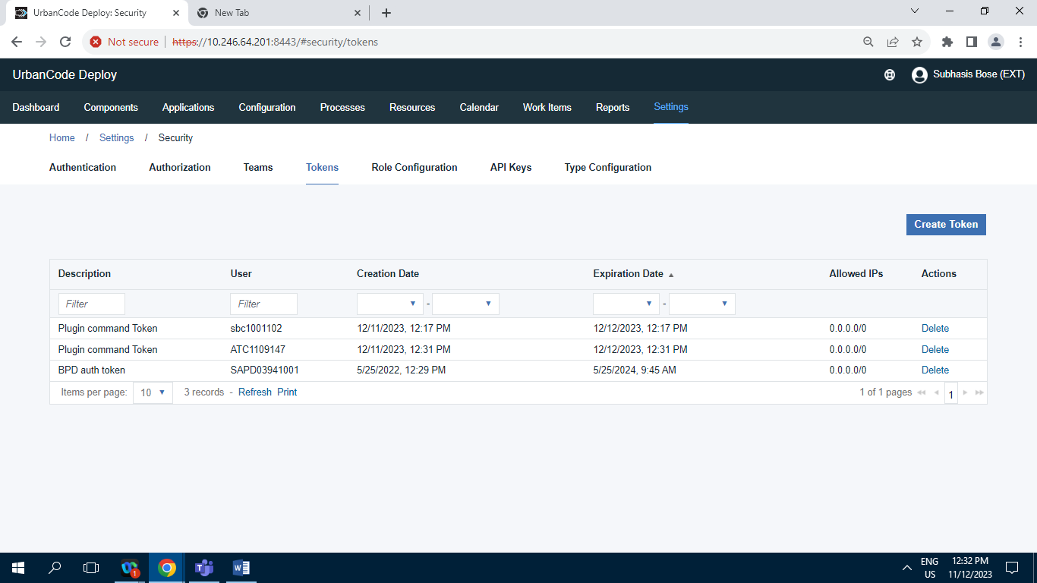

Screenshot of Tokens tab having 3 Records.

**11.2.6] Role Configuration :**

**11.2.6.A] Administrator :**

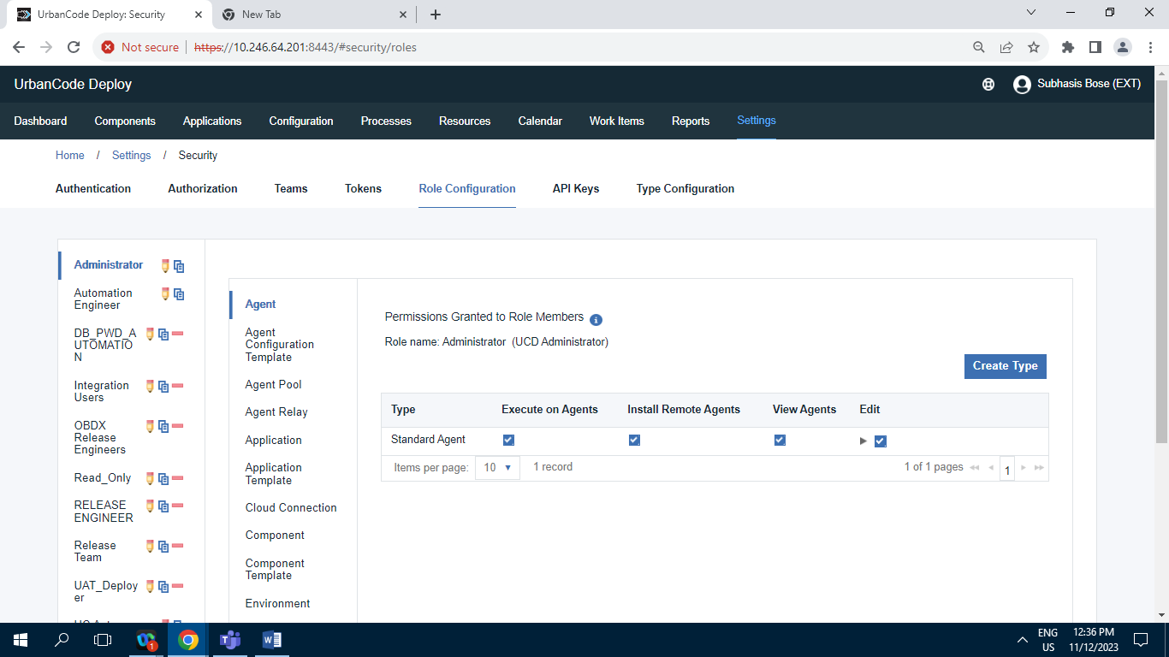

**11.2.6.B] Automation Engineer :**

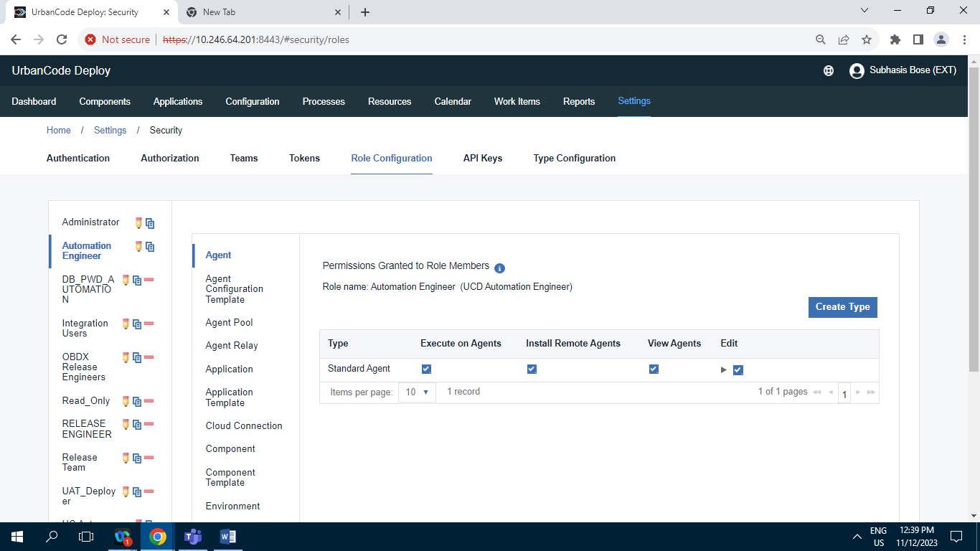

**11.2.6.C] DB_PWD_AUTOMATION :**

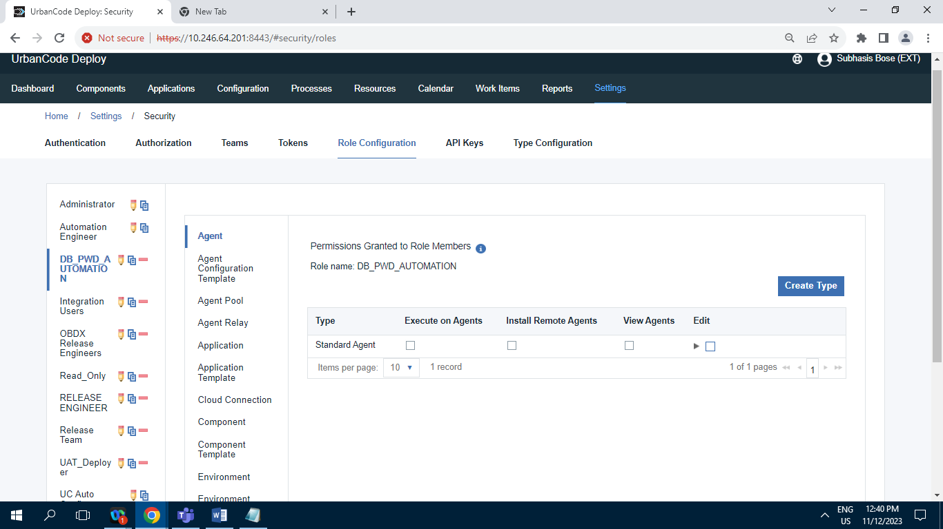

**11.2.6.D] Integration Users :**

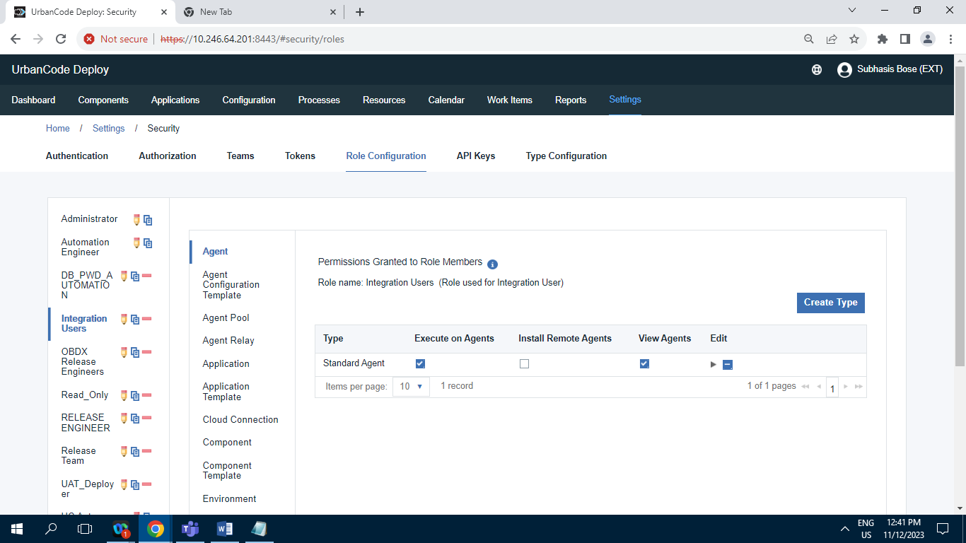

**11.2.6.E] ODBX Release Engineer :**

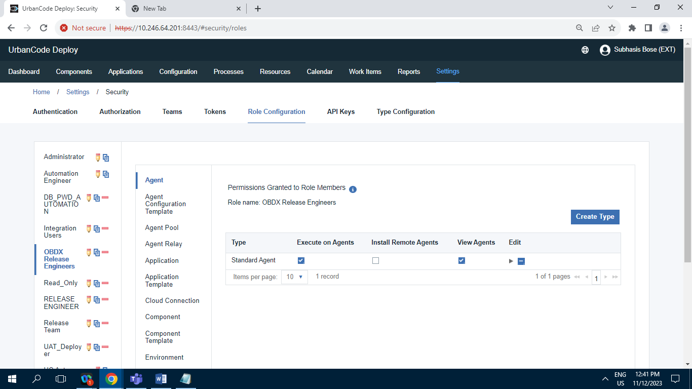

**11.2.6.F] Read_Only :**

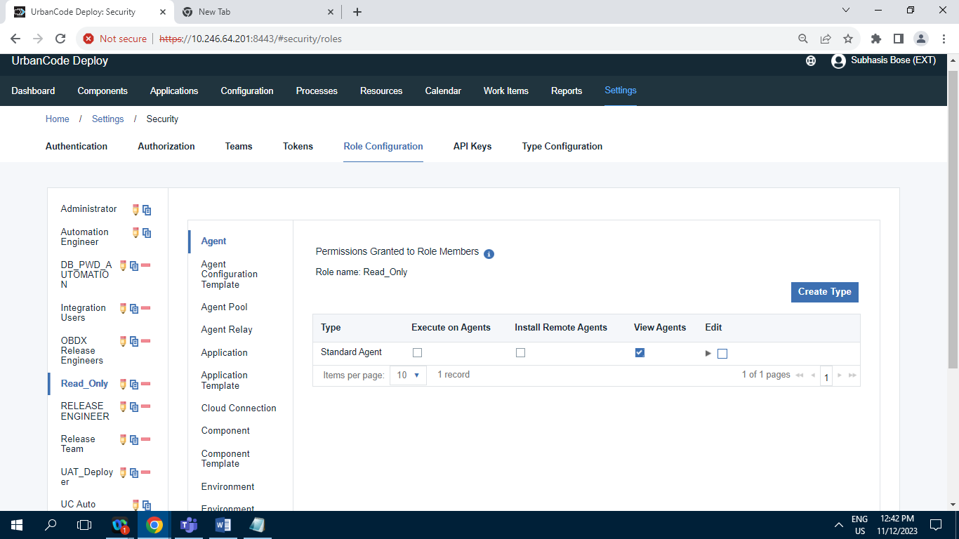

**11.2.6.G] RELEASE ENGINEER :**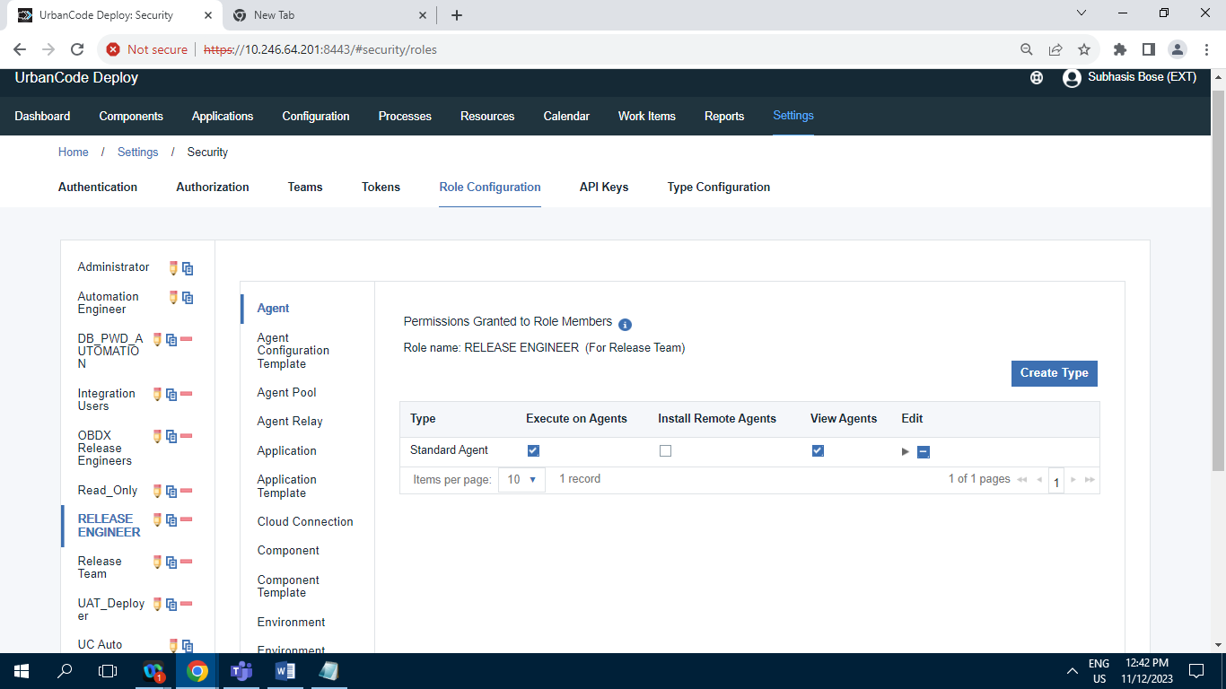

**11.2.6.H] Release Team :**

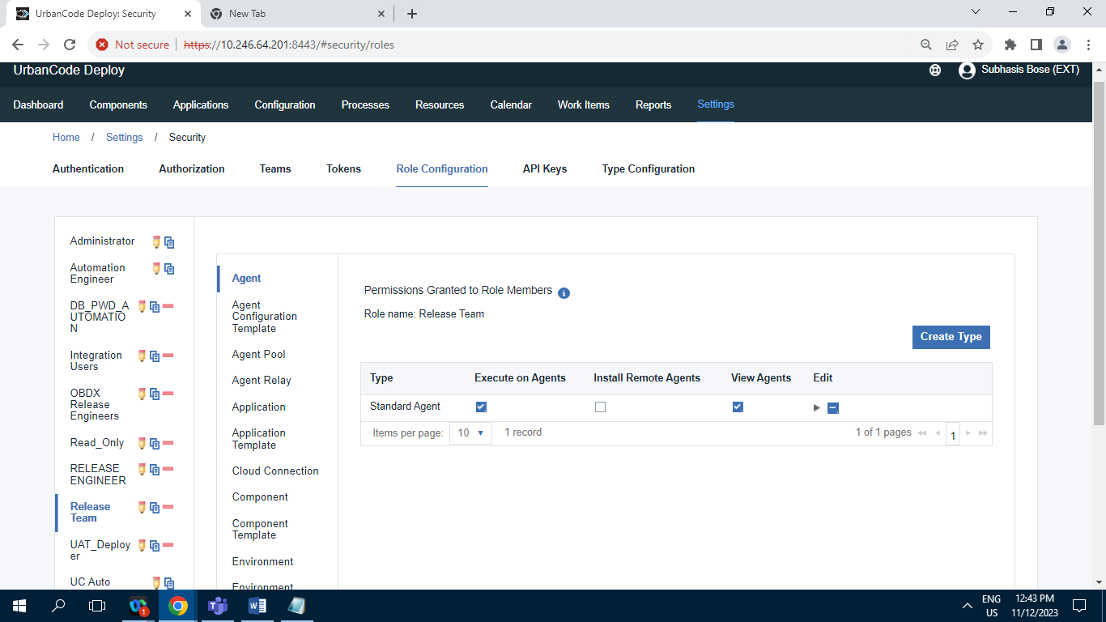

**11.2.6.I] UAT_Deployer :**

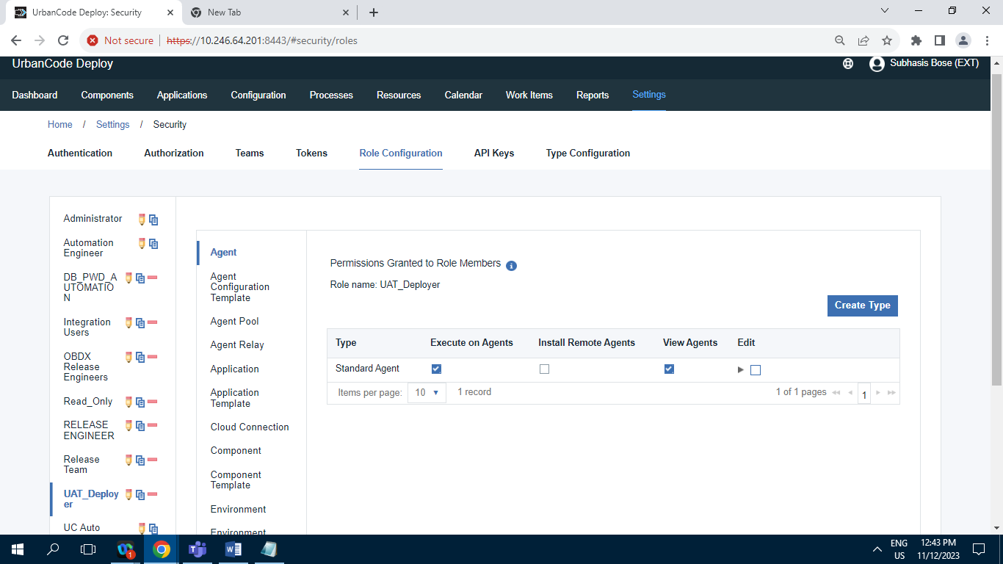

**11.2.6.J] UC Auto Configure :**

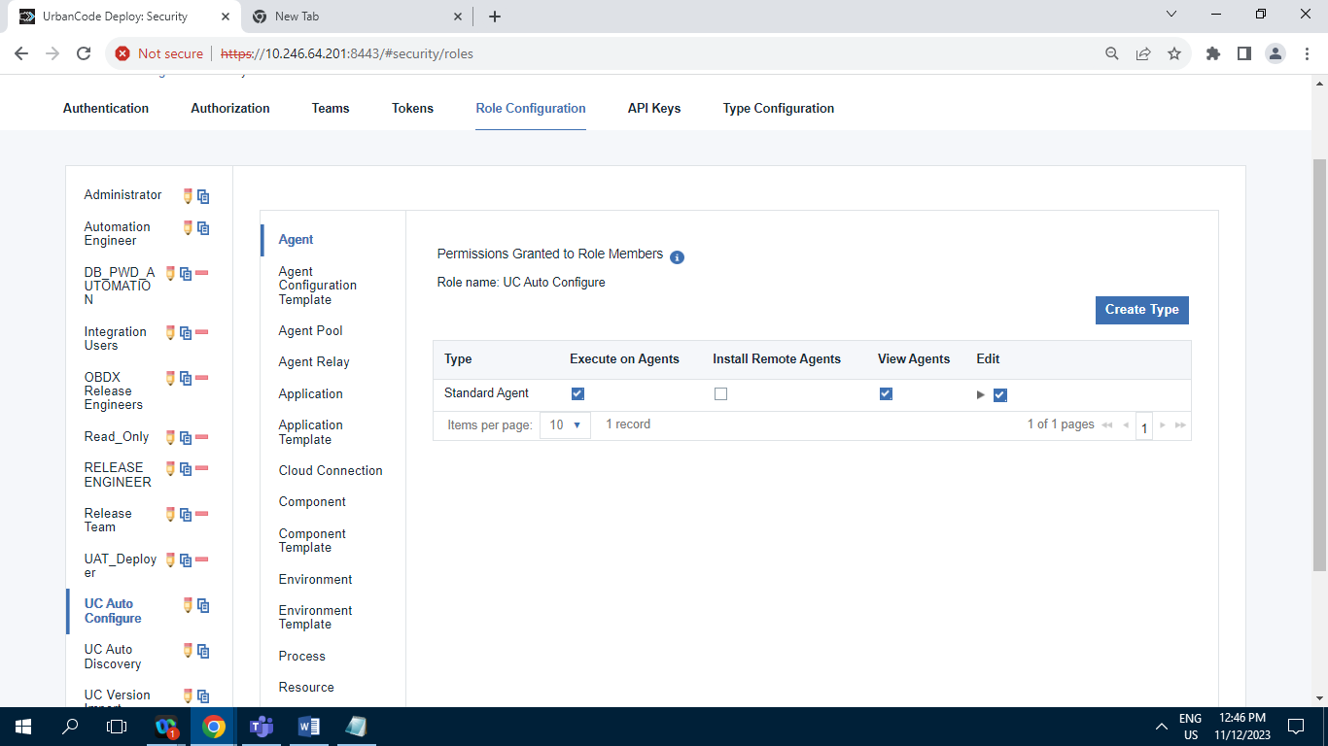

**11.2.6.K] UC Auto Discovery :**

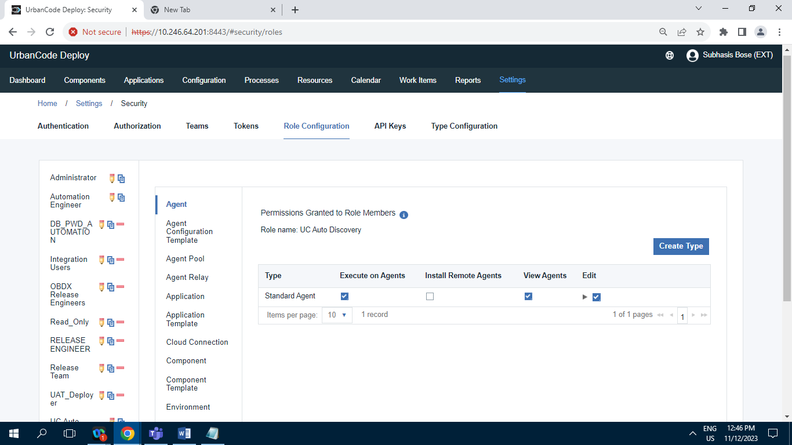

**11.2.6.L] UC Version Import :**

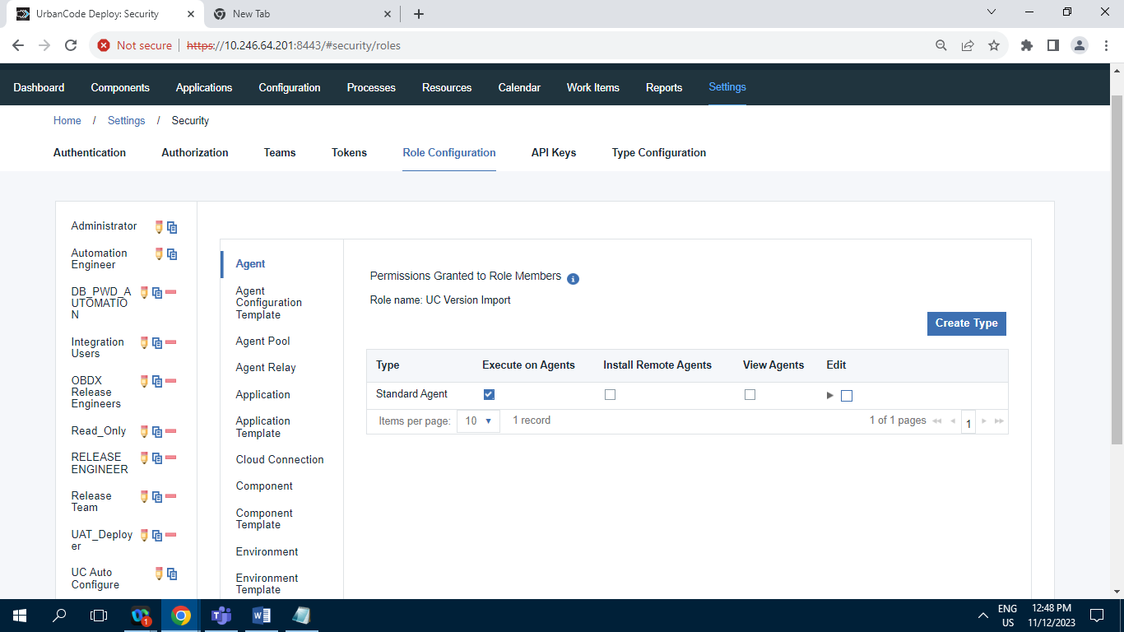

**11.2.7] Type Configuration :**

**11.2.7.1] Agent Types :**

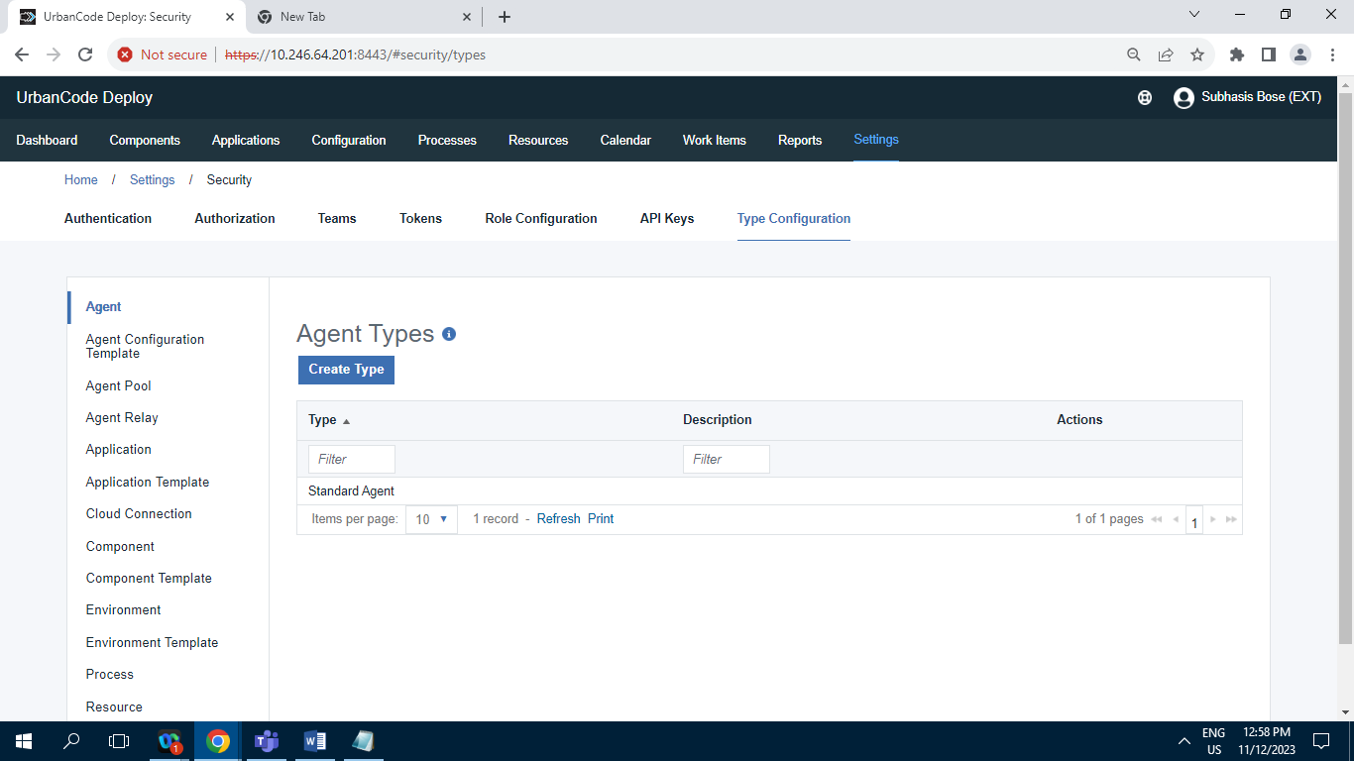

**Record = 1**

**11.2.7.2] Agent Configuration Template types :**

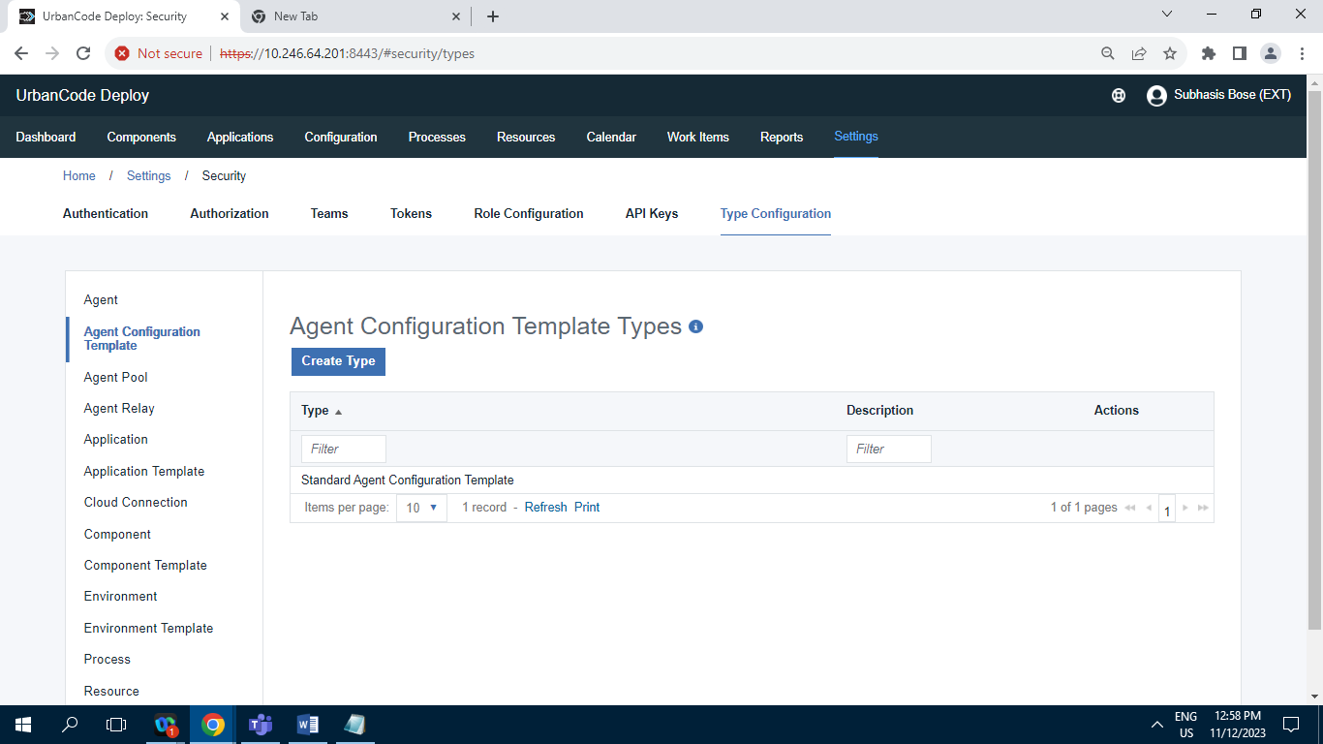

**Record = 1**

**11.2.7.3] Agent Pool Types :**

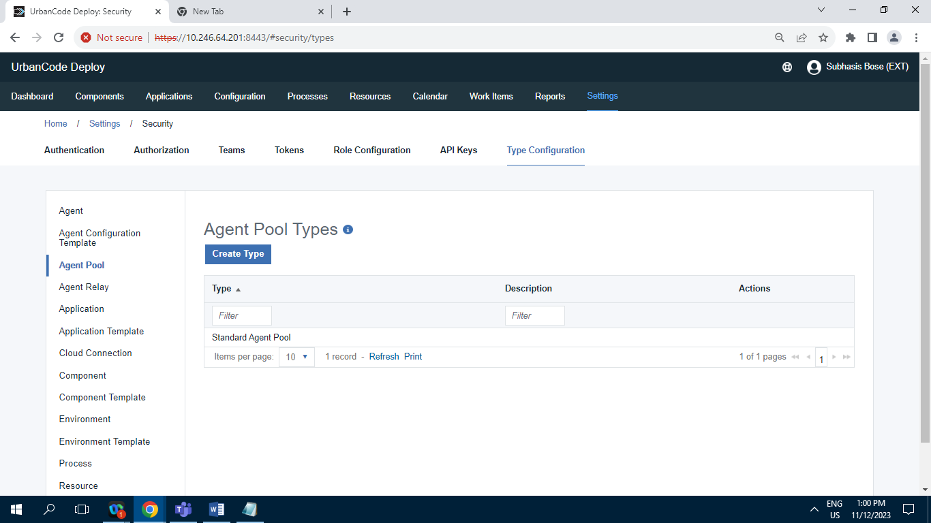

**Record = 1**

**11.2.7.4] Agent Relay Type :**

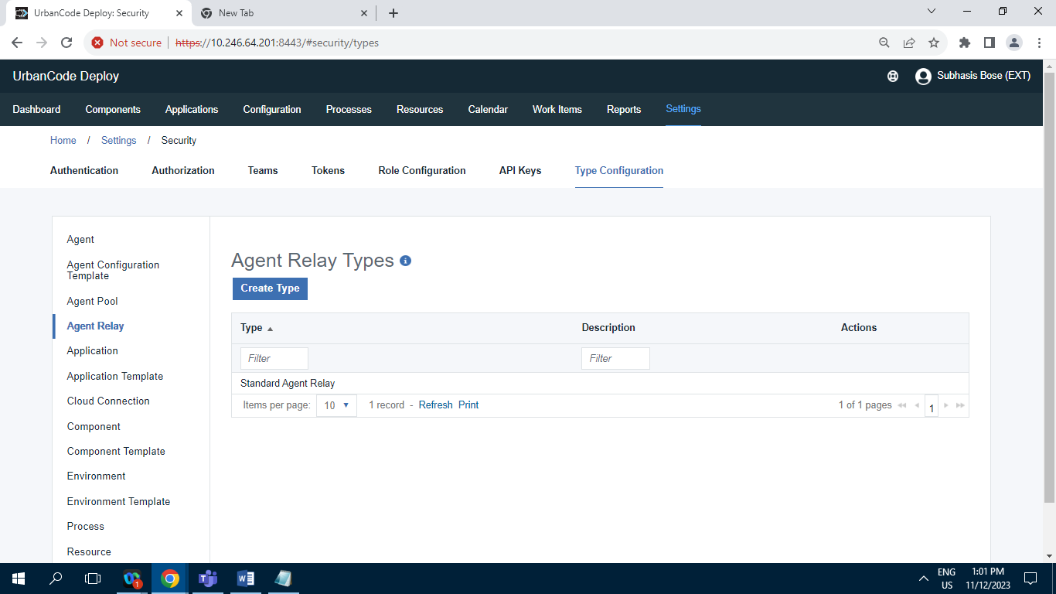

**Record = 1**

**11.2.7.5] Application :**

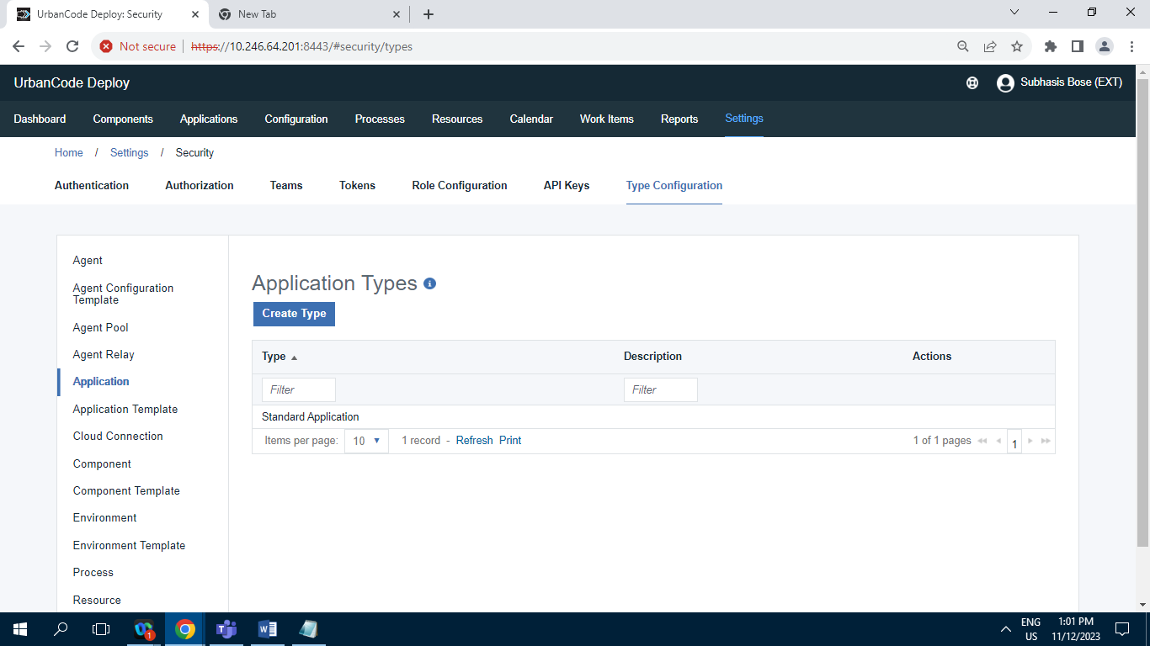

**Record =1**

**11.2.7.6] Application Template Type :**

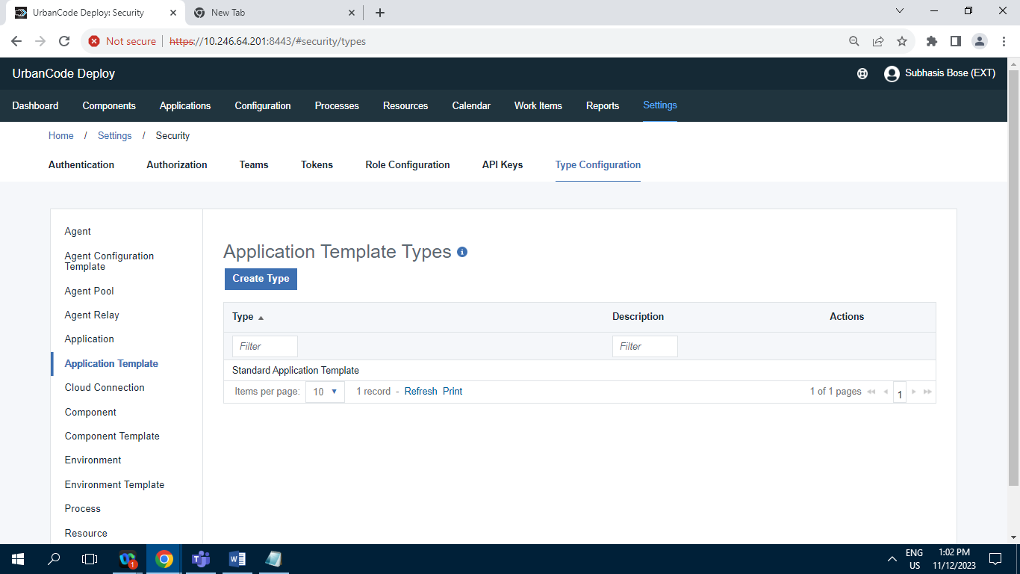**Record = 1**

**11.2.7.7] Cloud Connection types :**

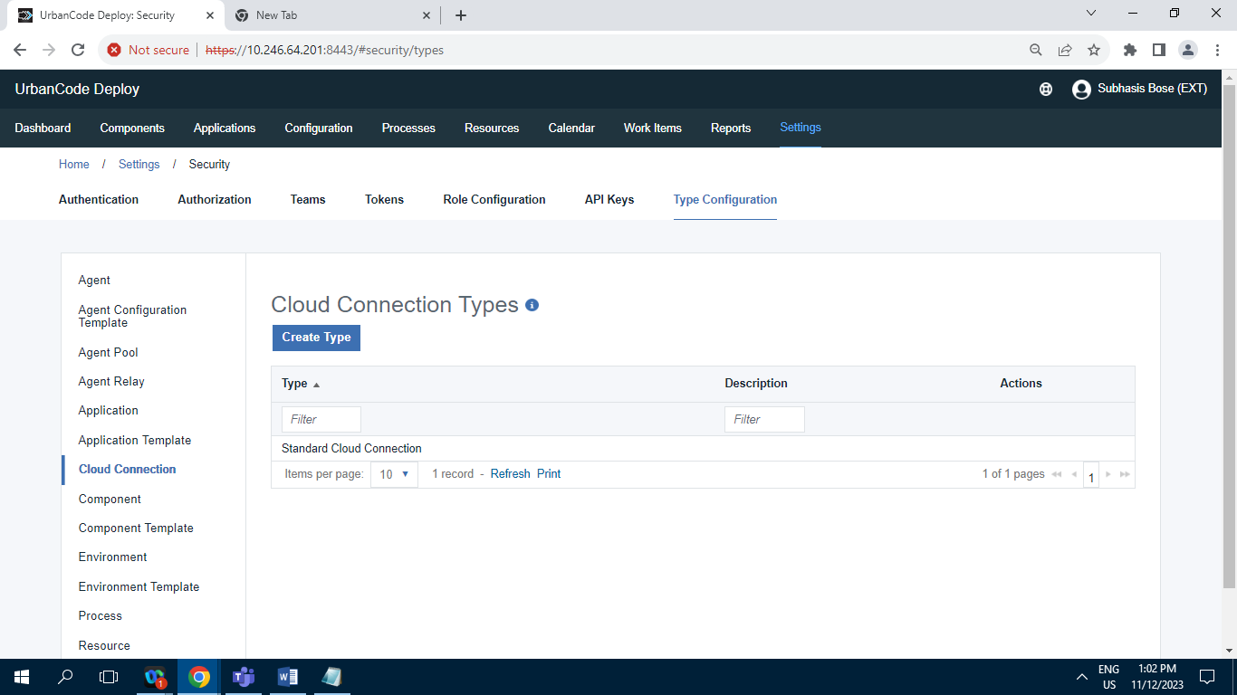

**Record = 1**

**11.2.7.8] Component Type :**

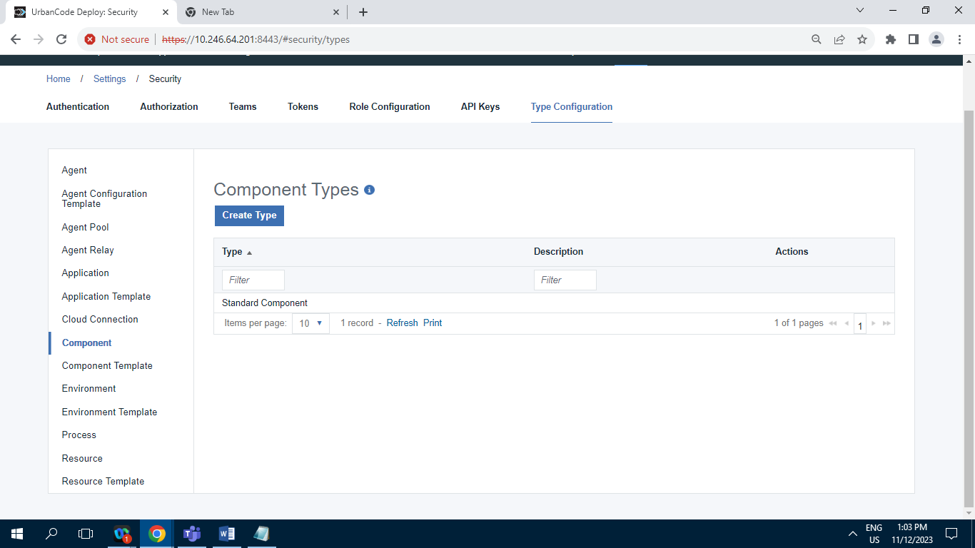

**Record = 1**

**11.2.7.9] Component Template Type :**

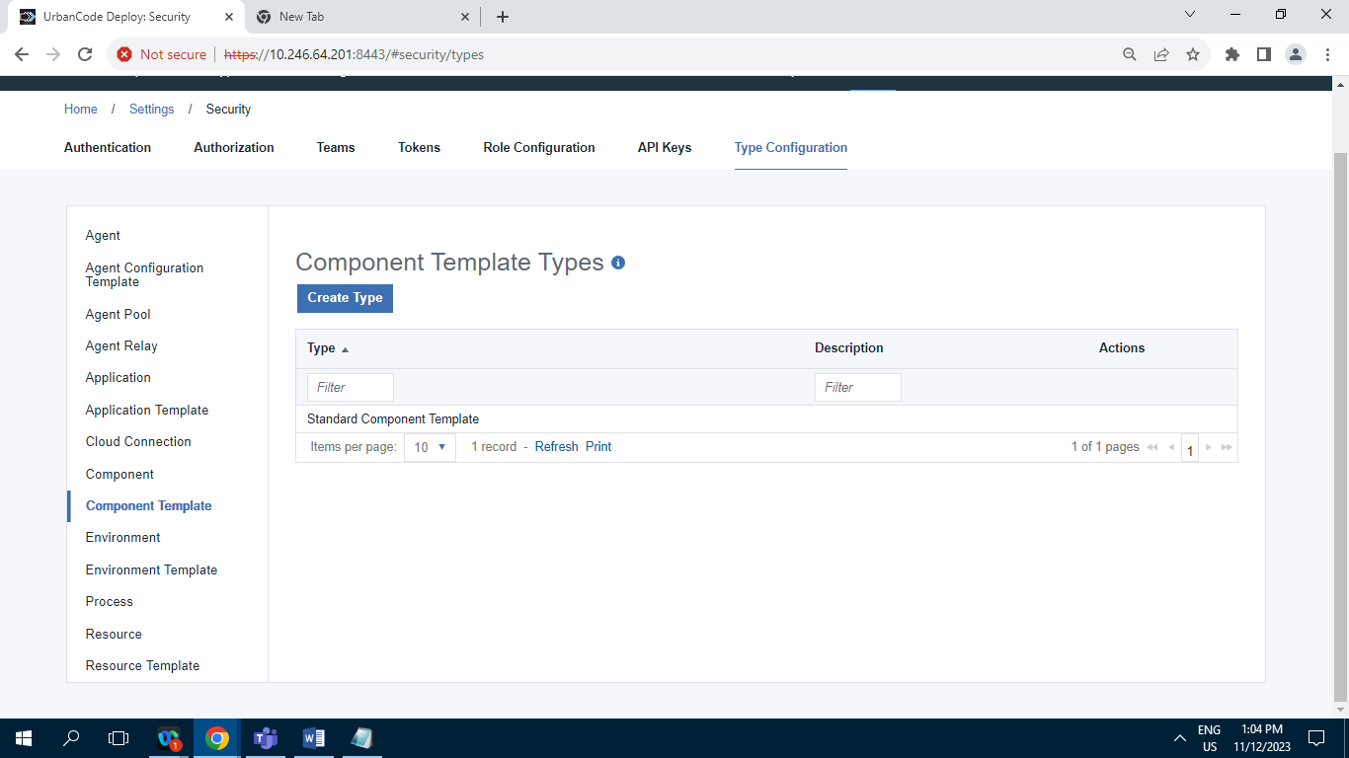

**11.2.7.10] Environment :**

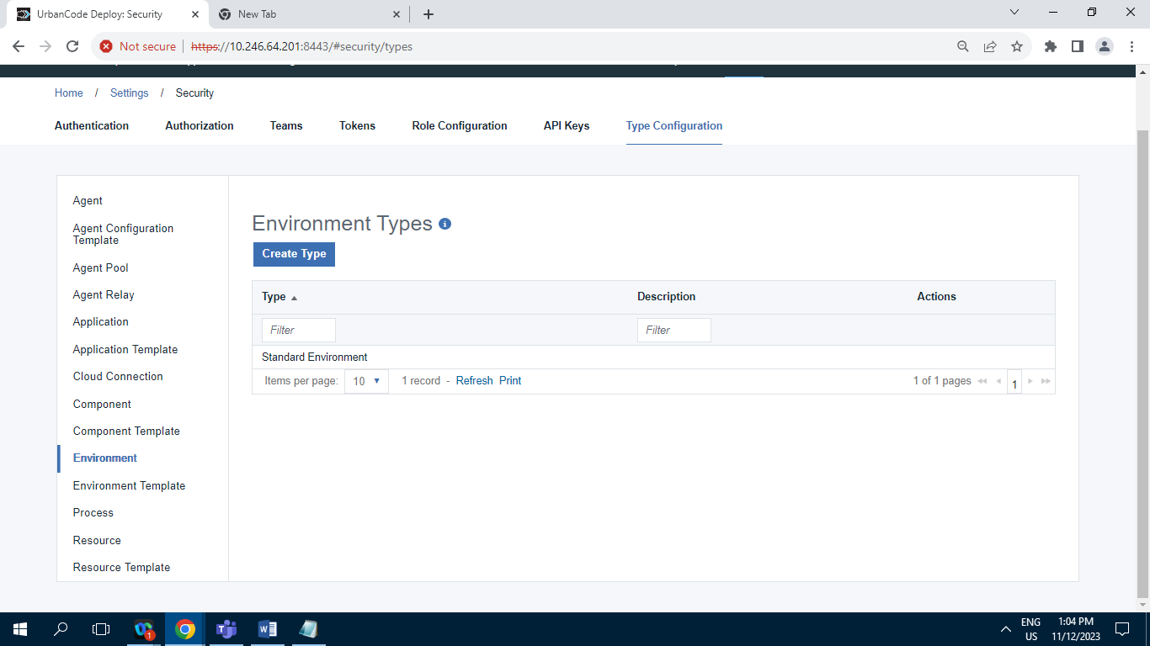

**Record = 1**

**11.2.7.11] Environment Template Type :**

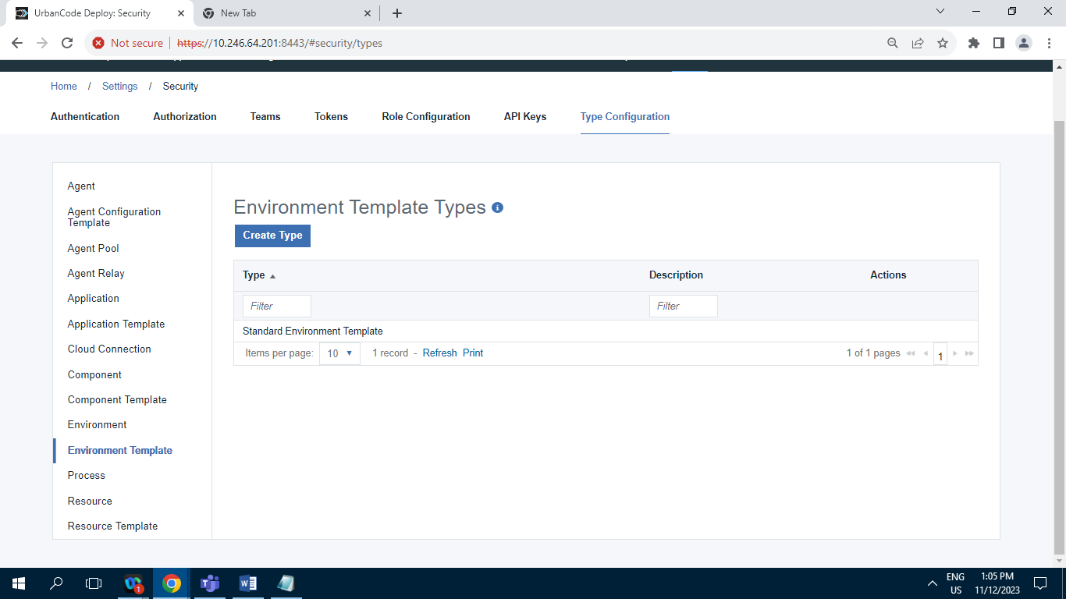

**Record = 1**

**11.2.7.12] Process :**

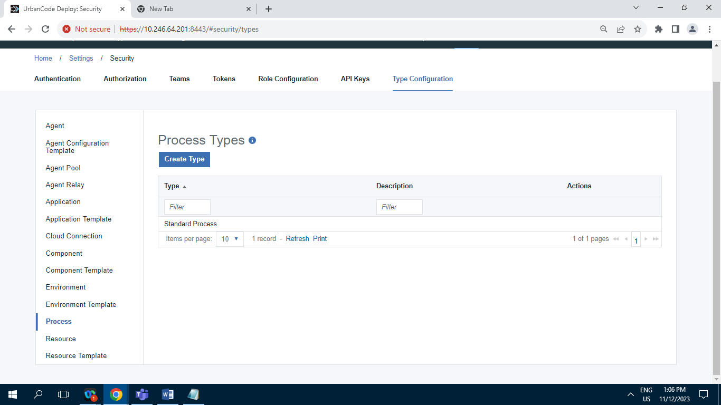

**Record = 1**

**11.2.7.13] Resource Type :**

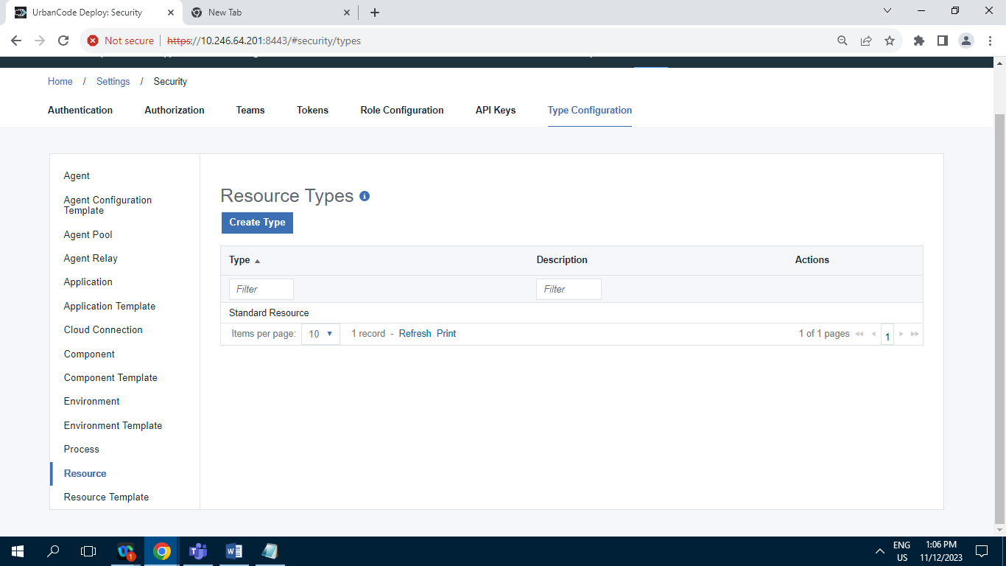

**Record = 1**

**11.2.7.14] Resource Template types :**

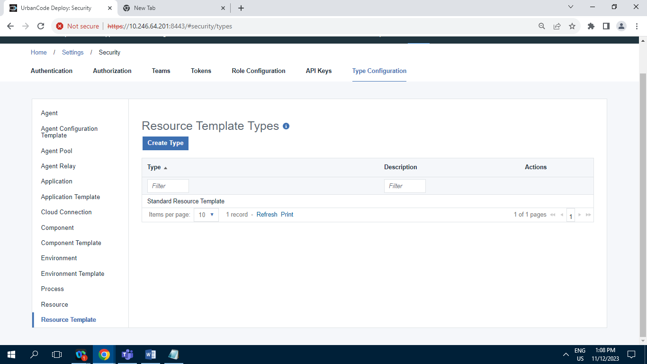

**Record = 1**

**11.3 ] System :**

**11.3.1] Logging :**

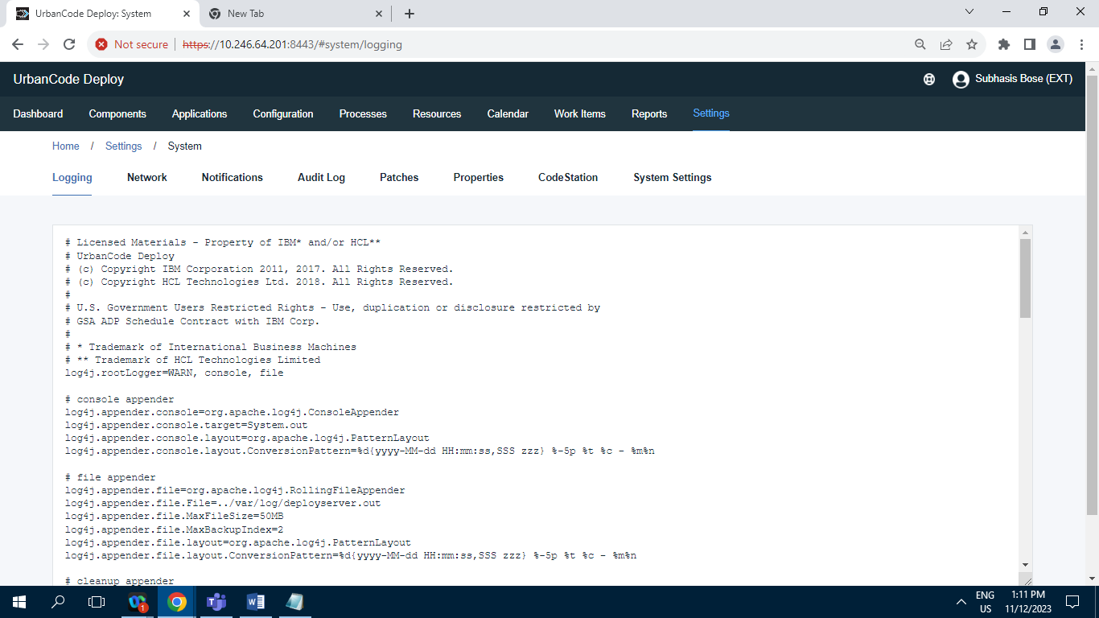

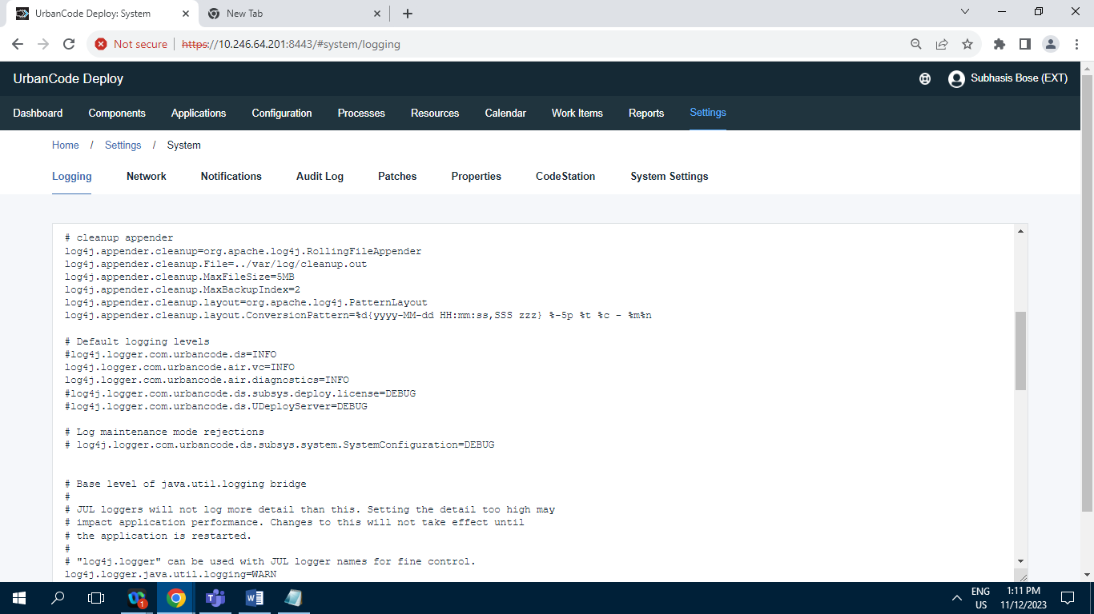

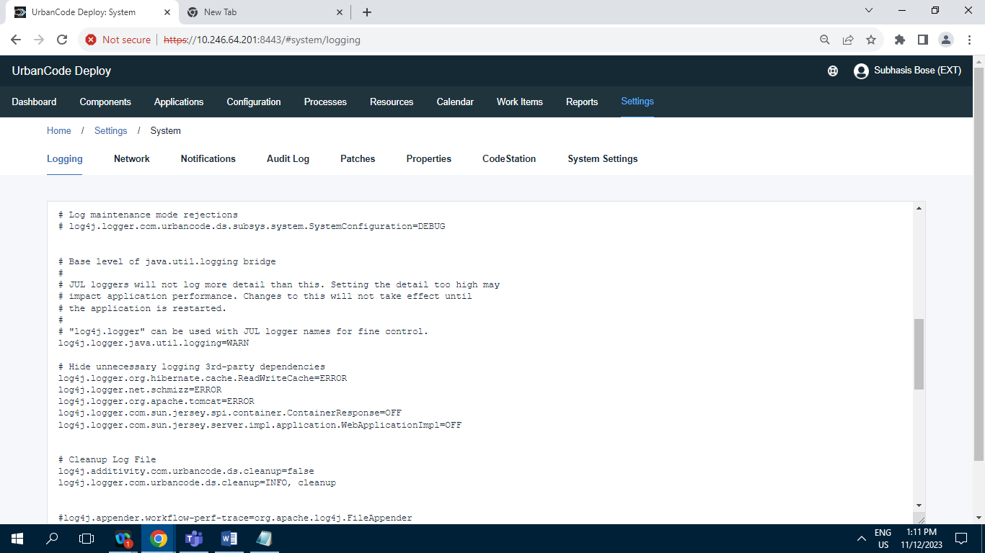

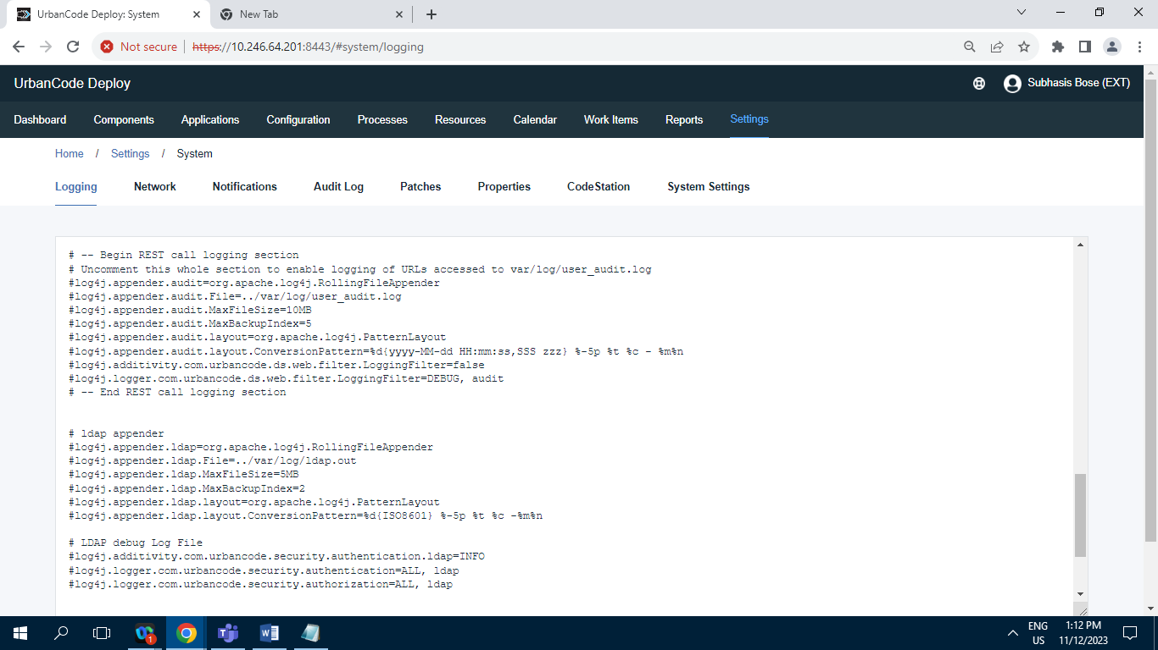

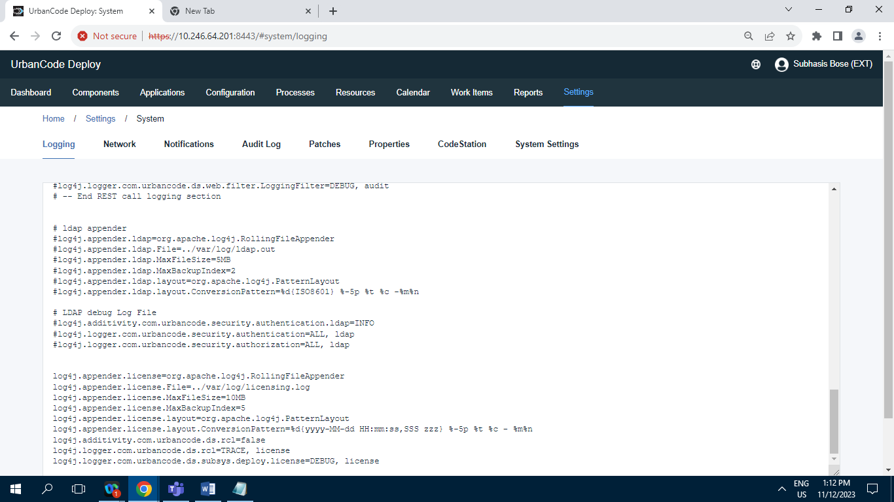

**11.3.2] Network :**

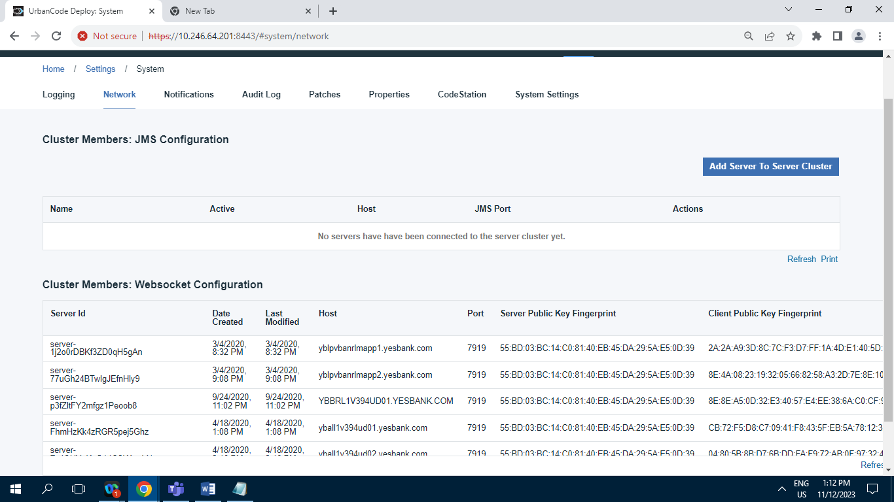

**11.3.3] Notification Scheme :**

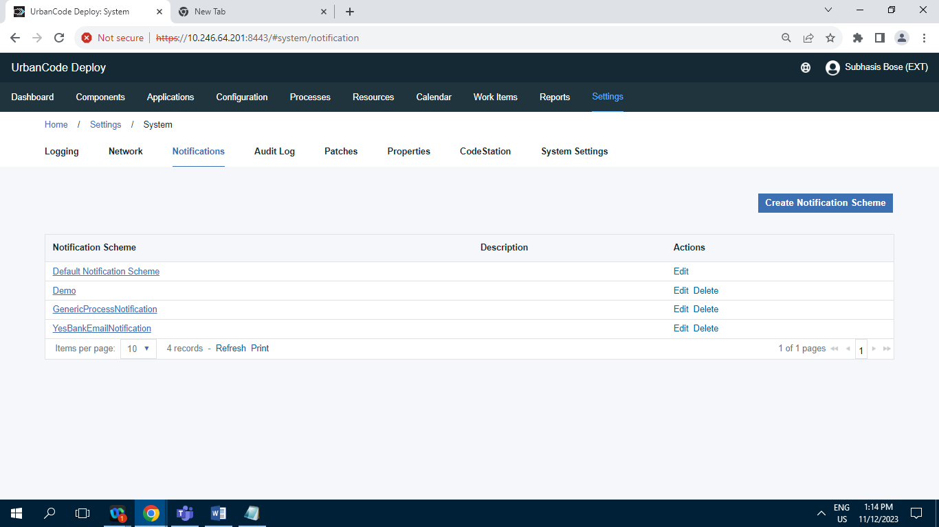

**Records = 4**

**11.3.4] Patches :**

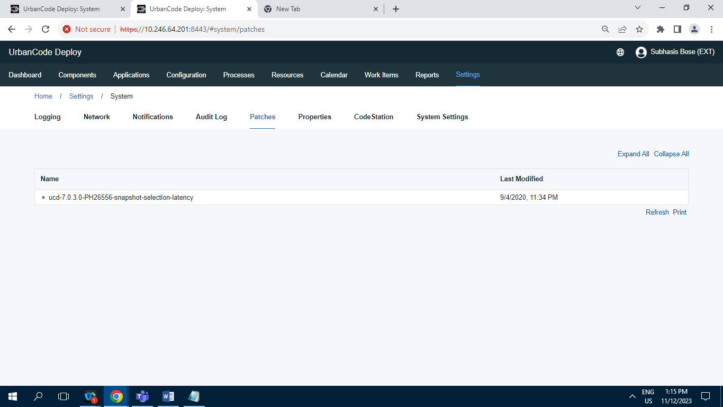

**11.3.5] Properties :**

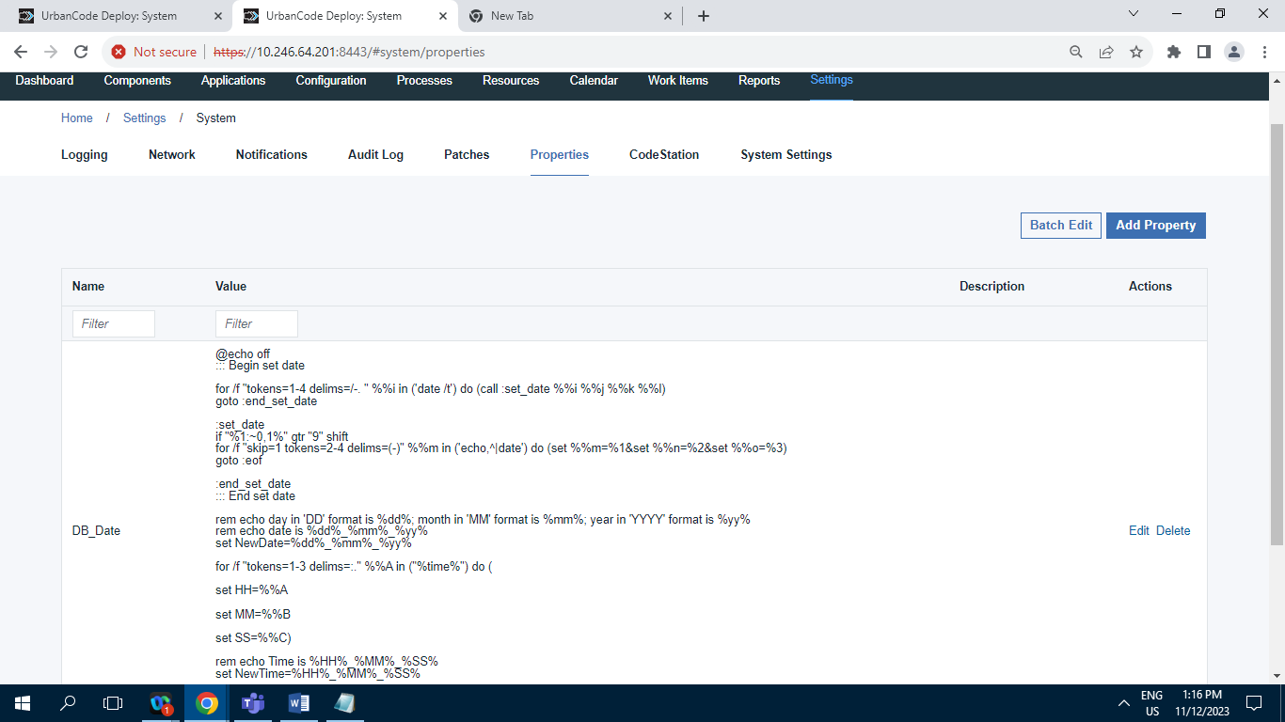

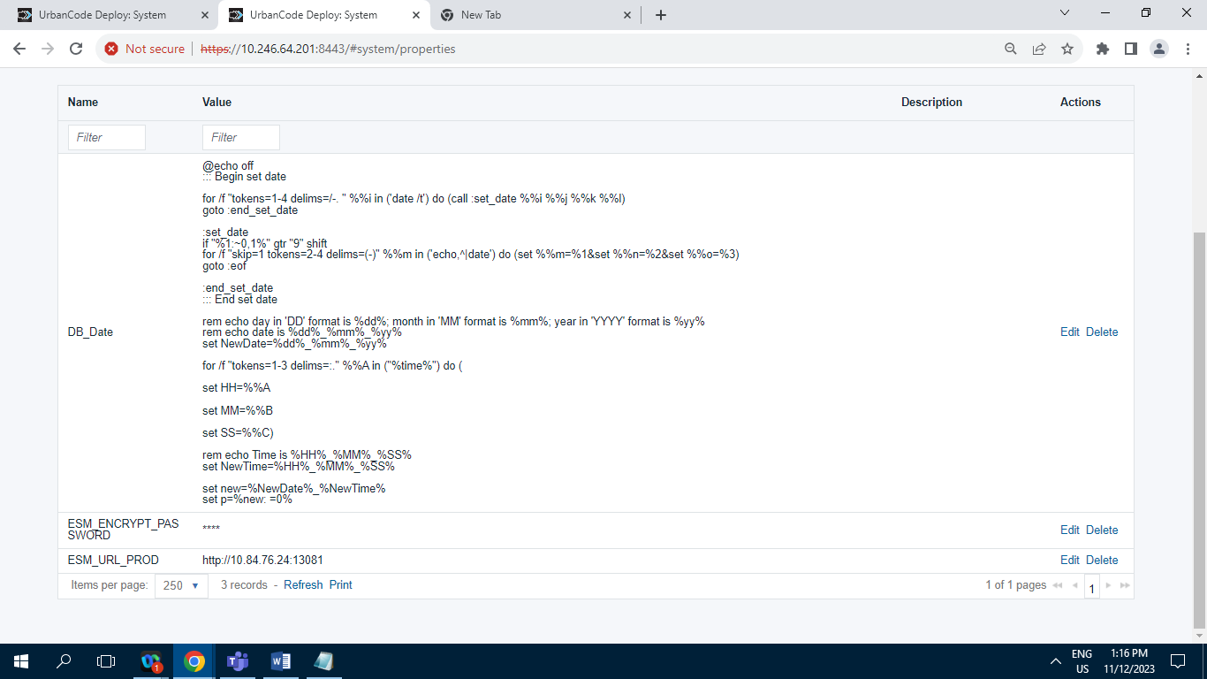

**Records = 3**

**11.3.6] Audit Log :**

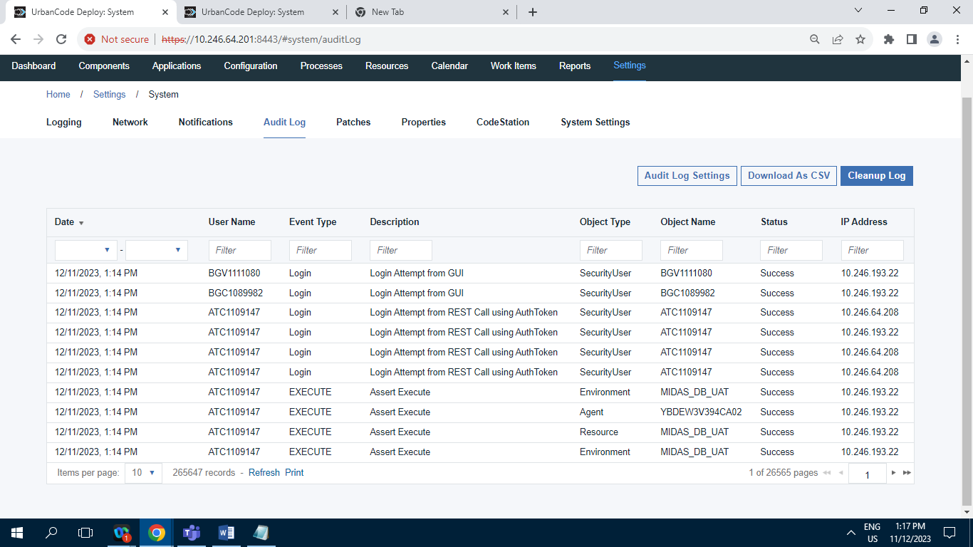

**Records = 265647**

**11.3.7] CodeStation :**

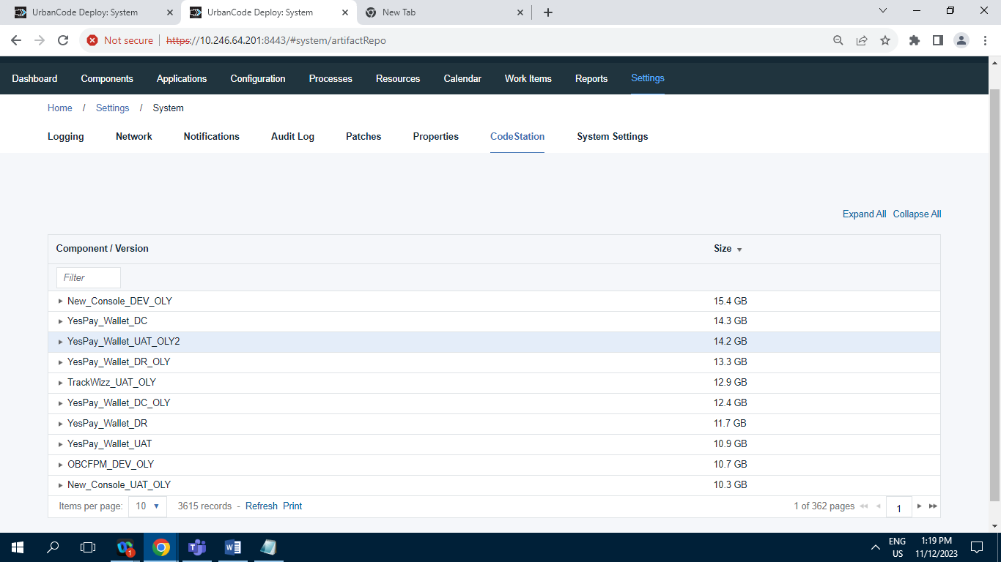

**Records = 3615**

**11.3.8] Diagnostics :**

**11.3.8.A] JAVA Thread Dumps :**

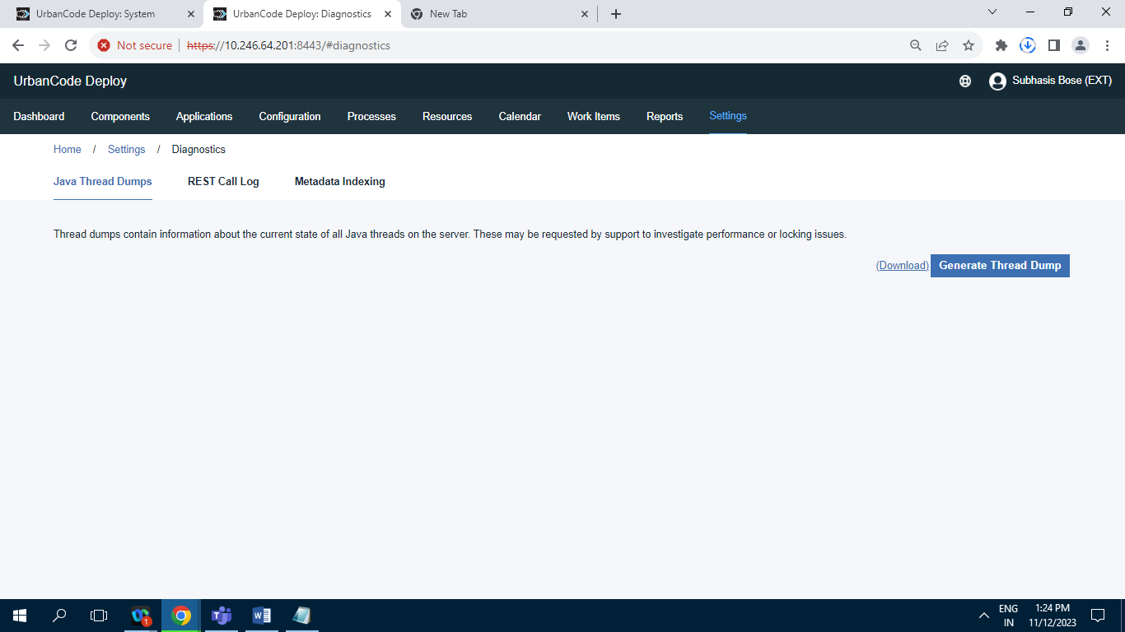

**11.3.8.B] REST call Log :**

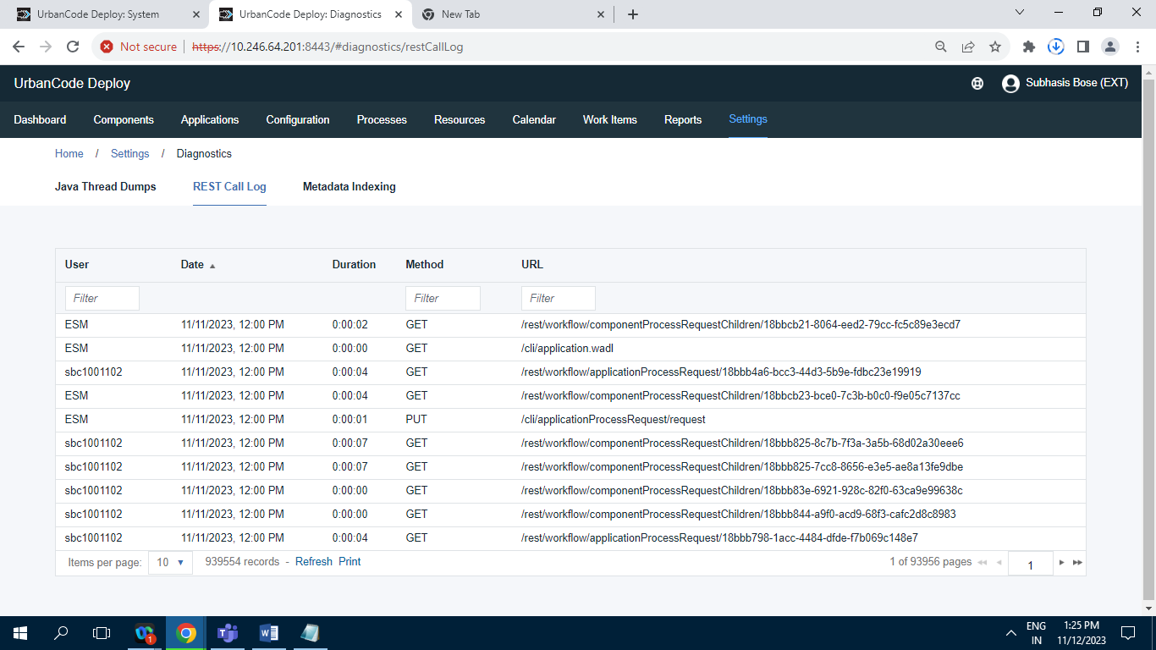

**Records = 939554**

**11.3.8.C] Metadata Indexing :**

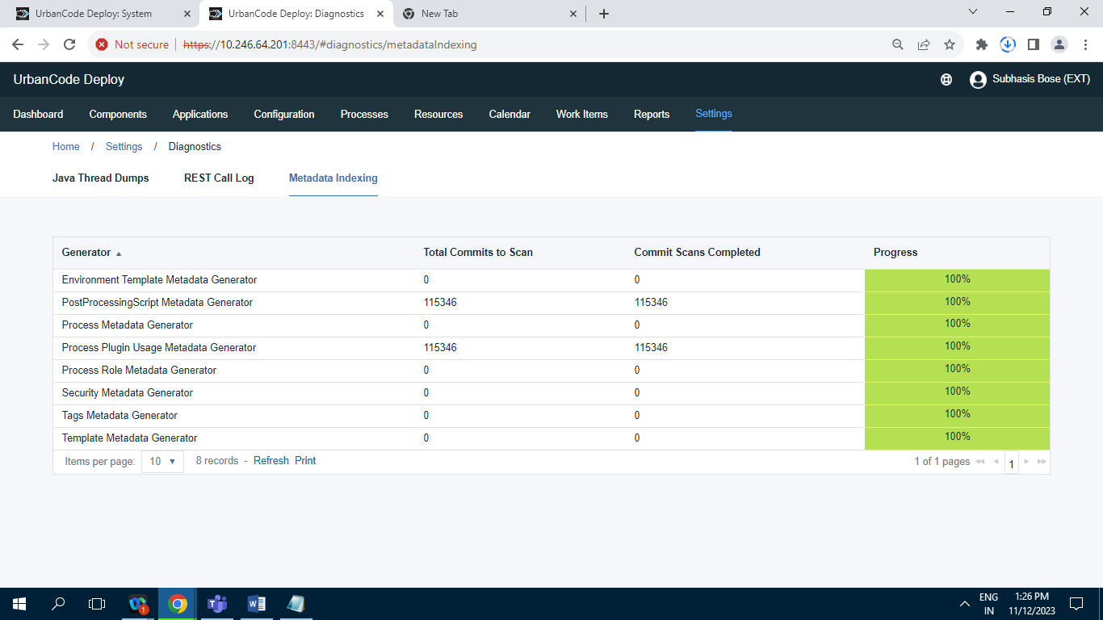

**Records = 8**

**11.3.9] System Settings :**

